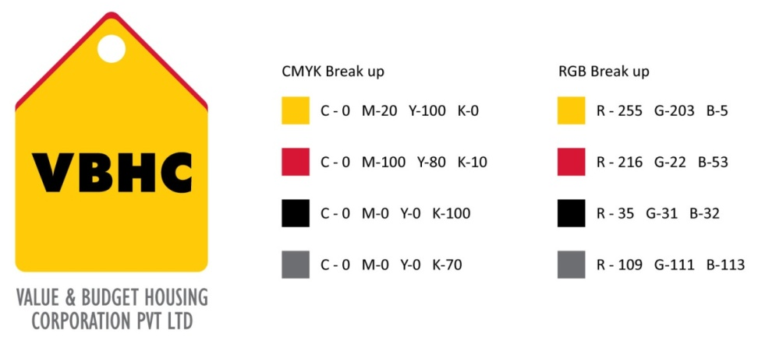**DESIGN DEVELOPMENT PLAN**

|  |  |  |  |
| --- | --- | --- | --- |
| **Document control NO**  **Project Name** | |  | **: VBHC/DES/ /01**  **:** |
| **Date** | **:** | |  |
| **Project Site** | **:** | |  |
| **Site Area** | **:** | |  |
| **Development Type** | **:** | |  |

|  |  |  |  |  |  |
| --- | --- | --- | --- | --- | --- |
| **S.N.** | **Activity** | **Start Date** | **Estimate Date** | **Finish Date** | **Person Responsible** |
| 1 | Predesign |  |  |  |  |
| 2 | Schematic Design |  |  |  |  |
| 3 | Design Development |  |  |  |  |
| 4 | Design Documentation |  |  |  |  |
| 5 | Construction Phase |  |  |  |  |

|  |  |  |  |
| --- | --- | --- | --- |
| ***Approved By*** | ***Name/Designation*** | ***Signature*** | ***Date*** |
| **Architect** | ***Chakravarthi*** |  |  |