**PROPERTY INSURANCE**

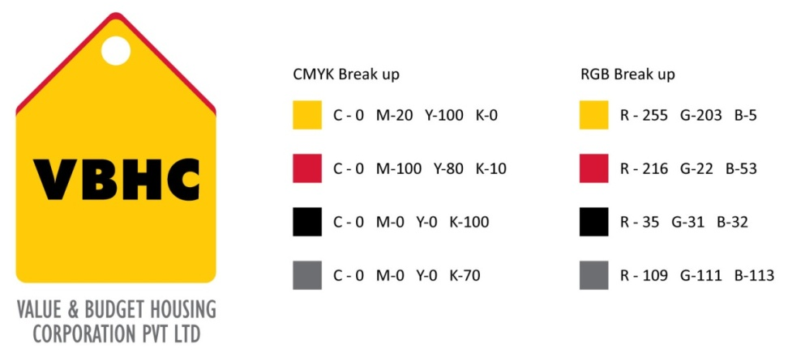

**Document Control No** : VBHC/HR/P/10

**Revision No** : Rev 1.1

**Date of Revision** : 01st April 2023

|  |  |  |  |
| --- | --- | --- | --- |
|  | ***Name/Designation*** | ***Signature*** | ***Date*** |
| ***Written By*** | ***Shashidhar Rao*** |  |  |
| ***Reviewed By*** | ***Kumar GVS*** |  |  |
|  |  |  |  |

**HISTORY OF REVISIONS**

|  |  |  |  |
| --- | --- | --- | --- |
| **Revision No.** | **Revision Date** | **Chapter/clause no.**  **& text affected** | **Reason for Revision** |
|  |  |  |  |
|  |  |  |  |
|  |  |  |  |
|  |  |  |  |
|  |  |  |  |
|  |  |  |  |
|  |  |  |  |
|  |  |  |  |
|  |  |  |  |
|  |  |  |  |
|  |  |  |  |
|  |  |  |  |
|  |  |  |  |
|  |  |  |  |
|  |  |  |  |

**TABLE OF CONTENTS**

|  |  |  |
| --- | --- | --- |
| **SL No.** | **CONTENTS** | **PAGE NO.** |
| 1. | Purpose | 1 |
| 2. | Process Trigger | 1 |
| 3. | Scope and Application | 1 |
| 4. | Process Owner  5. | 1 |
| 5. | Successor and Predecessor | 1 |
| 6. | Responsibilities & Authorities | 1 |
| 7. | Process Description | 2 |
| 8. | Efficiency measures and effectiveness measures | 2 |
| 9. | Risk associated with the process | 3 |
| 10. | Formats for maintaining records | 3 |
| 11. | Records | 3 |
| 12. | Annexure I | 3 |

**PROPERTY INSURANCE**

1. **PURPOSE**

To manage insurance related with all properties of the company.

1. **PROCESS TRIGGER**

This process is triggered when any property is purchased by the company on expiry of the existing policy.

1. **SCOPE AND APPLICATION**

All property owned by VBHC

1. **PROCESS OWNER**

HR – Head

1. **PREDECESSOR AND SUCCESSOR PROCESSES**
2. **RESPONSIBILITY AND AUTHORITY**

Provision of values of all items: Site Admin Heads

Preparation of asset list: Site Admin

Approval of selected insurance company: HR head

1. **PROCESS DESCRIPTION** 
   1. The Site Admin in coordination with the HR team prepares the asset list. The asset list will include all assets at every property of the company which include project sites as well as office buildings.
   2. The Site Admins will provide the values of all items present on the property.
   3. The asset list along with the value list is sent to the insurance consultant by the HR department.
   4. The insurance consultant suggests a list of companies, which provide various types of insurance at different premiums.
   5. The HR narrows down the list by selecting a few companies that match the requirements of VBHC.

*Steps 9.6 to 9.10: Carried out through the Insurance consultant*

* 1. Negotiation is carried out between the selected companies and the HR team.
  2. The insurance company that provides the best scheme as well as the services recommended.
  3. The selection of the insurance company is approved by the HR Head
  4. Once the approval is obtained, the HR Head processes for the payment of insurance premium to the insurance company.
  5. The insurance policy received from the insurance company is kept on record by the HR Head.

1. **EFFECIENCY MEASURES AND EFFECTIVENESS MEASURES**

Efficiency Measures: % premium paid for insurance cover

Effectiveness Measures: Value of assets left uncovered by insurance in a financial year

1. **RISK ASSOCIATED WITH THE PROCESS**
2. **FORMATS FOR MAINTAINING RECORDS GENERATED IN THE PROCESS**
3. **RECORDS**