PROJECT IT PLANNING



**Document Control No** : VBHC/IT/P/01

**Revision No** : Rev 2.1

**Date of Revision** : 23rd August 2023

|  |  |  |  |
| --- | --- | --- | --- |
|  | ***Name/Designation*** | ***Signature*** | ***Date*** |
| ***Written By*** | ***Kannan K R (AVP IT)*** |  |  |
| ***Reviewed By*** | ***Venkatesh Katta (IT consultant)*** |  |  |
|  |  |  |  |

## Value and Budget Housing Corporation Pvt. Ltd. VBHC House, 74&75, Millers Road Vasanthnagar

**Bangalore - 560052 | Karnataka**

|  |  |  |  |
| --- | --- | --- | --- |
| STANDARD OPERATING PROCEDURE | | | |
| Value and Budget Housing Corporation Pvt Ltd | PROJECT IT PLANNING | DOC.NO: VBHC/IT/P/01 |  |

# HISTORY OF REVISIONS

|  |  |  |  |
| --- | --- | --- | --- |
| **Revision No.** | **Revision Date** | **Chapter/clause no.** | **Reason for Revision** |
| 1.0 | 23-08-2021 |  | Updates of latest process |
|  |  |  |  |
|  |  |  |  |
|  |  |  |  |
|  |  |  |  |
|  |  |  |  |
|  |  |  |  |
|  |  |  |  |
|  |  |  |  |
|  |  |  |  |
|  |  |  |  |
|  |  |  |  |
|  |  |  |  |
|  |  |  |  |
|  |  |  |  |

**TABLE OF CONTENTS**

|  |  |  |
| --- | --- | --- |
| **SL No.** | **CONTENTS** | **PAGE NO.** |
| 1. | Purpose | 4 |
| 2. | Process Trigger | 4 |
| 3. | Scope and Application | 4 |
| 4. | Process Owner | 4 |
| 5. | Successor and Predecessor | 4 |
| 6. | Responsibilities & Authorities | 4 |
| 7. | Definitions and Abbreviations | 5 |
| 8. | Process Flow Chart | 6 |
| 9. | Process Description | 7 |
| 10. | Efficiency measures and effectiveness measures | 7 |
| 11. | Risk associated with the process | 7 |
| 12. | Records | 8 |

# PROJECT IT PLANNING

## PURPOSE

Hardware (Desktops, Laptops), Software and Network Connectivity & Email provisions for each project site.

## PROCESS TRIGGER

This process is triggered by intimation from Business Head of a project site, 6 to 8 weeks before the date of site launch.

## SCOPE AND APPLICATION

This process is applicable to every Project.

## PROCESS OWNER

IT Head

1. **PREDECESSOR AND SUCCESSOR PROCESSES** Predecessor Process: Prepare Master Schedule (15, PMC). Successor Process:

## RESPONSIBILITY AND AUTHORITY

To approve IT – Setup requirements: BH

To approve Configuration & Capacity requirements: IT Head To approve Cost Options & finalization: CEO / Operation Head To approve Vendor Tests: IT Infra Team

## DEFINITIONS & ABBREVIATIONS

* 1. CEO : Chief Executive Officer
  2. IT : Information Technology
  3. PBS : Project Breakdown Structure
  4. BOQ : Bill of Quantities

## PROCESS FLOW CHART

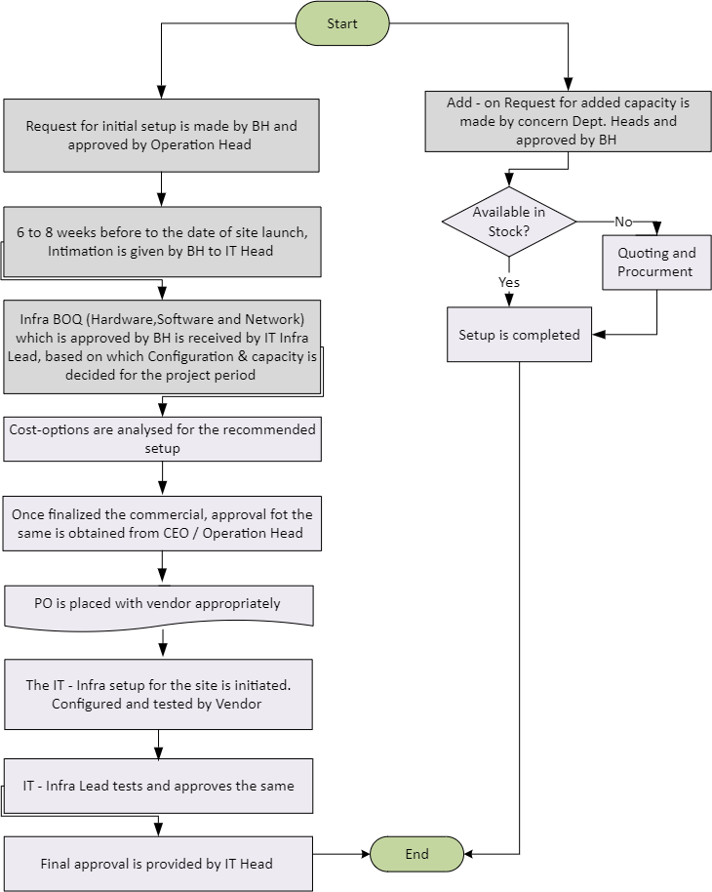

1. **PROCESS DESCRIPTION**
   1. Initial Setup:
      1. Request for initial setup is made by BH and Approved by Operation Head
      2. Before 6 to 8 weeks to the date of construction launch, intimation is given by Business Head to IT Head for full setup of Hardware / Software and Network.
      3. IT receives Infra BOQ (Hardware/Software and Network) approved by Business Head. Based on the same, the Configuration & Capacity of IT Infra is decided for the project.
      4. Cost options are analyzed for the recommended setup (approved by the CEO or Operation Head for total implementation cost) and PO is placed with the vendor appropriately (vendor is selected from approved vendor for every region. Refer 9.1.4 approval table Approved process for procurement of software / hardware under IT-Pro-Software & Hardware Inventory Management ISO Document
      5. Approval of PO is obtained as per workflow approval process in Quadra.
      6. The IT Infra setup is initiated, configured, and tested by vendor. The same is tested and approved by IT Infra Lead.
      7. Software is configured by IT Apps Lead and approved by IT Head
   2. Additional capacity setup:
      1. Request for additional capacity (for peripherals and PC’s only) required is made

by concern depts. and Approved by BH.

* + 1. If the stock is available, then set up is initiated immediately else quotations are obtained for procuring the same.

## EFFECIENCY MEASURES AND EFFECTIVENESS MEASURES

Efficiency Measures:

Planned Schedule Vs Actual Schedule Planned Cost Vs Actual Cost Effectiveness Measures:

## RISK ASSOCIATED WITH THE PROCESS

Timely approvals Change requests

## RECORDS

Quotations from Vendors – Minimum Retention Period – 1yr/Till Project Completion Purchase Orders – Minimum Retention Period – 1yr/Till Project Completion