**MATERIAL PROCUREMENT**

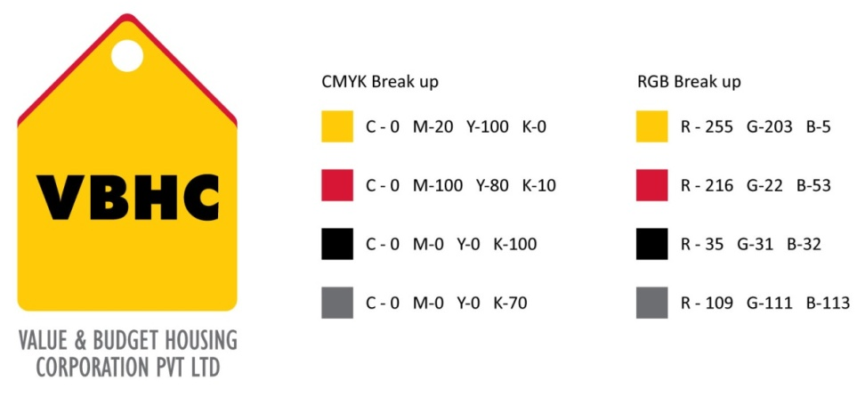

**Document Control No** : VBHC/P&C/P/01

**Revision No**  : Rev 3.1

**Date of Revision** : 25-08-2023

|  |  |  |  |
| --- | --- | --- | --- |
|  | ***Name/Designation*** | ***Signature*** | ***Date*** |
| ***Written By*** | ***Chandra Mohan JM*** |  |  |
| ***Reviewed By*** | ***Shiva Prasad*** |  |  |
| ***Approved By*** | ***Kumar GVS*** |  |  |

**HISTORY OF REVISIONS**

|  |  |  |  |
| --- | --- | --- | --- |
| **Revision No.** | **Revision Date** | **Chapter/clause no.**  **& text affected** | **Reason for Revision** |
| 2 | 25-Jan- 2018 | 9.6 | To update VRF approval rights |
| 2 | 25-Jan- 2018 | 9.10 | To add for Tax dept approval in quadra |
| 3 | 25 Aug -2021 |  |  |
| 3.1 | 25 Aug -2023 |  |  |
|  |  |  |  |
|  |  |  |  |
|  |  |  |  |
|  |  |  |  |
|  |  |  |  |
|  |  |  |  |
|  |  |  |  |
|  |  |  |  |
|  |  |  |  |
|  |  |  |  |
|  |  |  |  |

**TABLE OF CONTENTS**

|  |  |  |
| --- | --- | --- |
| **SL No.** | **CONTENTS** | **PAGE NO.** |
| 1. | Purpose | 1 |
| 2. | Process Trigger | 1 |
| 3. | Scope and Application | 1 |
| 4. | Process Owner  5. | 1 |
| 5. | Successor and Predecessor | 1 |
| 6. | Responsibilities & Authorities | 1 |
| 7. | Definitions and Abbreviations | 2 |
| 8. | Process Flow Chart | 3 |
| 9. | Process Description | 4 |
| 10. | Efficiency measures and effectiveness measures | 5 |
| 11. | Risk associated with the process. | 5 |
| 12. | Formats for maintaining records | 5 |
| 13. | Records | 5 |
| 14 | Annexure I | 5 |

**MATERIAL PROCUREMENT**

1. **PURPOSE**

To purchase the material of required specification, in time, as per the construction requirement.

1. **PROCESS TRIGGER**

Purchase Request raised through Quadra ERP after approval from the execution head.

1. **SCOPE AND APPLICATION**

This process is applicable to purchase of all kinds of material for construction related requirement at project sites / Office/ Maintenance.

1. **PROCESS OWNER**

Procurement and Contracts Head

1. **PREDECESSOR AND SUCCESSOR PROCESSES**

Predecessor Process: MSP Construction Schedule (PMC), Procurement Schedule , Prepare Project Budget (EST), Budget tracking Cost Control (EST).

Successor Process: Receive material, maintain inventory @ site (OP).

1. **RESPONSIBILITY AND AUTHORITY**

To approve on quality standards: Operation & Projects Head & Quality Head.

To approve finalized vendors: Operation & Projects Head & AVP- Procurement.

To approve indent/Requisition: Execution Heads & Project Managers.

To approve PO value <1.0 lakhs: AVP Procurement

To approve PO value >1.0 lakhs: Operation & Projects Head & Senior Vice President Operations

1. **DEFINITIONS & ABBREVIATIONS**
2. PO : Purchase Order
3. PR : Purchase Request
4. COO : Chief Operating Officer.
5. DGM : Deputy General Manager.
6. RH : Regional Head.
7. OP : Operations dept.
8. SPR : Supplier Performance Report
9. AVP : Assistant Vice President
10. **PROCESS FLOW CHART**

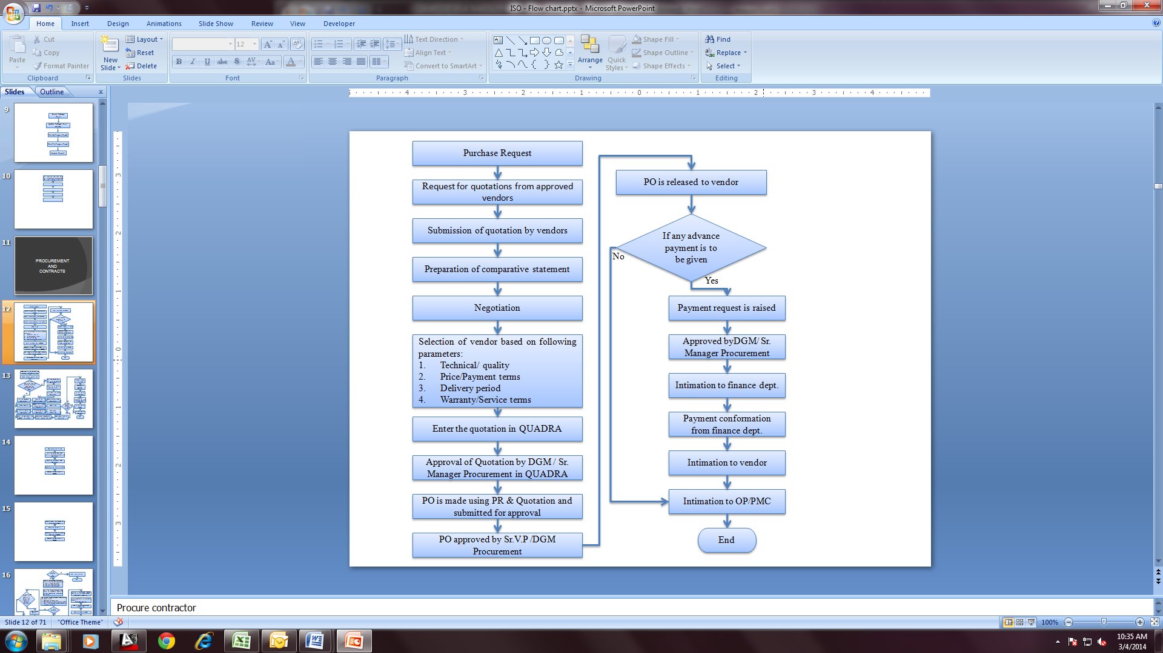

1. **PROCESS DESCRIPTION**
   1. Materials procurement process is initialized with Purchase Request, raised through Quadra ERP for material requirement from the execution team.
   2. Request for Quotations/Enquiry is sent to both approved as well as new vendors through email communication.
   3. A cost comparative statement is prepared from the commercial quotations received.
   4. After evaluating the quotations, multiple rounds of negotiation takes places with the vendors.
   5. Choice of the best vendor is done based on the parameters as follows:
      * Technical specifications / Quality Competence of the vendor / Approved brand.
      * Price and Payment terms.
      * Reliability on vendor in terms of Delivery period.
      * Warranty/ Service terms
   6. Final Comparative is shared with Operation & Projects Head & then get the approval.
   7. The details of the finalized vendor is entered in the Quadra approved vendor list & is then approved by Procurement Head & the final VRF (Vendor registration form) in Quadra is approved at accounts team.
   8. The details of quotation are then entered into QUADRA for approval.
   9. Quotation is approved by DGM/Sr. Manager Procurement in QUADRA.
   10. PO is made using PR & Quotation in QUADRA and submitted for approval.
   11. PO is approved by AVP Procurement & Contracts in QUADRA & email is sent to tax team for final approval in Quadra after checking for tax rates.
   12. Then PO is released to the selected vendor via email with a copy marked to site team.
   13. If any advance payment is to be given as per approved PO payment terms, then payment request is raised.
   14. Payment request is approved by AVP /DGM/Sr. Manager procurement.
   15. After approval the same is intimated to finance department for payment confirmation.
   16. Once the payment confirmation from finance dept. is received, it is intimated to vendor.
   17. In case of no advance payment, it is directly intimated to OPS/PMC dept. about the PO released.
2. **EFFECIENCY MEASURES AND EFFECTIVENESS MEASURES**

Efficiency Measures: Time taken to release the PO from PR date

Effectiveness Measures: Effectiveness can be measured by acceptance rate and timely material receipt that are reflected in Supplier Performance Rating. Average of all SPR is a measure of effectiveness of purchase process.

1. **RISK ASSOCIATED WITH THE PROCESS**

* The finalized vendor after accepting the PO may stop the supply of materials, if there is any drastic price escalation.
* Finalized vendor may not supply the materials as per the approved samples.
* The vendor may take the advance and not abide by the obligation. (Mitigation exp)

1. **FORMATS FOR MAINTAINING RECORDS GENERATED IN THE PROCESS**

Purchase request- generated in QUADRA

Comparative Statement for Vendors – Minimum Retention Period – 1yr/Till Project Completion

New Vendor registration form – Minimum Retention Period – 1yr/Till Project Completion

Purchase Order- generated in QUADRA

1. **RECORDS**

**ANNEXURE I**

|  |  |
| --- | --- |
| **Name of Format** | **Code** |
| Comparative Statement for Vendors | VBHC/P&C/P/01/MP01 |
| Vendor Empanelment Form | VBHC/P&C/P/01/MP02 |
| Vendor Registration Form | VBHC/P&C/P/01/MP03 |