R1 BUDGET

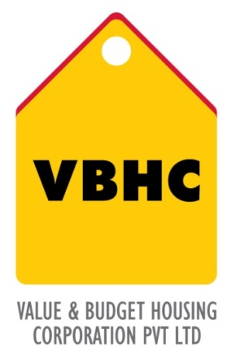
Document Control No : VBHC/EST/P/01
Revision No : Rev 1.1
Date of Revision : 31st August 2023

 | Name/Designation | Signature | Date
Written By | Azhar Ahmad
Reviewed By | Kumar GVS

HISTORY OF REVISIONS

Revision No. | Revision Date | Chapter/clause no.  & text affected | Reason for Revision

TABLE OF CONTENTS
SL No. | CONTENTS | PAGE NO.
1. | Purpose | 1
2. | Process Trigger | 1
3. | Scope and Application | 1
4. | Process Owner  5. | 1
5. | Successor and Predecessor | 1
6. | Responsibilities & Authorities | 1
7. | Definitions and Abbreviations | 1
8. | Process Flow Chart | 2
9. | Process Description | 2
10. | Efficiency measures and effectiveness measures | 3
11. | Risk associated with the process | 3
12. | Formats for maintaining records | 3
13. | Records | 3
14. | ANNEXURE | I

R1 BUDGET

- PURPOSE
To calculate indicative construction cost based on master plan and concept details.

- PROCESS TRIGGER
Master Plan

- SCOPE AND APPLICATION
This process is applicable to all ongoing and new projects of VBHC.

- PROCESS OWNER
Head – Estimation

- PREDECESSOR AND SUCCESSOR PROCESSES
Predecessor Process: Master plan including (D)
Successor Process: Securing Project Finance (FIN)

- RESPONSIBILITY AND AUTHORITY
Budget review : Head Estimation

- DEFINITIONS & ABBREVIATIONS

- PROCESS FLOW CHART

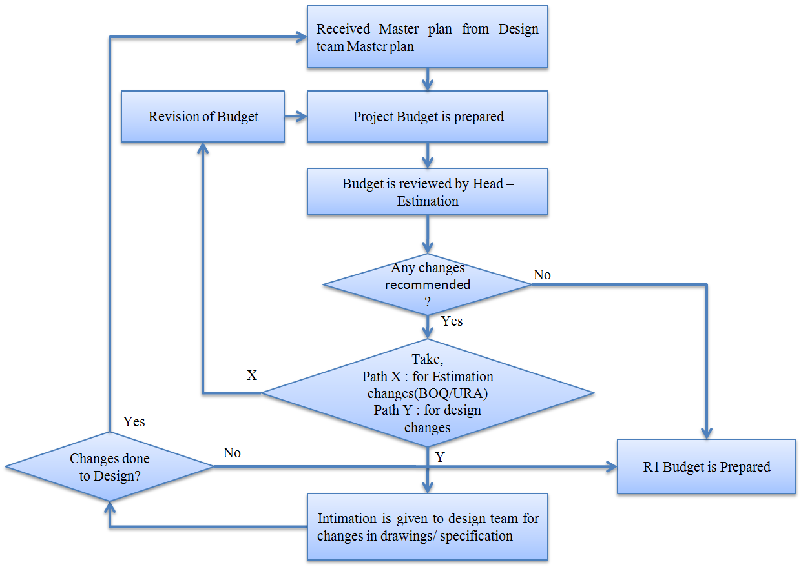

- PROCESS DESCRIPTION
  - Master plan received from Design Dept. is the essential Input to prepare R1 Project Budget by Estimation dept.
  - Other inputs (Such as Specifications, Phasing Plan etc.) are considered, if available, for budget preparation.
  - Based on inputs available budget is prepared and the same is reviewed by Head – Estimation.
  - If any changes are recommended by Head – Estimation, then
    - For estimation changes, the changes are incorporated and project budget is prepared by Estimation dept. which is an R1 Budget
    - For suggested design changes, the Design team is informed by Estimation dept. If revised inputs are received from design, same are incorporated for budget preparation.
- EFFECIENCY MEASURES AND EFFECTIVENESS MEASURES
Efficiency Measures:
Effectiveness Measures: Number of days taken to release R1 budget from the trigger
- RISK ASSOCIATED WITH THE PROCESS
The risk is on margins if the sales pricing is done based on this budget.
- FORMATS FOR MAINTAINING RECORDS GENERATED IN THE PROCESS
R1 Budget
- RECORDS
Record of R1 & R2 Budgets – Minimum Retention Period – Till Project Completion
- ANNEXURE I;
Name of Format | Code
R1 Budget | VBHC/EST/F/01

\

