SECURE FUNDS FOR LAND PURCHASE

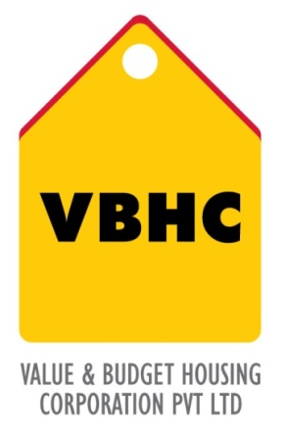
Document Control No : VBHC/FIN/P/01
Revision No : Rev 1.0
Date of Revision : 31st August 2013

 | Name/Designation | Signature | Date
Written By
Reviewed By
Approved By

HISTORY OF REVISIONS

Revision No. | Revision Date | Chapter/clause no.  & text affected | Reason for Revision

TABLE OF CONTENTS
SL No. | CONTENTS | PAGE NO.
1. | Purpose | 1
2. | Process Trigger | 1
3. | Scope and Application | 1
4. | Process Owner  5. | 1
5. | Successor and Predecessor | 1
6. | Responsibilities & Authorities | 1
7. | Definitions and Abbreviations | 2
8. | Process Flow Chart | 2
9. | Process Description | 2
10. | Efficiency measures and effectiveness measures | 3
11. | Risk associated with the process | 3
12. | Formats for maintaining records | 3
13. | Records | 3

SECURE FUNDS FOR LAND PURCHASE

- PURPOSE
To secure funds to purchase the land either through land acquisition or a joint development agreement.

- PROCESS TRIGGER
This process is triggered after the land for the project under consideration is approved feasible for purchase.

- SCOPE AND APPLICATION
All land acquisitions and purchases for VBHC projects, also those planned through joint venture.

- PROCESS OWNER
Finance – Head / Controller

- PREDECESSOR AND SUCCESSOR PROCESSES
Predecessor Process: Business Plan and Land feasibility (EST)
Successor Process: Acquire Land or JD Agreement (L)

- RESPONSIBILITY AND AUTHORITY
To present Business plan to investors: Top management and Finance – Head / Controller
To review and approve term sheet: Legal Department
Signing of term sheet: Designated authority as approved by board resolution.

- DEFINITIONS & ABBREVIATIONS

- PROCESS FLOW CHART

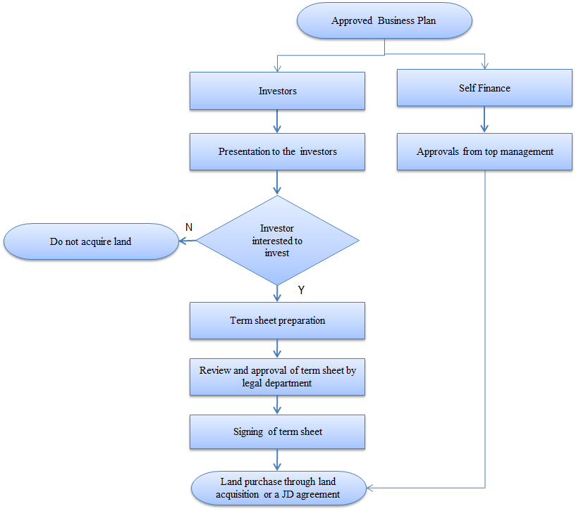
- PROCESS DESCRIPTION
- The approved R1 Business plan is used as input.
- It is decided whether to proceed with investors or self-finance.
- In both cases, the top management’s approval is required.
- The top management and the finance head present the approved R1 business plan to the investors.
- The investors decide if they are willing to invest in the project under consideration.
If the investors are interested in the business plan, a term sheet is provided to the investor. The term sheet has an investor specific format.
- The term sheet is reviewed and approved by the legal department, any financial information needed for the term sheet is provided by the finance department.
- The term sheet is presented to the board for approval and has to be signed by the designated authority.

This is communicated to the existing investors

- EFFECIENCY MEASURES AND EFFECTIVENESS MEASURES
Efficiency Measures: Number of days required to seal a deal with investors.
Effectiveness Measures: Success ration-number of investor who invest/ Number of investors approached.

- RISK ASSOCIATED WITH THE PROCESS
- If the secured funds cannot be invested, the funds become redundant.
- Capital utilization should occur in the stipulated time frame as per planned cost inventory.

- FORMATS FOR MAINTAINING RECORDS GENERATED IN THE PROCESS

- RECORDS
- Term Sheet
- Investor agreement

