PROJECT APPROVAL BY BANK

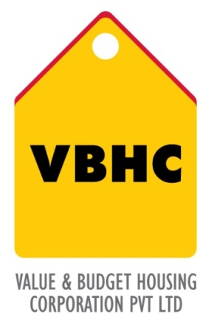
Document Control No : VBHC/HL/P/01
Revision No : Rev 1.0
Date of Revision : 31st August 2013

 | Name/Designation | Signature | Date
Written By
Reviewed By
Approved By

TABLE OF CONTENTS
SL No. | CONTENTS | PAGE NO.
1. | Purpose | 1
2. | Process Trigger | 1
3. | Scope and Application | 1
4. | Process Owner  5. | 1
5. | Successor and Predecessor | 1
6. | Responsibilities & Authorities | 1
7. | Definitions and Abbreviations | 1
8. | Process Flow Chart | 2
9. | Process Description | 2
10. | Efficiency measures and effectiveness measures | 3
11. | Risk associated with the process | 3
12. | Formats for maintaining records | 3
13. | Records | 3

PROJECT APPROVAL BY BANK

- PURPOSE
To obtain project approval from bank in order to eliminate possible delay by avoiding repetitive jobs in processing of loan applications from different purchasers who propose to buy dwelling units in the same project.

- PROCESS TRIGGER
This process triggers when intimation is received from BH about sales launch

- SCOPE AND APPLICATION
This is a onetime process carried out for every project.

- PROCESS OWNER
Sr. Manager, Home Loans

- PREDECESSOR AND SUCCESSOR PROCESSES
Predecessor Process: Project Sales Launch
Successor Process: Home loan customer approval

- RESPONSIBILITY AND AUTHORITY

- DEFINITIONS & ABBREVIATIONS
- BH : Business Head
- CRM : Customer Relationship Management

- PROCESS FLOW CHART
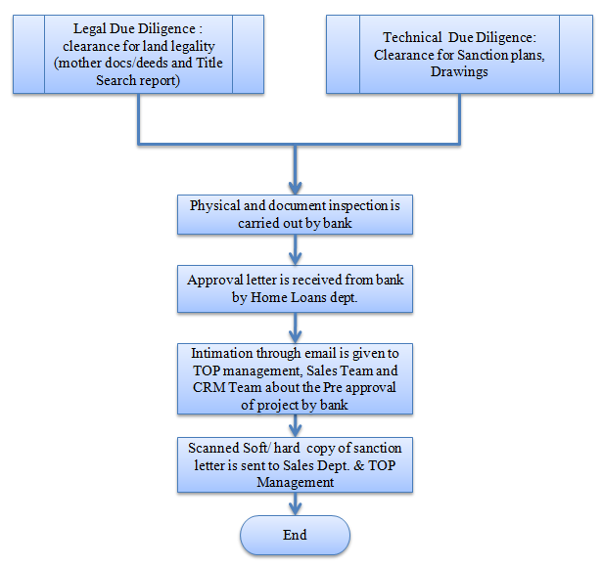

- PROCESS DESCRIPTION
  - Sr. Manager – Home Loans in consultation with Top Management decides a minimum of three banks (HDFC, and other banks) to approach for project approval.
  - After the technical and legal due diligence the Sr. Manager – Home Loans submits the following documents to the Bank's Board of Executive Directors for consideration and project approval based on banks requirement:
- 7/12 extract OR property card. (latest)
- NA order.
- ULC order (if any)
- Mother Documents, Title & Search report. (latest)
- Sanctioned plans (blue prints)
- Original NOC in bank's format
- Agreement for sale, Index II and payment receipts (in original)
- Possession letter (can be for furniture purpose if OC not yet rcvd)
- Final Demand letter with Architects Certificate.
  - After physical and document inspection carried out by bank, the approval letter is received by Sr. Manager – Home Loans from bank.
  - Intimation through email is given by Sr. Manager – Home Loans to TOP Management, CRM and Sales Team about approval of project by bank.
  - Scanned soft/hard copy of approval/sanction letter is sent to Sales Dept. & TOP Management.

- EFFECIENCY MEASURES AND EFFECTIVENESS MEASURES
Efficiency Measures:
Effectiveness Measures: Project Approval by a minimum of 3 banks
- RISK ASSOCIATED WITH THE PROCESS

- FORMATS FOR MAINTAINING RECORDS GENERATED IN THE PROCESS

- RECORDS
Bank’s Approval letters (wherever applicable) – Minimum Retention Period – Till Project Completion.

