RECRUITMENT

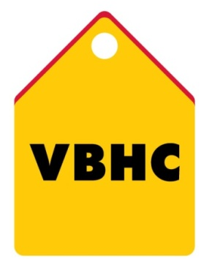
Document Control No : VBHC/HR/P/01
Revision No : Rev 1.1
Date of Revision : 01st April 2023

 | Name/Designation | Signature | Date
Written By | Shashidhar Rao
Reviewed By | Kumar GVS

HISTORY OF REVISIONS

Revision No. | Revision Date | Chapter/clause no.  & text affected | Reason for Revision

TABLE OF CONTENTS
SL No. | CONTENTS | PAGE NO.
1. | Purpose | 1
2. | Process Trigger | 1
3. | Scope and Application | 1
4. | Process Owner  5. | 1
5. | Successor and Predecessor | 1
6. | Responsibilities & Authorities | 1
7. | Definitions and Abbreviations | 2
8. | Process Flow Chart | 2
9. | Process Description | 3
10. | Efficiency measures and effectiveness measures | 4
11. | Risk associated with the process | 5
12. | Formats for maintaining records | 5
13. | Records | 5
14. | Annexure I | 5

RECRUITMENT

- PURPOSE
To ensure that the suitable candidates as per the requirements of the concerned department are recruited and appointed by the Organization and to arrange & provide requisite skilled manpower for each category at the appropriate time

- PROCESS TRIGGER
As and when a requirement arises from a department the recruitment process comes alive. It could be due to resignation or need of additional man power or commencement of new projects.

- SCOPE AND APPLICATION
This covers all activities of Recruitment & Selection/Interdepartmental Transfers across all locations.

- PROCESS OWNER
Head – HR

- PREDECESSOR AND SUCCESSOR PROCESSES
Pre-construction Planning and Salary & Wage Administration

- RESPONSIBILITY AND AUTHORITY
Head of department in coordination with the HR team is responsible for the implementation of this procedure.

- DEFINITIONS & ABBREVIATIONS
HOD: Head of Department.
IDT: Inter Departmental Transfers.

- PROCESS FLOW CHART

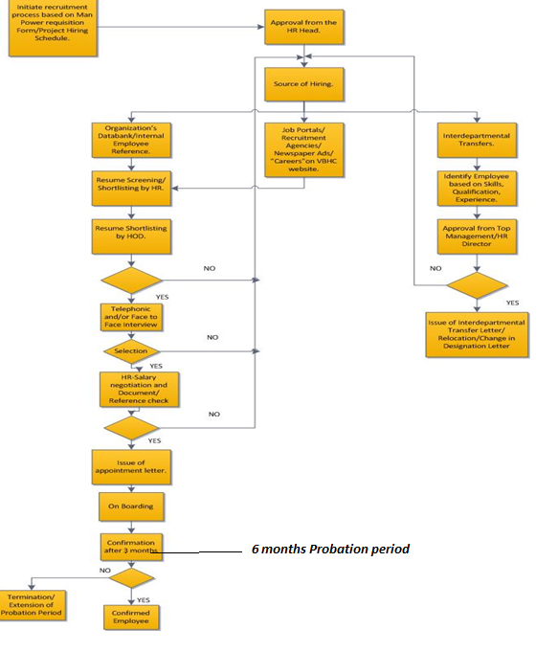

- PROCESS DESCRIPTION
  - The HR team initiates the recruitment process based on Man Power Requisition Form received through email from HODs or as per Project specific Hiring Schedule.
  - The requirement is sent to the HR Head for his approval.
  - Upon receipt of approval, HR team decides an appropriate source of hiring.
  - Various sources of hiring are:
- Organization’s databank and Internal Employee Reference.
- Job Portals/Recruitment Agencies/Newspaper Advertisements.
- Inter Departmental Transfers (IDT).
  - Organization’s databank consists of pool of resumes already available with the Recruitment team. Under Internal Employee Reference, job openings are displayed on the company’s intranet. In case a suitable employee is identified within the organization, an Inter Departmental Transfer can take place upon approval from top Management.
  - In case of hiring through Organization’s databank, Internal Employee Reference, Job Portals, Recruitment Agencies, Newspaper Advertisements and Careers section on the VBHC website resumes are first screened and shortlisted by the HR team. HR Head’s approval is required for engaging recruitment agencies or publishing Newspaper Advertisement.
  - The shortlisted resumes are sent to the HODs of the respective departments for further short listing.
  - The shortlisted resumes are called in for a face to face interview or in case of out station candidates a telephonic interview is conducted.
  - The HR discussion is conducted with the shortlisted candidates where the salary is negotiated, and designations are concluded. Documents are checked for every candidate and reference is checked for manager and above position.
  - Offer letter is issued to the selected candidate containing the date of joining, designation and salary details.
  - On the date of joining, the employee is given an induction and the joining formalities are conducted.
  - During the first six months of employment, the employee will be under probation and will be confirmed after six months upon recommendation from the Functional Head of the respective department depending upon the employee’s performance.
  - In case of unsatisfactory performance, the Functional Head may recommend either termination or extension of the probation period.
  - Upon successful completion of the Probation, a Confirmation Letter is issued to the employee.
  - In case of Inter Departmental Transfers, employees within the organization are identified based on skills, qualification and experience by HR department.
  - With HOD’s consent identified employee’s profile is sent to the Top Management/HR Director for approval.
  - If the profile gets approved, relevant documentations viz. Inter Departmental Transfer Letter/Relocation Letter/Change in Designation Letter is issued.

10. EFFICIENCY MEASURES AND EFFECTIVENESS MEASURES
Efficiency Measures:
- Average time to recruit for manager and above positions.
- Average time to recruit for other positions.
Effectiveness Measures:
- Analysis of the performance of the recruited employees during the Appraisal process.
- Lesser number of employees with extended Probation Period will imply that the Recruitment process was effective

11. RISKS ASSOCIATED WITH THE PROCESS
Not finding the right fit for the described position may pose a delay in the recruitment process itself as well as this may pose hindrance in the operations of the department.
Employee may or may not join the company despite accepting the offer.

12. FORMATS FOR MAINTAINING RECORDS GENERATED IN THE PROCESS
- Manpower requisition Form
- Evaluation Form
- Employee Joining Check List

13. RECORDS
ANNEXURE I
Name of Format | Code
Manpower requisition Form | VBHC/HR/F/01
Evaluation Form | VBHC/HR/F/02
Employee Joining Check List | VBHC/HR/F/03

