ACQUIRE LAND OR JD AGREEMENT

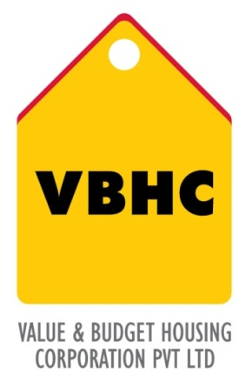
Document Control No : VBHC/LAN/P/01

Revision No : Rev 1.1

Date of Revision : 31st August 2023

 | Name/Designation | Signature | Date
Written By | Royal Reddy
Reviewed By | Kumar GVS

HISTORY OF REVISIONS

Revision No. | Revision Date | Chapter/clause no.  & text affected | Reason for Revision

TABLE OF CONTENTS
SL No. | CONTENTS | PAGE NO.
1. | Purpose | 1
2. | Process Trigger | 1
3. | Scope and Application | 1
4. | Process Owner  5. | 1
5. | Successor and Predecessor | 1
6. | Responsibilities & Authorities | 1
7. | Definitions and Abbreviations | 1
8. | Process Flow Chart | 2
9. | Process Description | 3
10. | Efficiency measures and effectiveness measures | 3
11. | Risk associated with the process | 3
12. | Formats for maintaining records | 3
13. | Records | 3

ACQUIRE LAND OR JD AGREEMENT

- PURPOSE
To acquire land either by directly buying or entering a joint development agreement with the land owners or by any other agreement which facilitates development rights to VBHC.

- PROCESS TRIGGER
This process is triggered after land is declared feasible for construction of the project and the funds for land purchase are secured.
3.0 SCOPE AND APPLICATION
All VBHC projects.

- PROCESS OWNER
Land Committee: Head
- PREDECESSOR AND SUCCESSOR PROCESSES
Predecessor Process: Securing Funds for Land Purchase ( L)
Successor Process: Master Planning (D)

- RESPONSIBILITY AND AUTHORITY
Review of all agreements: Legal Department
Approval of Proposals: Top Management
- DEFINITIONS & ABBREVIATIONS
ATS –Agreement-to-sell

8.0 PROCESS FLOW CHART
START
JD agreement or outright sale ?
Sales deed signed between owner and VBHC and reviewed by the legal department
Approved by top management
Approved by top management
END
Owner gives developing rights to the company
Agreement to enter a Joint development and reviewed by the legal department
Property registered in the Company’s name
Outright sale
Appropriate document is signed

- PROCESS DESCRIPTION
  - In a joint development :
    - An agreement is entered with the owner, clearly stating the percentage of stock holding options and all the terms and conditions regarding the joint development. The drafts come from both parties. The legal department drafts the agreement for VBHC.
    - Owner gives developing rights to the company.
    - The agreement is reviewed by the legal department and approved by the top management.
    - All the appropriate documents are signed.
  - In an outright sale :
    - Sales deed is signed between the owner and VBHC (authorised signatory as per board resolution) which states, the terms of payment.
    - The sales dead is reviewed by the legal department and approved by the top management.\
    - The property is then registered in the company’s name :
- Registration of sale deed/ agreement for sale/ development agreement by power of attorney
- Paying stamp duty and registration charges.

- EFFECIENCY MEASURES AND EFFECTIVENESS MEASURES
Efficiency Measures
Effectiveness Measures: Collection of required documents within stipulated time

- RISK ASSOCIATED WITH THE PROCESS
If legal aspects are not properly reviewed, the company might enter into legal issues later into the project.

- FORMATS FOR MAINTAINING RECORDS GENERATED IN THE PROCESS

- RECORDS

