LEGAL DUE DILIGENCE

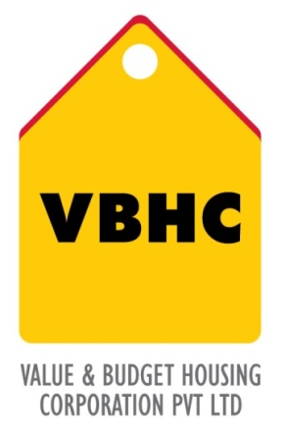
Document Control No : VBHC/LEG/P/01

Revision No : Rev 1.0

Date of Revision : 31st August 2013

 | Name/Designation | Signature | Date
Written By
Reviewed By
Approved By

TABLE OF CONTENTS
SL No. | CONTENTS | PAGE NO.
1. | Purpose | 1
2. | Process Trigger | 1
3. | Scope and Application | 1
4. | Process Owner  5. | 1
5. | Successor and Predecessor | 1
6. | Responsibilities & Authorities | 1
7. | Definitions and Abbreviations | 2
8. | Process Flow Chart | 2
9. | Process Description | 3
10. | Efficiency measures and effectiveness measures | 3
11. | Risk associated with the process | 3
12. | Formats for maintaining records | 4
13. | Records | 4

LEGAL DUE DILIGENCE

- PURPOSE
To conduct a thorough legal examination of the land before purchase in order to minimize liabilities or risks.

- PROCESS TRIGGER
This process is triggered after the R0 business plan is complete and approval to proceed with due diligence is granted.

- SCOPE AND APPLICATION
All land acquisitions and purchases for VBHC projects.

- PROCESS OWNER
Legal Head

- PREDECESSOR AND SUCCESSOR PROCESSES
Predecessor Process: R0 Business Plan and Feasibility (Fin, P3)
Successor Process: Acquire Land or JD Agreement (L, P21)

- RESPONSIBILITY AND AUTHORITY
- To engage an external council: Legal Head
- To decide whether to proceed with the preparing the R1 business plan: Top management

- DEFINITIONS & ABBREVIATIONS
- R0
- PROCESS FLOW CHART
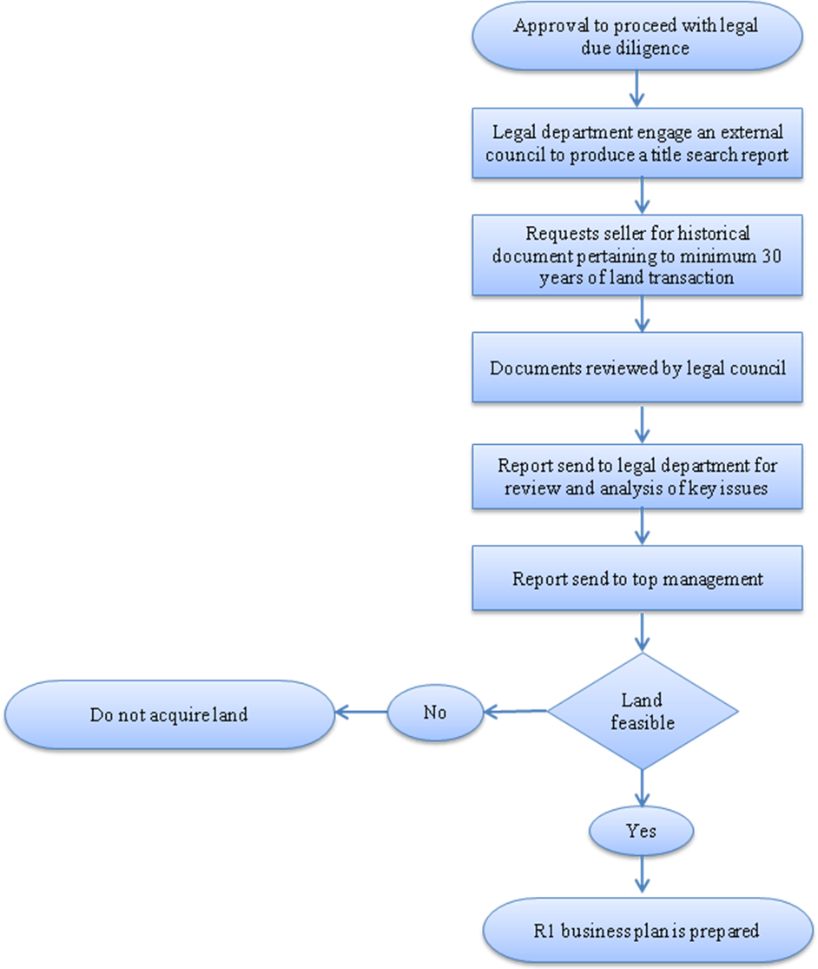

- PROCESS DESCRIPTION
- The legal head obtains quotes and commercial terms from selected lawyers. The external council is selected by the legal head with approval from the top management
- The external council is engaged to produce a title search report which will entail all the details of the property title. The legal format of the title search report change from state to state and has a bank specific format.
- Now we hire a legal team, who will do a title search report for us.
- They publish an advertisement in the newspaper asking for any objectionable claim in the land.
- They ask for different mutation entries, death certificate, and other documents which are required from time to time.
- They will check the documents for a minimum of 30 years history to make sure that now claimant to property arises after the sale.
- After their check and go ahead we get a legal document saying that the current owner is having the clear and marketable title in the property.
- The legal department reviews the report, analyzes the key issues, study changes and provides solutions and forward the report to the top management.
- The top management decided whether to purchase the land under consideration.

- EFFECIENCY MEASURES AND EFFECTIVENESS MEASURES
Efficiency Measures: Number of days required to submit legal due diligence to the top management.
Effectiveness Measures: Legal liabilities encountered on the land parcel.

- RISK ASSOCIATED WITH THE PROCESS
If not carried out efficiently, the company might confront certain legal liabilities and risks further into the project.

- FORMATS FOR MAINTAINING RECORDS GENERATED IN THE PROCESS

- RECORDS

