PRE-CONSTRUCTION SITE PRELIMINARIES

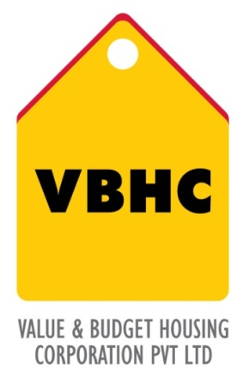
Document Control No : VBHC/OPE/P/01
Revision No : Rev 1.1
Date of Revision : 31st August 2023

 | Name/Designation | Signature | Date
Written By | Shivaprasad
Reviewed By | Kumar GVS

TABLE OF CONTENTS
SL No. | CONTENTS | PAGE NO.
1. | Purpose | 1
2. | Process Trigger | 1
3. | Scope and Application | 1
4. | Process Owner  5. | 1
5. | Successor and Predecessor | 1
6. | Responsibilities & Authorities | 1
7. | Definitions and Abbreviations | 2
8. | Process Flow Chart | 2
9. | Process Description | 2
10. | Efficiency measures and effectiveness measures | 3
11. | Risk associated with the process | 3
12. | Formats for maintaining records | 3
13. | Records | 3
14. | Annexure 1 | 4

PRECONSTRUCTION SITE PRELIMINARIES

- PURPOSE
To conduct and implement all pre construction site preliminary activity prior to the construction of the project.

- PROCESS TRIGGER
The process is triggered once the project master schedule is prepared and prior to construction.
- SCOPE AND APPLICATION
All VBHC projects
- PROCESS OWNER
Head: Operation
- PREDECESSOR AND SUCCESSOR PROCESSES
Predecessor: Project Master Schedule (P30,PMC)
Successor: Pre-Construction Monitoring (P32,PMC), Health and Safety Management (P55,OP).

- RESPONSIBILITY AND AUTHORITY
- Charting out activities: Operations Department in consultation with the Business head
- Listing out all the equipment needed for the implementation : PMC department
- Approval of indents / requisitions :Business Head
- Purchase of all required items : Purchase Department

- DEFINITIONS & ABBREVIATIONS

- PROCESS FLOW CHART
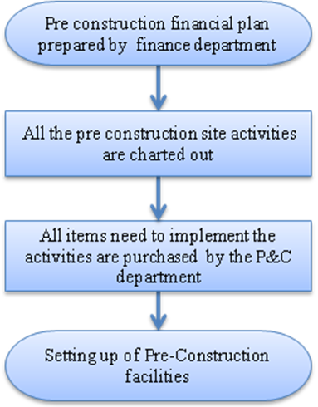

- PROCESS DESCRIPTION
  - The preconstruction financial plan is received from the financial department
  - All the preconstruction that needs to take place before the construction starts are charted out by the operations department in consultation with the Business head.
  - All the items ( i.e. materials, equipment etc) to implement the pre construction activities are purchased by the P&C department after receiving the indents from the PMC department with the approval of the business head.
  - All the facilities that are required are set up as per the schedule.
Following are the preconstruction facilities to be set up:
- Boundary wall
- Government Survey
- Marketing office portacabin
- Soft and hard Landscaping of marketing area
- Sample apartment
- Picket fence separating sample apartment from construction area
- Internet connectivity for marketing office
- Procurement of desktops, cafeteria for marketing office
- Setting up of washroom with soak pit
- Electrical connection of 10 KVA
- Stores Portacabin
- Security kiosk with toilets
- Labour Colony
- I.T Set up

10. EFFECIENCY MEASURE AND EFFECTIVENESS MEASURE
Efficiency Measures:
Effectiveness Measures: Actual vs scheduled completion
- RISK ASSOCIATED WITH THE PROCESS

- FORMATS FOR MAINTAINING RECORDS GENERATED IN THE PROCESS

