PREPARE MASTER SCHEDULE

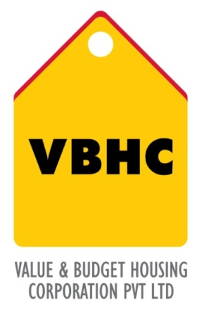
Document Control No : VBHC/PMC/P/01
Department : PMC
Revision No : Rev 1.0

 | Name/Designation | Signature | Date
Written By | Shivaprasad
Reviewed By | Kumar GVS

HISTORY OF REVISIONS

Revision No. | Revision Date | Chapter/clause no.  & text affected | Reason for Revision

TABLE OF CONTENTS

SL No. | CONTENTS | PAGE NO.
1. | Purpose | 1
2. | Process Trigger | 1
3. | Scope and Application | 1
4. | Process Owner  5. | 1
5. | Successor and Predecessor | 1
6. | Responsibilities & Authorities | 1
7. | Definitions and Abbreviations | 2
8. | Process Flow Chart | 3
9. | Process Description | 3
10. | Efficiency measures and effectiveness measures | 4
11. | Risk associated with the process | 4
12. | Formats for maintaining records | 5
13. | Records | 5
14. | Annexure 1 | 6
PREPARE MASTER SCHEDULE

- PURPOSE
To establish a process to prepare and implement the Project Master Schedule in order to timeline all construction activities of the project.
- PROCESS TRIGGER
This process is triggered when Master Plan including phasing concept and schematic is finalized by Design Department.
- SCOPE AND APPLICATION
This process applies to all VBHC projects
- PROCESS OWNER
PMC - Head.
- PREDECESSOR AND SUCCESSOR PROCESSES
Predecessor Process: Master Plan including phasing concept and schematics (P10,D)
Successor Process: Site Coordination (P29, PMC), Pre-construction HR Planning (P31,PMC), Project IT-Infra Setup (P48,IT), Pre-construction site preliminaries (P33,OP), Pre-construction and construction monitoring (P27,PMC),Security ( P50,ADM), Labour Camp(P51,ADM), Transportation (P52,ADM)
- RESPONSIBILITY AND AUTHORITY
To approve Project Master Schedule : COO
- DEFINITIONS & ABBREVIATIONS
- PMS : Project Master Schedule.
- PMC : Project Management.
- COO : Chief Operating Officer
- MSP : Micro Soft Project
- Project Start Intimation: The COO/Sales Head informs the existence of a project, and provides the project manager/ Sr VP Design, Planning & Construction with the authority to apply organizational resources to project activities
- Deliverables: A tangible or intangible object produced as a result of the project that is intended to be delivered to the customers. A deliverable could be approvals from various authorities, flat, block, amenities or any other component of project promised to customer.
- Project Break-down Structure :A deliverable oriented hierarchical decomposition of the work to be executed by the project team to accomplish the project objectives and create the required deliverables. It organizes and defines the total scope of the project. Each descending level represents an increasingly detailed definition of the project work.

- PROCESS FLOW CHART
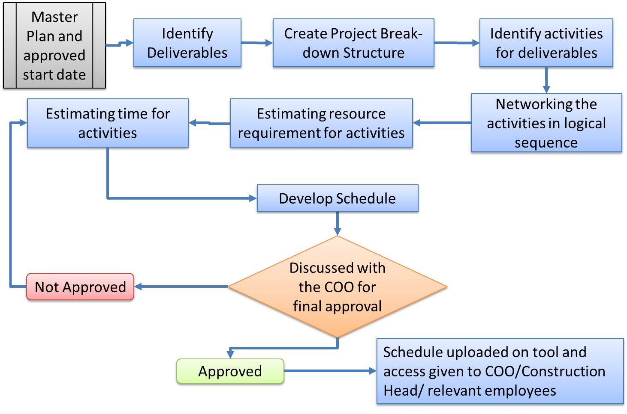

- PROCESS DESCRIPTION
  - Master Plan from Design Dept. and the approved start date from COO/BH is received by PMC dept.
  - Deliverables are identified by the PMC department ;(For example: Flat is a deliverable which is promised to be delivered to the customer within 18months from the date of launch of project).
  - Project Break-down Structure and Networking of flat wise activities (i.e. linking of activities) in a logical sequence that they need to be carried out are prepared in MSP by Manager – PMC.
  - Resources such as labor required to complete each and every activity of the project are estimated and allocated to the activities in MSP by the PMC department in coordination with the site in charge.
  - Amount of time required to complete a task/activity with available resources is determined using productivity norms for the labor and machinery is assigned as activity duration in MSP by PMC department.
  - Based on resources estimated & time estimated, project schedule from start to end is developed along with start date & finish date for the project in MSP by PMC department.
  - The schedule developed is discussed with the COO for final approval. The approved schedule is loaded on tool (Microsoft Project) to Construction head, COO and relevant employees for their review and usage.

- EFFECIENCY MEASURES AND EFFECTIVENESS MEASURES
Efficiency Measures: Number of days taken to complete the PMS will be 30days from the date of availability inputs.
Effectiveness Measures:
- RISK ASSOCIATED WITH THE PROCESS
Unforeseen circumstances with respect to Force Majeure need to be assumed suitably.
Risk factors:
1. Optimistic schedule may lead to project time overrun.
2. Very conservative schedule may lead to cost overrun.

- FORMATS FOR MAINTAINING RECORDS GENERATED IN THE PROCESS
Project Master Schedule format
- RECORDS

ANNEXURE I
Name of Format | Code
Project Master Schedule | VBHC/PMC/F/01

