MANAGEMENT REVIEW MEETING

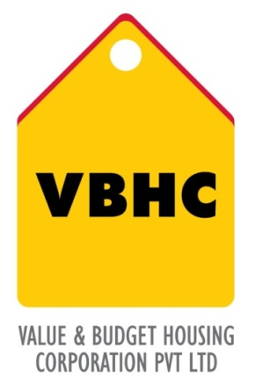
Document Control No : VBHC/QMS/P/01
Revision No : Rev 1.1
Date of Revision : 31st August 2023

 | Name/Designation | Signature | Date
Written By | Ramesh
Reviewed By | Nagesh
Approved By | Kumar GVS

HISTORY OF REVISIONS

Revision No. | Revision Date | Chapter/clause no.  & text affected | Reason for Revision

TABLE OF CONTENTS
SL No. | CONTENTS | PAGE NO.
1. | Purpose | 1
2. | Process Trigger | 1
3. | Scope and Application | 1
4. | Process Owner  5. | 1
5. | Successor and Predecessor | 1
6. | Responsibilities & Authorities | 1
7. | Definitions and Abbreviations | 2
8. | Process Flow Chart | 2
9. | Process Description | 3
10. | Efficiency measures and effectiveness measures | 4
11. | Risk associated with the process | 4
12. | Formats for maintaining records | 4
13. | Records | 4
14 | Annexure I | 5

MRM

- PURPOSE
To provide a system for scheduling, conducting, and recording management reviews to ensure continued system effectiveness and alignment with quality policy and objectives of the QMS.
- PROCESS TRIGGER
This is a periodic process carried out quarterly.

- SCOPE AND APPLICATION
This procedure applies to all processes of VBHC’s QMS.

- PROCESS OWNER
Management Representative

- PREDECESSOR AND SUCCESSOR PROCESSES
Predecessor Process: NCR, Internal audits, CAPA, Obtaining customer feedback
Successor Process: MRM [this is a cyclic process]

- RESPONSIBILITY AND AUTHORITY
Management Representative:
The Management Representative (MR) is to ensure the implementation of this procedure and is responsible for the compilation and analysis of appropriate review data and scheduling the periodic Management Review Meeting (MRM)

- DEFINITIONS & ABBREVIATIONS
- QMS : Quality Management System
- MR : Management Representative
- MRM : Management Review Meeting
- MD : Managing Director

- PROCESS FLOW CHART

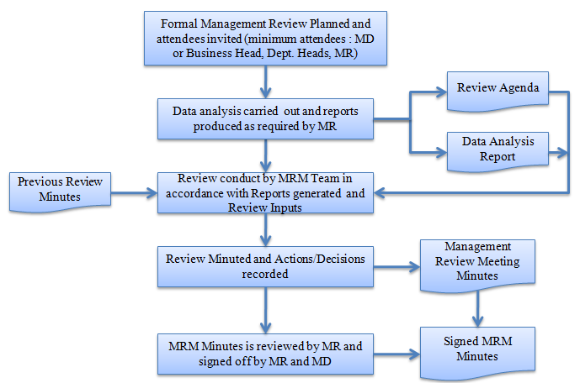

- PROCESS DESCRIPTION
  - Management reviews are held a quarterly and more often as deemed necessary by the MR or MD. MR shall release the schedule of the MRM along with the internal audit plan.
  - Management reviews are held to ensure the process management system’s continuing suitability, adequacy, and effectiveness. The reviews include assessing opportunities for improvement and the need for changes to the integrated process management system, including the quality policy and district objectives.
  - The Managing Director, Management Representatives and Department Heads are members of the Management Review Team. To conduct a formal management review, majority of the membership must be present.
  - The management review shall be chaired by the Managing Director and coordinated by the Management Representative.
  - Review inputs:
The input to management reviews shall include information on:
- Follow-up actions, if applicable, from previous management reviews;
- Results of internal audits which indicate performance and conformity to ISO 9001 requirements conducted since the previous review;
- Customer feedback, as a result of customer complaints and/or customer surveys conducted, when required;
- Status of corrective and preventive actions;
- Continued relevance of the Quality policy and objectives;
- Planned changes that could affect the Quality Management System; and
- Recommendations for improvement
  - Review output:
The output from the MRM shall include any decisions or actions in relation to:
- Recommendations / decisions for improvement of the effectiveness of the Quality management system and its associated processes;
- Any resource needs determined; and
- Required audits
  - The management review meeting minutes prepared by any one of MR Team shall include the items discussed on the agenda, action items assigned, elements from paragraph 9.5, and any miscellaneous items discussed.
  - MRM Minutes is reviewed by MR and signed off by MR and MD.
  - MRM is documented by MR.
  - The minutes of the MRM are taken as a review input in MRM conducted later.

- EFFECIENCY MEASURES AND EFFECTIVENESS MEASURES
Efficiency Measures: Number of MRMs conducted as scheduled
Effectiveness Measures: Sustenance of ISO: 9001 certificate [is applicable]

- RISK ASSOCIATED WITH THE PROCESS
None

- FORMATS FOR MAINTAINING RECORDS GENERATED IN THE PROCESS
Previous Management review meeting minutes

- RECORDS
MRM Schedule, MOM & Attendance sheet – Minimum Retention Period – 3Yrs

ANNEXURE I
Name of Format | Code
Management review meeting minutes | VBHC/QMS/F/07

