WORKMAN TRAINING

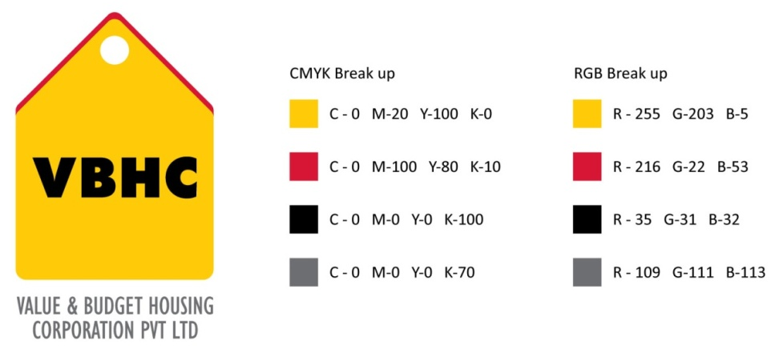
Document Control No : VBHC/QUA/P/01
Revision No : Rev 1.1
Date of Revision : 31st August 2023

 | Name/Designation | Signature | Date
Written By | Rakshith
Reviewed By | Shivaprasad

HISTORY OF REVISIONS

Revision No. | Revision Date | Chapter/clause no.  & text affected | Reason for Revision

TABLE OF CONTENTS

SL No. | CONTENTS | PAGE NO.
1. | Purpose | 1
2. | Process Trigger | 1
3. | Scope and Application | 1
4. | Process Owner  5. | 1
5. | Successor and Predecessor | 1
6. | Responsibilities & Authorities | 1
7. | Definitions and Abbreviations | 1
8. | Process Flow Chart | 2
9. | Process Description | 2
10. | Efficiency measures and effectiveness measures | 3
11. | Risk associated with the process | 3
12. | Formats for maintaining records | 3
13. | Records | 3
14 | Annexure I | 5

WORKMAN TRAINING

- PURPOSE
To define a process for workman pre-qualification and training in order to improve the productivity of the worker/Labour

- PROCESS TRIGGER
The process triggers in the following situations:
- While commencing any new activity at a project and a group of workmen join
- When a new Labour/Worker joins VBHC sites
- If any defect / NC is observed during execution of work by Quality dept.

- SCOPE AND APPLICATION
This process is applicable to all the workers/Labours working with VBHC.

- PROCESS OWNER
Asst. Manager – Quality

- PREDECESSOR AND SUCCESSOR PROCESSES
Predecessor Process: None
Successor Process: Daily Construction Management

- RESPONSIBILITY AND AUTHORITY
Sampling work Approval by Asst. Manager – Quality

- DEFINITIONS & ABBREVIATIONS

- PROCESS FLOW CHART
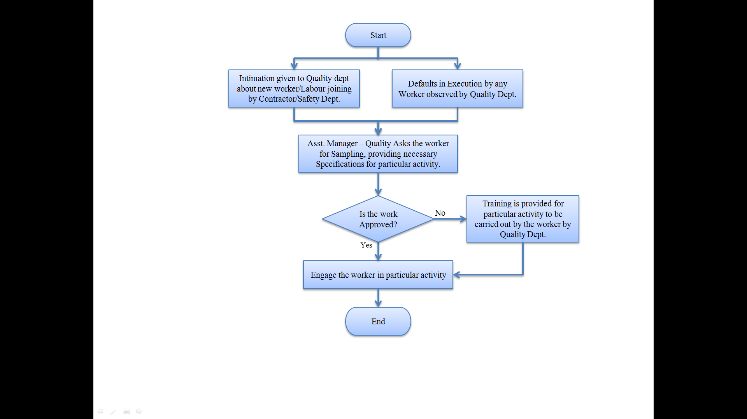
- PROCESS DESCRIPTION
  - Intimation is given to the Quality dept about new workers’ joining by Contractor/Safety Dept.
  - Then Asst. Manager – Quality provides the specification of the work and asks the worker for executing a sample of the work.
  - The Quality department observes the worker while he performs the activity to assess if the correct sequence and method is being followed. After completion of the sample task, the finished work is inspected for conformance to requirements/specifications
  - If the process and output of the work executed by the worker is satisfactory then Asst. Manager – Quality approves the work and engages the worker in particular activity
  - Else Training is provided for particular activity to be carried out by the worker by Quality Dept. and step 9.1 is repeated.
  - The observation of work executed is carried out daily by the quality department and if any defect/ NC is found then the above mentioned steps 9.2 to 9.5 are repeated
  - A list of tested and qualified workmen is maintained detailing the activity for which the worker is approved. In case a pre-qualified worker is inducted to any new site, the activity of training is dispensed with.

- EFFECIENCY MEASURES AND EFFECTIVENESS MEASURES
Efficiency Measures: Number of workmen prequalified / trained per month
Effectiveness Measures: Percentage of total workmen deployed who are prequalified.

- RISK ASSOCIATED WITH THE PROCESS

- FORMATS FOR MAINTAINING RECORDS GENERATED IN THE PROCESS
ITP’s

- RECORDS
Workman Training record – Minimum Retention Period – Till Project Completion

ANNEXURE I
Name of Format | Code
ITP : for concrete including RMC | VBHC/QUA/F/01
ITP : for steel or wire mesh | VBHC/QUA/F/02
ITP : for door frames, composite shutters & flushed doors | VBHC/QUA/F/03

