INTERNAL AND EXTERNAL COMMUNICATION

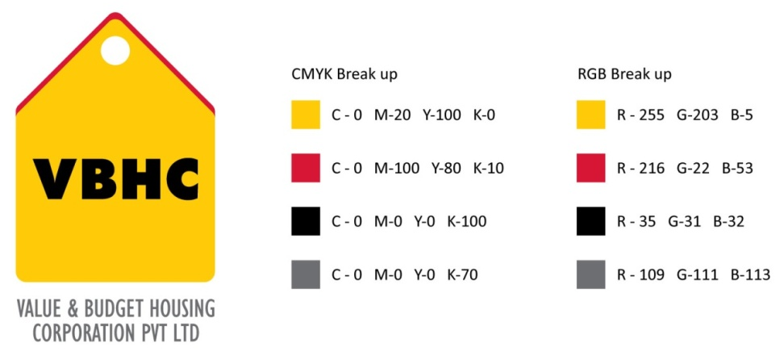
Document Control No : VBHC/TOP/P/01
Revision No : Rev 1.1
Date of Revision : 31st August 2023

 | Name/Designation | Signature | Date
Written By | Ramesh Kumar
Reviewed By | Kumar GVS

HISTORY OF REVISIONS

Revision No. | Revision Date | Chapter/clause no.  & text affected | Reason for Revision

TABLE OF CONTENTS
SL No. | CONTENTS | PAGE NO.
1. | Purpose | 1
2. | Process Trigger | 1
3. | Scope and Application | 1
4. | Process Owner  5. | 1
5. | Successor and Predecessor | 1
6. | Responsibilities & Authorities | 1
7. | Definitions and Abbreviations | 1
8. | Process Description | 2
9. | Efficiency measures and effectiveness measures | 5
10. | Risk associated with the process | 5
11. | Formats for maintaining records | 5
12. | Records | 5

INTERNAL AND EXTERNAL COMMUNICATION

- PURPOSE
To describe the existing methods of Internal and External communications adopted to enhance communication among all parties/entities involved in BOS.

- PROCESS TRIGGER
This is an ongoing process reviewed by HR/TOP Management yearly.

- SCOPE AND APPLICATION
This procedure applies to all the employees and entities involved in BOS of VBHC.

- PROCESS OWNER
TOP Management

- PREDECESSOR AND SUCCESSOR PROCESSES
Predecessor Process: None
Successor Process: NA

- RESPONSIBILITY AND AUTHORITY
Refer table:1 - Channels of communication with internal and external entities/parties and responsible department to communicate with

- DEFINITIONS & ABBREVIATIONS
- BOS : Business Operating System

- PROCESS DESCRIPTION
  - Internal Communication:
A variety of processes are used for internal communication. The effectiveness of these communication processes are evaluated on an ongoing basis, through management review, employee surveys, training programs, organization audits and inspections, and informal discussions.
Effective internal communications are considered crucial to the effectiveness of the system. These communications serve to encourage individuals who work within the Region and to motivate them to fulfill their obligations towards achieving the objectives and targets of organization.
The mechanisms that are used for various types of communications include, but are not limited to:
- Letters
- Memorandums
- Direct Mailings
- Email
- Intranet
- Face – to – face communication
- Notice boards
- Review meetings
- Conference calls
- Telephone calls

  - External Communication:
Effective external communications are extremely important in fostering mutually affirming and respectful relationships with the all the external parties/entities involved in BOS.
The mechanisms that are used for various types of communications include, but are not limited to:
- Advertisements
- Banners
- Posters
- Annual reports (social or financial)
- Company newsletters/trade magazines
- Press releases
- Folders / brochures
- Weblogs
- Websites
- Extranet
- Pamphlets
- Telephone
- Faxes
- Videos
- Billboards

  - Response time:
Response time to internal and external communication is dependent upon the complexity of the inquiry.

  - Communication system:
The table below shows the Parties/Entities involved in the communication and respective person responsible to communicate with them:

Table: 1 – Channels of communication with internal and external entities/parties and responsible department to communicate with
SL.No | Communication Entities | Internal Communication Channels | External Communication Channels | Responsible Department
1 | Suppliers/Vendors |  | Email, Hard copy | For RFQ, PO, and WO – Procurement and Contracts dept.
1 | Suppliers/Vendors |  | Email, Hard copy | For Technical – Design/Quality/  Operations dept.
2 | Subcontractors |  | Email, Hard copy | For RFQ, PO, and WO – Procurement and Contracts dept.
2 | Subcontractors |  | Email, Hard copy | For Technical – Design/Quality/  Operations dept.
3 | Quality Consultant |  | Email, Telephone, Conference call | Quality dept.
3 | Plumbing Consultant  Electrical Consultant  Fire Fighting Consultant  Structural Consultant  PHE Consultant  Topography Consultant |  | Email, Telephone | Design dept.
3 | EHSC Consultant |  | Email, Telephone | Admin dept.
3 | Salary Consultant |  | Email, Telephone | HR dept.
4 | Investors |  | Email, Letters | TOP Management  Legal dept.  Finance dept.(CFO, Financial controller)
5 | Professional services (Auditors, Legal, etc) |  | Email, Letters, Telephone | For Auditors : Finance dept.
5 | Professional services (Auditors, Legal, etc) |  | Email, Letters, Telephone | For Legal Services: Legal dept.
6 | Sales Channel Partners |  | Email, Letters, Telephone | Sales Team  Marketing dept.  Business Head
7 | Employees | Email, Internal Memos, Notice Board, Phone calls, Face – to – face communication, Review Meetings |  | HR/Admin dept.
8 | General Public |  | Mass Media, Advertisements, Banners, Posters, Pamphlets, Telephone. | TOP Management  Marketing dept.
9 | Customers |  | Email, Letters, Telephone | CRM dept.  Sales Team
10 | Media |  | Email, Letters, Telephone | TOP Management  Marketing dept.
11 | Competitors/other Businesses and Industries |  | Email, Letters, Annual reports, Press releases | TOP Management
12 | Legislators/Govt. Agencies/  Regulators offices |  | Email, Letters and other applicable forms. | Legal dept.  Consultant
13 | The Courts |  | Affidavit and all other applicable forms | Legal dept.

- EFFECIENCY MEASURES AND EFFECTIVENESS MEASURES
Efficiency Measures:
Internal performance measure of process operations
Improvement may benefit process owners as well as customers

Effectiveness Measures:
External performance measure of process output or quality

- RISK ASSOCIATED WITH THE PROCESS

- FORMATS FOR MAINTAINING RECORDS GENERATED IN THE PROCESS

- RECORDS
Records of All External Communications Received and Issued to the Public, Media, and Interested Parties.
Legal
Consultant

