**APPOINT CONTRACTORS**

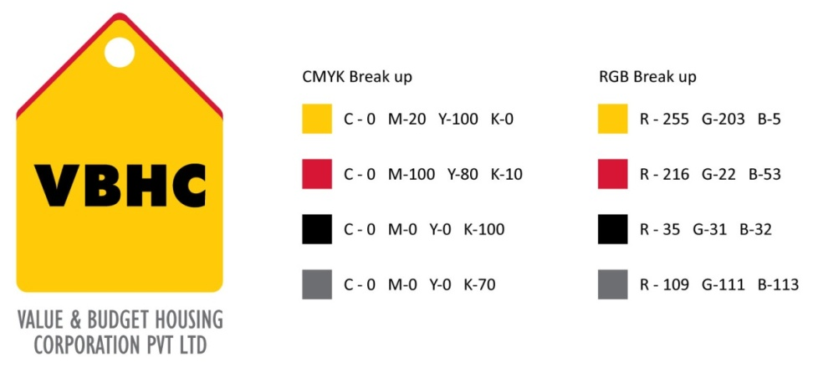

**Document Control No** : VBHC/P&C/P/02

**Revision No**  : Rev 3

**Date of Revision : 26-08-2023** :

|  |  |  |  |
| --- | --- | --- | --- |
|  | ***Name/Designation*** | ***Signature*** | ***Date*** |
| ***Written By*** | ***Chandra Mohan JM*** |  |  |
| ***Reviewed By*** | ***Shiva Prasad*** |  |  |
| ***Approved By*** | ***Kumar GVS*** |  |  |

**HISTORY OF REVISIONS**

|  |  |  |  |
| --- | --- | --- | --- |
| **Revision No.** | **Revision Date** | **Chapter/clause no.**  **& text affected** | **Reason for Revision** |
| 3 | 26-08-2023 |  |  |
|  |  |  |  |
|  |  |  |  |
|  |  |  |  |
|  |  |  |  |
|  |  |  |  |
|  |  |  |  |
|  |  |  |  |
|  |  |  |  |
|  |  |  |  |
|  |  |  |  |
|  |  |  |  |
|  |  |  |  |
|  |  |  |  |
|  |  |  |  |

**TABLE OF CONTENTS**

|  |  |  |
| --- | --- | --- |
| **SL No.** | **CONTENTS** | **PAGE NO.** |
| 1. | Purpose | 1 |
| 2. | Process Trigger | 1 |
| 3. | Scope and Application | 1 |
| 4. | Process Owner  5. | 1 |
| 5. | Successor and Predecessor | 1 |
| 6. | Responsibilities & Authorities | 1 |
| 7. | Definitions and Abbreviations | 2 |
| 8. | Process Flow Chart | 3 |
| 9. | Process Description | 4 |
| 10. | Efficiency measures and effectiveness measures | 5 |
| 11. | Risk associated with the process | 5 |
| 12. | Formats for maintaining records | 6 |
| 13. | Records | 6 |
| 14 | Annexure I | 6 |

**APPOINT CONTRACTORS**

1. **PURPOSE**

To engage contractors / labour contractors who are capable of completing the contracted work with required quality & with required number of manpower in given time frame at a competitive price.

1. **PROCESS TRIGGER**

Intimation by PMC team/ OP team/ WO request raised in Quadra ERP

1. **SCOPE AND APPLICATION**

This process will apply to all contracted works that are carried out at VBHC projects.

1. **PROCESS OWNER**

Procurement and Contracts Head

1. **PREDECESSOR AND SUCCESSOR PROCESSES**

Predecessor Process: Updating Construction Schedule (PMC), Prepare Project Budget (EST), Budget tracking Cost Control (EST), GFC Generation (D).

Successor Process: Contract Management (OP).

1. **RESPONSIBILITY AND AUTHORITY**

To approve finalized contractor: AVP (P&C)/ Operation & Projects Head

1. **DEFINITIONS & ABBREVIATIONS**
2. BOQ : Bill of Quantities.
3. LOI : Letter of Intent
4. COO : Chief Operating Officer
5. OPS : Operations dept.
6. PMC : Project Management dept.
7. AVP : Assistant Vice President
8. RFP : Request for Proposal
9. LOI : “Letter of Intent” or “LOI” means the letter of Intent issued by the Owner to the Contractor.
10. WORK ORDER/CONTRACT AGREEMENT:

“Contract Agreement/ Work Order” shall have the same meaning and shall include any award of work in writing with general terms and conditions / special conditions of the Enquiry, enclosures, Annexure, and subsequent amendments thereto issued by the Owner and accepted by the Contractor.

1. **PROCESS FLOW CHART**

1. **PROCESS DESCRIPTION**
   1. Appointing contractors is a process initialized with Work Order request raised in Quadra ERP from OP/PMC team based on BOQ from the estimation department and drawings from design team.
   2. Request for Proposal (RFP) is prepared by contracts dept.
   3. If any new contractor is required for any specific/new work, then pre – qualification is carried out for contractor for major contracts only (value greater than Rs 75Lakhs) as mentioned below:

* Pre – qualification format is distributed to the contractors.
* Receiving the feedback forms from contractors and
* Selecting the contractor based on the previous works experience and credentials.
  1. If available contractors are competent enough and are capable to carry out the work, then contractors are selected from list of approved contractors available in QUADRA.
  2. RFP ie BOQ is floated to Pre – Qualified contractors and new contractors through email & if value of works more than Rs 75 lakhs tender is floated to Pre – Qualified contractors.
  3. Receiving the bids from contractors with price quotations and various documents attached as per the terms and conditions mentioned in RFP / Tender.
  4. RFP / Tender is opened in the presence of authorized persons and at the time and place indicated by the contracting authority.
  5. For all the bids received, comparison statement is prepared and analyzed.
  6. Negotiation takes place between both the parties and Finalization of contractor is done based on following parameters:
* Price and Payment terms,
* Schedule/ completion time,
* Quality/Technical competence,
* Machinery/Equipment deployment, and
* Staff/Labour deployment at site.
  1. Final Comparative is shared with Projects & Operations head & then get the approval.
  2. LOI is issued to approved contractor by email asking him to start the works / Hard copy in company letter head if the value of works more than Rs 75 lakhs.
  3. Work Order is prepared & is entered into QUADRA by Asst. Manager/Contracts engg.
  4. Work order is approved by Sr.V.P/ AVP/Manager Contracts in QUADRA & mail sent to tax team for final approval in Quadra.
  5. Work order is sent to the contractor by email and copy marked to site team.
  6. If no advance payment is to be paid to the contractor, then it is directly intimated to OPS/PMC dept about the Work Order released.
  7. If any advance payment is to be paid to the contractor, then payment request is raised.
  8. Payment Request is approved by Execution Head/ AVP Contracts in QUADRA.
  9. After approval it is intimated to finance department for payment processing.
  10. Once the payment conformation from finance dept. is received, it is intimated to contractor and OPS/PMC dept.

1. **EFFECIENCY MEASURES AND EFFECTIVENESS MEASURES**

Efficiency Measures: Average time taken to release the work order

Effectiveness Measures: Contract Performance Rating from

1. **RISK ASSOCIATED WITH THE PROCESS**

* The finalized contractor may not start the execution of works by mentioning the prices agreed is not working out to him due to raise in the material and labour rates after finalization of works and issue of work order.
* The contractor may stop the works and ask for price escalation in the middle of the contract period due to raise in the material and labour rates.

1. **FORMATS FOR MAINTAINING RECORDS GENERATED IN THE PROCESS**

Contractor Pre-qualification format – Minimum Retention Period – 1yr/Till Project Completion

Comparative Statement for Contractors – Minimum Retention Period – 1yr/Till Project Completion

Work Order (generated in Quadra)

1. **RECORDS**

**ANNEXURE I**

|  |  |
| --- | --- |
| **Name of Format** | **Code** |
| Contractor Pre-qualification format | VBHC/P&C/P/02/AC01 |
| Comparative Statement | VBHC/P&C/P/02/AC02 |