PROCURE, IMPLEMENT&MAINTAIN S/W

**Document Control No** : VBHC/IT/P/02

**Revision No** : Rev 2.1

**Date of Revision** : 23-Aug-2023

|  |  |  |  |
| --- | --- | --- | --- |
|  | ***Name/Designation*** | ***Signature*** | ***Date*** |
| ***Written By*** | ***Kannan K.R (AVP IT)*** |  |  |
| ***Reviewed By*** | ***Venkatesh Katta ( IT Consultant)*** |  |  |
|  |  |  |  |

## Value and Budget Housing Corporation Pvt. Ltd. 74&75, Millers Road

**Vasanth Nagar, Near Vikram Hospital Bangalore - 560052 | Karnataka**

|  |  |  |  |
| --- | --- | --- | --- |
| STANDARD OPERATING PROCEDURE | | | |
| Value and Budget Housing Corporation Pvt Ltd | PROCURE, IMPLEMENT & MAINTAIN S/W | DOC.NO: VBHC/IT/P/02 |  |

# HISTORY OF REVISIONS

|  |  |  |  |
| --- | --- | --- | --- |
| **Revision No.** | **Revision Date** | **Chapter/clause no.** | **Reason for Revision** |
| 2 | 23-08-2021 |  | Latest process update |
|  |  |  |  |
|  |  |  |  |
|  |  |  |  |
|  |  |  |  |
|  |  |  |  |
|  |  |  |  |
|  |  |  |  |
|  |  |  |  |
|  |  |  |  |
|  |  |  |  |
|  |  |  |  |
|  |  |  |  |
|  |  |  |  |
|  |  |  |  |

**TABLE OF CONTENTS**

|  |  |  |
| --- | --- | --- |
| **SL No.** | **CONTENTS** | **PAGE NO.** |
| 1. | Purpose | 3 |
| 2. | Process Trigger | 3 |
| 3. | Scope and Application | 3 |
| 4. | Process Owner | 3 |
| 5. | Successor and Predecessor | 3 |
| 6. | Responsibilities & Authorities | 4 |
| 7. | Definitions and Abbreviations | 5 |
| 8. | Process Flow Chart | 6,7 |
| 9. | Process Description | 8,9 |
| 10. | Efficiency measures and effectiveness measures | 10 |
| 11. | Risk associated with the process | 10 |
| 12. | Records | 10 |

# PROCUREMENT, IMPLEMENT & MAINTAIN S/W

## PURPOSE

Resolution of all Hardware, Software, Access/Security etc. issues, Business Continuity Management as the primary objective.

## PROCESS TRIGGER

The process is triggered when any of the following occurs:

* + Business need is identified by the Top Management/IT Head /Dept. Head.
  + any user experiences a problem with using any system or application
  + The network/link monitoring tool puts out alerts that require manual intervention

## SCOPE AND APPLICATION

This process is applicable to all the projects

## PROCESS OWNER

IT-Infra Lead

## PREDECESSOR AND SUCCESSOR PROCESSES

Predecessor Process: Successor Process:

## RESPONSIBILITY AND AUTHORITY

L1 is handled by IT support Engineer / IT Infra Lead

IT team is sending email to the concerned technical support desk for raising incidents of category L2 & L3.

Approval for incidents of category L1: IT HEAD To approve test run: IT-Infra Lead

Approval for Vendor finalization: Dept. Head/IT HEAD

## DEFINITIONS & ABBREVIATIONS

1. IT Head : Head of IT Department
2. IT : Information Technology
3. TAT : Turn Around Time
4. S/w : Software
5. DB : Database
6. **PROCESS FLOW CHART**

**PROCURE / MAINTENANCE OF SOFTWARE**

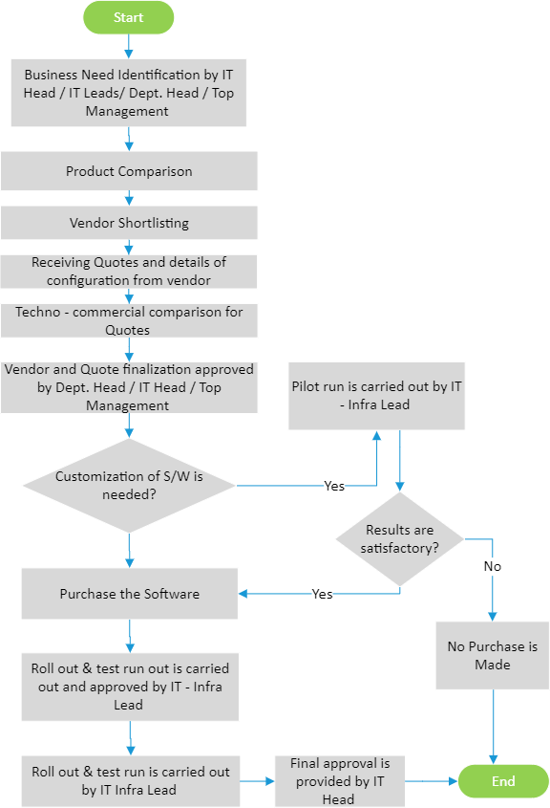

**INCIDENT MAINTENANCE**

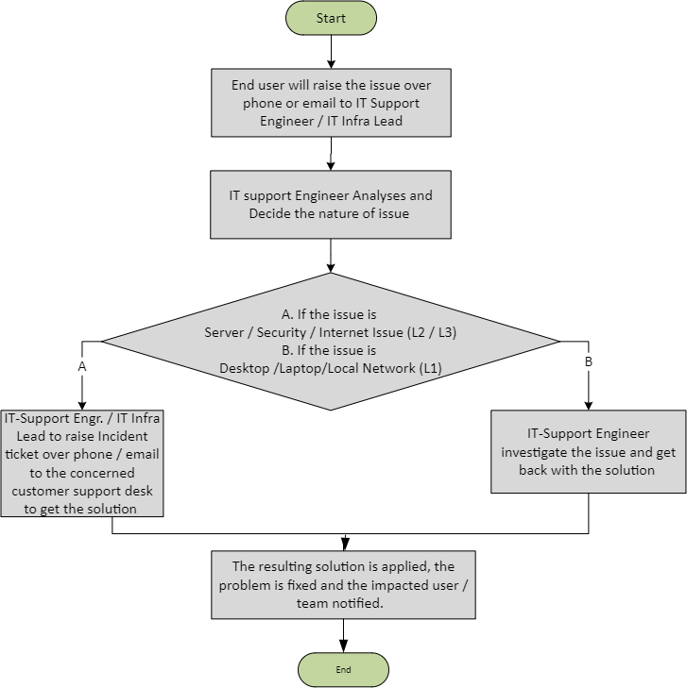

## PROCESS DESCRIPTION

### Procurement and Implementation of Software:

* + 1. Business need identified by the Top Management/IT Head / Dept. Head.
    2. Product comparison is made by IT Infra Lead
    3. Short listing of vendors
    4. Quoting process initiated
    5. Receiving Quotes and configuration details from Vendor.
    6. Techno – Commercial comparison between the Quotes is made by IT Infra Lead
    7. Vendor and Quote Finalization Approved by IT Head / Dept. Head / Top Management
    8. If customization of software is needed, then Pilot run is carried out by IT Infra Lead.
    9. If the result of Pilot study is satisfactory, then Purchase is made.
    10. Roll out and Test run out is carried out by IT Infra Lead and approved by IT Head.

### Incident Maintenance:

* + 1. Incident related details are forwarded to IT Support Engineer.
    2. Incident is investigated and classified as one of the following by IT Support Engineer

/ IT Infra Lead

|  |  |  |  |  |
| --- | --- | --- | --- | --- |
| # | **Category** | **Sub-Category** | **Routed to** | **Level of Severity** |
| 1 | Hardware related issue | Server / OS / Network (On  / Off Cloud) | Customer support desk (3rd Party) | L2 / L3 |
| 2 | Application related issue | Quadra /Zing HR / Salesforce (On cloud) | Customer Support Desk (3rd Party) |
| 3 | Security | Firewall | Customer Support Desk (Firewall support vendor) |
| 4 | Desktop / Laptop | Local or Remote System / Local Network | IT Support Engineer | L1 |

* + 1. The relevant team investigates the issue and gets back to the support-engineer with the solution.
    2. If the incident is of L2 or L3 category or if the solution is not evident to the support engineer, raising ticket over phone / email to concerned customer support desk to get solution
    3. If the incident is of L1 category, then the solution is provided by the resident IT Support Engineer.
    4. The resulting solution is applied, the problem fixed and the impacted user (or team) is notified.

## EFFECIENCY MEASURES AND EFFECTIVENESS MEASURES

Efficiency Measures:

Average TAT for resolution by severity

# of incidents trends by severity per system Effectiveness Measures:

## RISK ASSOCIATED WITH THE PROCESS

* Delay in resolution could impact the productivity of construction site or other business processes.
* Increasing trend in # incidents could lead to system instability.
* Maintaining Uptime 99%

## Records

Emails and Approval documents