R2 BUDGET

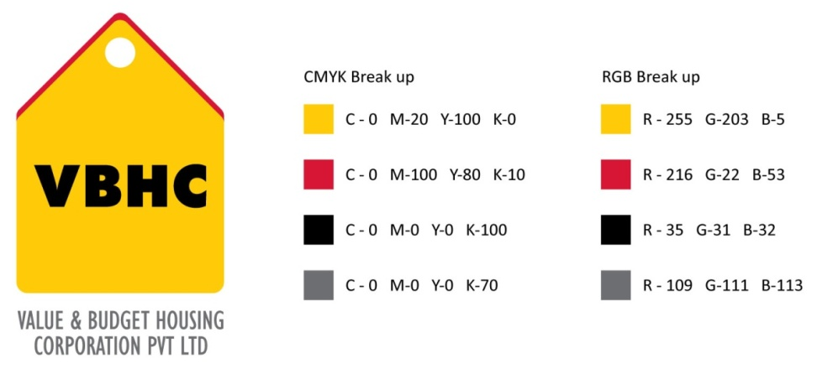
Document Control No : VBHC/EST/P/02
Revision No : Rev 1.1
Date of Revision : 31st August 2023

 | Name/Designation | Signature | Date
Written By | Azhar Ahmad
Reviewed By | Kumar GVS
Approved By

HISTORY OF REVISIONS

Revision No. | Revision Date | Chapter/clause no.  & text affected | Reason for Revision

TABLE OF CONTENTS
SL No. | CONTENTS | PAGE NO.
1. | Purpose | 1
2. | Process Trigger | 1
3. | Scope and Application | 1
4. | Process Owner  5. | 1
5. | Successor and Predecessor | 1
6. | Responsibilities & Authorities | 1
7. | Definitions and Abbreviations | 1
8. | Process Flow Chart | 2
9. | Process Description | 3
10. | Efficiency measures and effectiveness measures | 3
11. | Risk associated with the process | 3
12. | Formats for maintaining records | 3
13. | Records | 3
14 | Annexure I | 4

R2 BUDGET

- PURPOSE
To calculate final construction cost based on GFC drawings.
- PROCESS TRIGGER
GFC’s from Design Team
- SCOPE AND APPLICATION
This process is applicable to all ongoing and new projects of VBHC.
- PROCESS OWNER
Head – Estimation
- PREDECESSOR AND SUCCESSOR PROCESSES
Predecessor Process: GFC Generation (D)
Successor Process: Budget Tracking, Cost Control and Revisions ( EST), Procure Materials (P&C), Appoint Contractors (P&C),Site Coordination (PMC)
- RESPONSIBILITY AND AUTHORITY
Approval of Budget : COO
- DEFINITIONS & ABBREVIATIONS
- URA : Unit Rate Analysis
- P&C Dept : Procurement and Contracts Department
- BOQ : Bill of Quantities
- COO : Chief Operations Officer
- PROCESS FLOW CHART
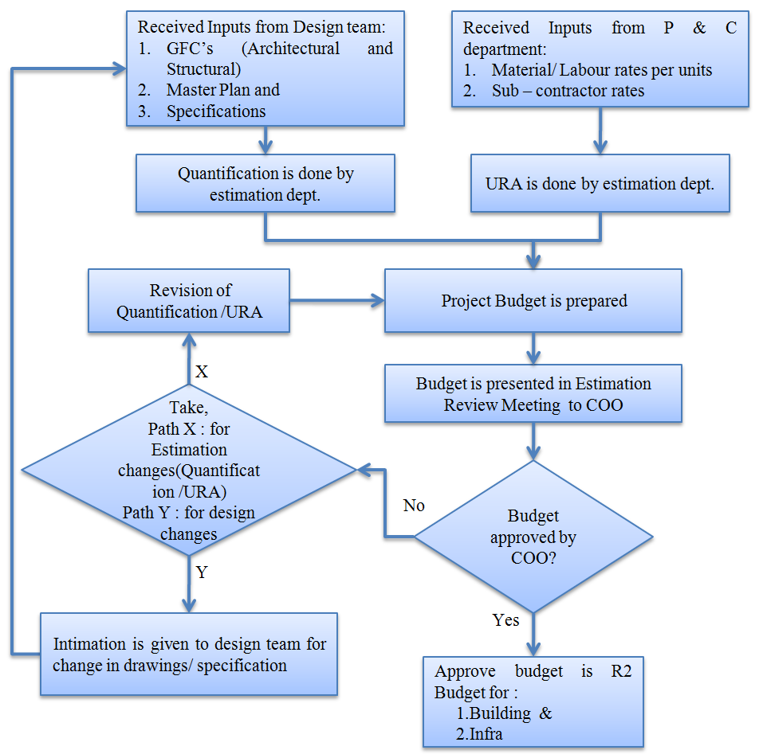

- PROCESS DESCRIPTION
  - Following inputs are received by Estimation dept. from other departments:
    - Master Plan, Specifications, GFC’s (Architectural and Structural) from Design team. (some infrastructure design may not be available in full detail)
    - Material/Labour rates and sub- contractor rates from P & C dept. (Estimation team can override the inputs received from P & C.)
  - Quantification and URA are prepared by Estimation dept. based on inputs received.
  - Project budget is prepared by Estimation dept. and the same is presented in Estimation Review Meeting to COO.
  - If any changes are recommended by COO, then
    - For estimation changes (Quantification /URA) revision of Quantification /URA is done and project budget is prepared by Estimation dept.
    - For Design changes, the Design team is intimated for changes in specifications/drawings by Estimation dept. The new inputs are considered for further budget preparation by Estimation dept.
  - The budget approved by COO is R2 budget for :
- Building
- Infra.
- EFFECIENCY MEASURES AND EFFECTIVENESS MEASURES
Efficiency Measures: Deviation between R1 and R2 Budget
Effectiveness Measures: Number of days taken to release R2 budget from the trigger
- RISK ASSOCIATED WITH THE PROCESS
This budget is prepared using all the available information. Limited risk can be because of, unanticipated price increase and infrastructural details that are not finalised at this budgeting.
- FORMATS FOR MAINTAINING RECORDS GENERATED IN THE PROCESS
R2 Budget
- RECORDS
Record of R1 & R2 Budgets – Minimum Retention Period – Till Project Completion

- ANNEXURE I;
Name of Format | Code
R2 Budget | VBHC/EST/F/02

