SECURING PROJECT FINANCE

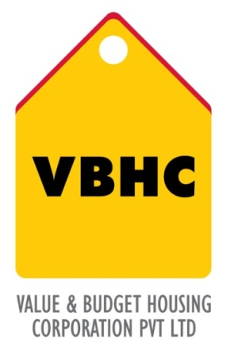
Document Control No : VBHC/FIN/P/02
Revision No : Rev 1.0
Date of Revision : 31st August 2013

 | Name/Designation | Signature | Date
Written By
Reviewed By
Approved By

HISTORY OF REVISIONS

Revision No. | Revision Date | Chapter/clause no.  & text affected | Reason for Revision

TABLE OF CONTENTS
SL No. | CONTENTS | PAGE NO.
1. | Purpose | 1
2. | Process Trigger | 1
3. | Scope and Application | 1
4. | Process Owner  5. | 1
5. | Successor and Predecessor | 1
6. | Responsibilities & Authorities | 1
7. | Definitions and Abbreviations | 2
8. | Process Flow Chart | 2
9. | Process Description | 2
10. | Efficiency measures and effectiveness measures | 3
11. | Risk associated with the process | 3
12. | Formats for maintaining records | 3
13. | Records | 3

SECURING PROJECT FINANCE

- PURPOSE
To secure construction finance for the project after realizing project costs from the R1 project budget in the form of credit line or term loan.

- PROCESS TRIGGER
This process is triggered after the R1 Project Budget and the pre-construction financial planning is complete.

- SCOPE AND APPLICATION
All VBHC projects.
- PROCESS OWNER
Chief Finance Officer (CFO)

- PREDECESSOR AND SUCCESSOR PROCESSES
Predecessor Process: R1 Budget (Est, P 26)
Successor Process: Project Specific Legal Compliances (Leg, P18), Sales planning and launch (SM, P43)

- RESPONSIBILITY AND AUTHORITY
To apply for construction finance from bank: Finance – Head/Controller
To conduct legal due diligence: Panel lawyers on behalf of bank and Legal Department
Authorized appointment of the panel of lawyers: Legal Head

- DEFINITIONS & ABBREVIATIONS
- R1: First Revision

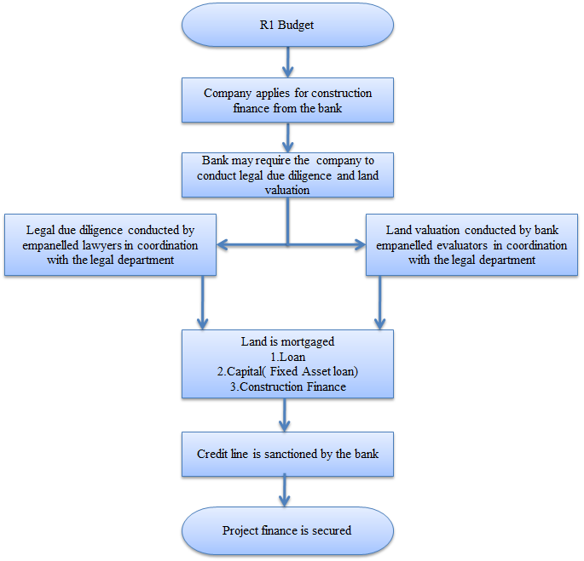
- PROCESS FLOW CHART

- PROCESS DESCRIPTION
  - The R1 budget provides all the costs related to the project.
  - The company applies for construction finance which may be availed by mortgaging land, security for receivables and fixed assets ; both present and future. The amount of construction finance and terms are agreed by the CFO or the MD.
  - The bank may require the company to conduct legal due diligence and land valuation of the land under consideration.
  - The legal due diligence is conducted by empanelled lawyers on behalf of the bank in coordination with the legal department of the company. VBHC appoints from empanelled lawyers of the bank.
  - The land is valued by bank empanelled valuators in coordination with the legal department of the company. Valuators are appointed in the same manner as the lawyers
  - Land is mortgaged. Land mortgage is authorized by board resolution If carried out after September 12th , member resolution is also required ( acc to Companies Act , section 180/185 ) .A draft is provided by the bank which is reviewed by our legal team.
  - Project finance is secured.

- EFFECIENCY MEASURES AND EFFECTIVENESS MEASURES
Efficiency Measures: Number of days from the date of completion of land purchase to availing credit line
Effectiveness Measures: Credit Line/ Cost of Land
Rate of Interest with respect to Prime Lending Rate

- RISK ASSOCIATED WITH THE PROCESS
- Land is mortgaged, in case of default, the bank can salvage the property.
- Too high or too low loan amount can have adverse impact on cash management.

- FORMATS FOR MAINTAINING RECORDS GENERATED IN THE PROCESS

- RECORDS

