CUSTOMER APPROVAL

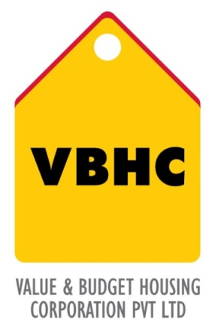
Document Control No : VBHC/HL/P/02
Revision No : Rev 1.0
Date of Revision : 31st August 2013

 | Name/Designation | Signature | Date
Written By
Reviewed By
Approved By

HISTORY OF REVISIONS

Revision No. | Revision Date | Chapter/clause no.  & text affected | Reason for Revision

TABLE OF CONTENTS
SL No. | CONTENTS | PAGE NO.
1. | Purpose | 1
2. | Process Trigger | 1
3. | Scope and Application | 1
4. | Process Owner  5. | 1
5. | Successor and Predecessor | 1
6. | Responsibilities & Authorities | 1
7. | Definitions and Abbreviations | 1
8. | Process Flow Chart | 2
9. | Process Description | 3
10. | Efficiency measures and effectiveness measures | 4
11. | Risk associated with the process | 4
12. | Formats for maintaining records | 4
13. | Records | 4
14 | Annexure I | 5

CUSTOMER APPROVAL

- PURPOSE
To establish a Customer Approval process to support customers in processing of loan payments.

- PROCESS TRIGGER
The process is triggered when the CRM – Team gives notification about approved bookings to Home Loans dept.

- SCOPE AND APPLICATION
This process is applicable to all the customers who book the property at any project of VBHC.

- PROCESS OWNER
Sr. Manager, Home Loans

- PREDECESSOR AND SUCCESSOR PROCESSES
Predecessor Process: Welcome Call and Agreement Signing (P43, CRM)
Successor Process: Milestone Billing and Collection (CRM)

- RESPONSIBILITY AND AUTHORITY

- DEFINITIONS & ABBREVIATIONS
- SF : Sales Force
- CRM : Customer Relationship Management

- PROCESS FLOW CHART

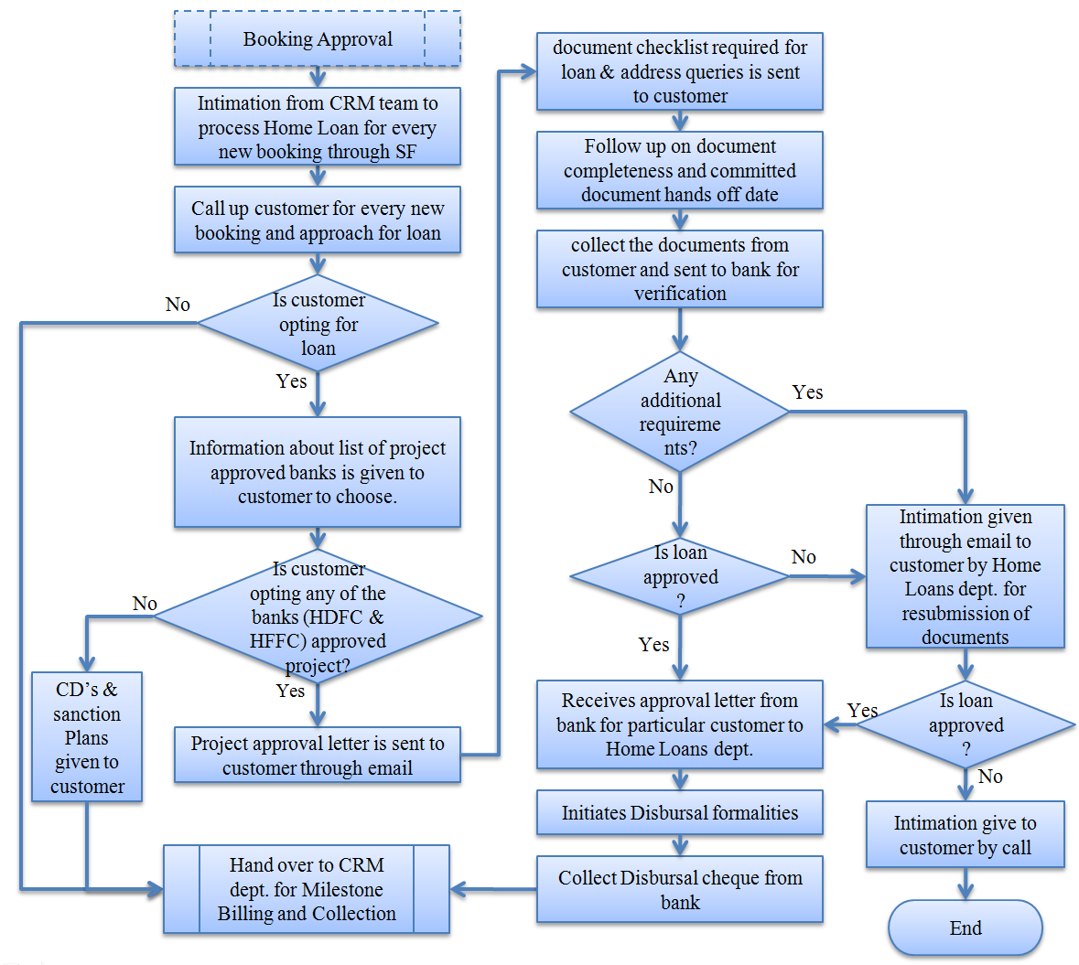

- PROCESS DESCRIPTION
  - Home Loans team gets the information about new bookings from Sales Force.
  - The Home Loans team shall call up customer for every new booking and approach for loan.
  - If customer opts for self payment, then Home Loans team shall update the Loan Response Code to Self Finance in SF.
  - If customer opts for home loan, then information about banks which approved VBHC projects is given to customer by Home Loans team to choose one among them.
  - If customer opts a bank which is not a project approved bank, then CD’s and sanction plans are given to customer by Home Loans team shall update the Loan Response Code accordingly in SF.
  - If customer opts a bank from list of project approved banks, then project approval letter is sent to customer through email by Home Loans team.
  - The format for Document List required for loan that is provided by bank for (Domestic or NRI) customers is forwarded to respective customer by Home Loans team.
  - Home Loans team follows up on document completeness; collect the documents from customer and sends to the bank for verification.(for HDFC)
  - If any additional requirements are recommended by bank, then Home Loans team shall intimate customer through email for resubmission of documents.
  - If loan is not approved by bank, then intimation is given to customer by Home Loans team by call.
  - If loan is approved by bank after all required documents submitted by customer, then intimation about customer approval is received by Home Loans team from bank.
  - Home Loans team shall initiate disbursal formalities.
  - Home Loans team shall intimate to CRM team to collect disbursal cheque from bank.

- EFFECIENCY MEASURES AND EFFECTIVENESS MEASURES
Efficiency Measures:
Average Turn Around Time (1day)
Effectiveness Measures:
- RISK ASSOCIATED WITH THE PROCESS

- FORMATS FOR MAINTAINING RECORDS GENERATED IN THE PROCESS

- RECORDS
Document list for Loan Approval & Disbursement provided by respective bank – Minimum Retention Period – Till Project Completion.

