ORGANIZATION STRUCTURE

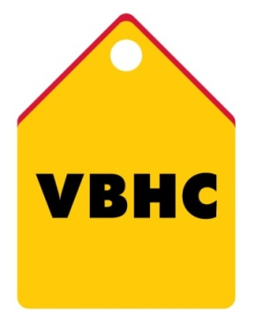
Document Control No : VBHC/HR/P/02
Revision No : Rev1.1
Date of Revision : 01st April 2023

 | Name/Designation | Signature | Date
Written By | Shashidhar Rao
Reviewed By | Kumar GVS

HISTORY OF REVISIONS

Revision No. | Revision Date | Chapter/clause no.  & text affected | Reason for Revision

TABLE OF CONTENTS
SL No. | CONTENTS | PAGE NO.
1. | Purpose | 1
2. | Process Trigger | 1
3. | Scope and Application | 1
4. | Process Owner  5. | 1
5. | Successor and Predecessor | 1
6. | Responsibilities & Authorities | 1
7. | Definitions and Abbreviations | 1
8. | Process Flow Chart | 2
9. | Process Description | 2
10. | Efficiency measures and effectiveness measures | 3
11. | Risk associated with the process | 3
12. | Formats for maintaining records | 3
13. | Records | 3
14. | Annexure I | 3

ORGANISATION STRUCTURE

- PURPOSE
The purpose of this process is to establish an organisation structure and to provide guidelines for reorganization to improve the effectiveness and/or efficiency of the functions of organisation.
- PROCESS TRIGGER
The organisation structure is reviewed if as there is change in management/department heads.
- SCOPE AND APPLICATION
This is applicable to overall VBHC.
- PROCESS OWNER
HR – Head/ HR Team
- PREDECESSOR AND SUCCESSOR PROCESSES
Predecessor Process: Recruitment of New head of the department
Successor Process: New structure
- RESPONSIBILITY AND AUTHORITY.
To approve Organisation structure : HR – Head

- DEFINITIONS & ABBREVIATIONS
- HR : Human Resource

- PROCESS FLOW CHART

- PROCESS DESCRIPTION
  - Preparation of organisation structure:
    - Organizational structure allows the expressed allocation of responsibilities for different functions and processes to different entities such as the branch, department, workgroup and individual. Organizational structure affects organizational action in two big ways.
- First, it provides the foundation on which standard operating procedures and routines rest.
- Second, it determines which individuals get to participate in which decision-making processes, and thus to what extent their views shape the organization’s actions.
    - Organisation structures (project specific and corporate specific) are prepared by HR team and approved by Head, HR
    - The organisational charts are visible to all employees of the company in Zinghr HRMS.
  - Restructuring the organisation chart:
    - Restructuring shall be done because of any of the following reasons:
- To enhance the ability to adapt itself to changing environments,
- To become more flexible and
- To enhance the capacity of the organisation to sustain its activities
    - The organisation structure is reviewed as an when required/changes requested by Managers/HOD of the department.
    - If any changes are recommended, then changes are incorporated and restructured by HR team with taken necessary approvals.
    - The updated organisational charts are visible to all employees under Zinghr HRMS

- EFFECIENCY MEASURES AND EFFECTIVENESS MEASURES
Efficiency Measures: NIL
Effectiveness Measures: Revised Organsiation chart

- RISK ASSOCIATED WITH THE PROCESS - NIL
- FORMATS FOR MAINTAINING RECORDS GENERATED IN THE PROCESS
- RECORDS

