AGREEMENT FOR LAND PURCHASE OR ACQUISITION

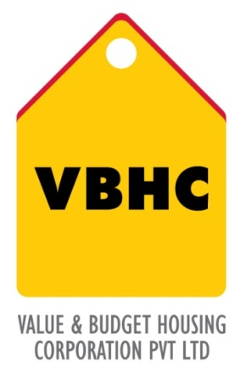
Document Control No : VBHC/LAN/P/02

Revision No : Rev1.1

Date of Revision : 31st August 2023

 | Name/Designation | Signature | Date
Written By | Royal Reddy
Reviewed By | Kumar GVS

HISTORY OF REVISIONS

Revision No. | Revision Date | Chapter/clause no.  & text affected | Reason for Revision

TABLE OF CONTENTS
SL No. | CONTENTS | PAGE NO.
1. | Purpose | 1
2. | Process Trigger | 1
3. | Scope and Application | 1
4. | Process Owner  5. | 1
5. | Successor and Predecessor | 1
6. | Responsibilities & Authorities | 1
7. | Definitions and Abbreviations | 1
8. | Process Flow Chart | 2
9. | Process Description | 3
10. | Efficiency measures and effectiveness measures | 3
11. | Risk associated with the process | 4
12. | Formats for maintaining records | 4
13. | Records | 4

AGREEMENT FOR LAND PURCHASE OR ACQUISITION

- PURPOSE
An ATS or term sheet or MoU is signed by which VBHC enters in an agreement with the seller or landowner whereby VBHC will purchase the land, if legal and technical due diligence is favorable.

- PROCESS TRIGGER
This process is triggered after land is feasible for construction of the project after conducting a preliminary due diligence and the financials for the land under consideration is prepared.
3.0 SCOPE AND APPLICATION
All VBHC projects.

- PROCESS OWNER
Land Committee: Head
- PREDECESSOR AND SUCCESSOR PROCESSES
Predecessor Process: Prelim Tech due diligence ( D), Land Purchase Financials (Est)
Successor Process: Detailed Tech due diligence (D), Legal due diligence (Leg)

- RESPONSIBILITY AND AUTHORITY
Review of all agreements: Top management

- DEFINITIONS & ABBREVIATIONS
ATS –Agreement-to-sell
MoU- Memorandum of Understanding
- PROCESS FLOW CHART
END
START
Agreement signed by both parties
ATS or term sheet or MoU provided by landowner / agent of landowner or by VBHC
VBHC Top management reviews the agreement
Agreed token amount to be paid to the other party

- PROCESS DESCRIPTION
  - The ATS or term sheet or MoU is provided by the landowner or agent of the landowner or by VBHC. These documents outline the terms of purchase.
  - The token amount to be paid to the landowner is defined in the ATS or term sheet or MoU. The ATS or term sheet or MoU also includes the time frame for conducting due diligence (both legal and technical).
  - The top management reviews the agreement, all the terms and conditions.
  - The ATS or term sheet or MoU is signed by both the parties.
  - The agreed token amount is paid to the other party.

- EFFECIENCY MEASURES AND EFFECTIVENESS MEASURES
Efficiency Measures
Effectiveness Measures: Charting and signing of agreement within stipulated time

- RISK ASSOCIATED WITH THE PROCESS
If the conditions of agreement are not properly reviewed, the company might enter into legal issues later into the project.

- FORMATS FOR MAINTAINING RECORDS GENERATED IN THE PROCESS

- RECORDS

