PROJECT SPECIFIC LEGAL COMPLIANCE
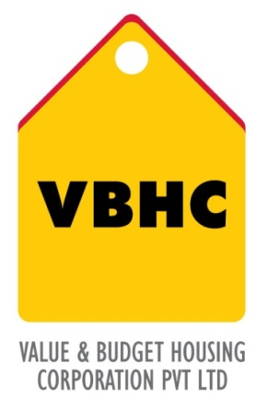
Document Control No : VBHC/LEG/P/02

Revision No : Rev 1.0

Date of Revision : 31st August 2013

 | Name/Designation | Signature | Date
Written By
Reviewed By
Approved By

HISTORY OF REVISIONS

Revision No. | Revision Date | Chapter/clause no.  & text affected | Reason for Revision

TABLE OF CONTENTS
SL No. | CONTENTS | PAGE NO.
1. | Purpose | 1
2. | Process Trigger | 1
3. | Scope and Application | 1
4. | Process Owner  5. | 1
5. | Successor and Predecessor | 1
6. | Responsibilities & Authorities | 1
7. | Definitions and Abbreviations | 2
8. | Process Flow Chart | 2
9. | Process Description | 3
10. | Efficiency measures and effectiveness measures | 3
11. | Risk associated with the process | 3
12. | Formats for maintaining records | 4
13. | Records | 4

PROJECT SPECIFIC LEGAL COMPLIANCES

- PURPOSE
To ensure that the company follows all relevant laws and regulations throughout the entire span of the project.

- PROCESS TRIGGER
This process is triggered after land for the project is purchased.

- SCOPE AND APPLICATION
All VBHC projects till project closure.
To be applied throughout the entire span of the project, from securing project finance to demobilization and closure.
- PROCESS OWNER
Legal – Head

- PREDECESSOR AND SUCCESSOR PROCESSES
Predecessor Process: Securing Project Finance (Fin, P7)
Successor Process: END

- RESPONSIBILITY AND AUTHORITY
- To classify all the legal laws applicable to the specific project: Legal Head
- To engage external consultant: Legal Head

- DEFINITIONS & ABBREVIATIONS

- PROCESS FLOW CHART
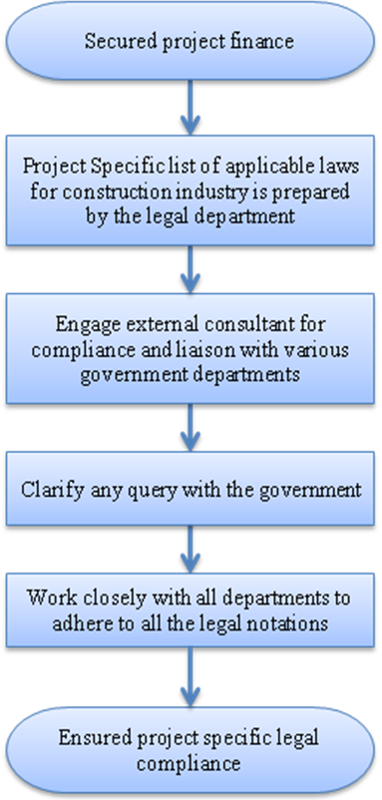

- PROCESS DESCRIPTION
- The Finance department secures the project finance.
- The legal department prepares a specific list of all applicable laws for construction industry not limited to the following:
- Construction Workers Act.
- Workers Welfare Act during construction.
- ESI Act by the various contractors engaged in the construction process.
- CLRA by the contractors engaged in the construction work.
- EPF Act by the contractors.
- Workmen Compensation Act.
- Payment of Wages Act, Payment of Bonus Act by the respective contractors.
- Interstate Labour Migration Act
- Compliance of the requirement of the insurance of the site including man and material against natural hazards or accident
The legal department is responsible for the compliance of all the above laws.
- Legal department engage an external consultant for compliance and liaison with various government department. The legal department will provide the required information and document to the external consultant.
- If any queries develop they are cleared immediately with the government.
- The legal department has to work with all departments of the company, in order to align their goals by adhering to the legal notations.
- A compliance certificate is submitted quarterly to the investors by the M.D.

- EFFECIENCY MEASURES AND EFFECTIVENESS MEASURES
Efficiency Measures: Date by which compliance report filed with the top management every month.
Effectiveness Measures: Number of non- compliances (target NIL)
11.0 RISK ASSOCIATED WITH THE PROCESS
If the company does not follow all the legal laws and regulations, the company may have to face any legal liability or legal risk further into the project.

- FORMATS FOR MAINTAINING RECORDS GENERATED IN THE PROCESS

- RECORDS

