DAILY CONSTRUCTION MANAGEMENT

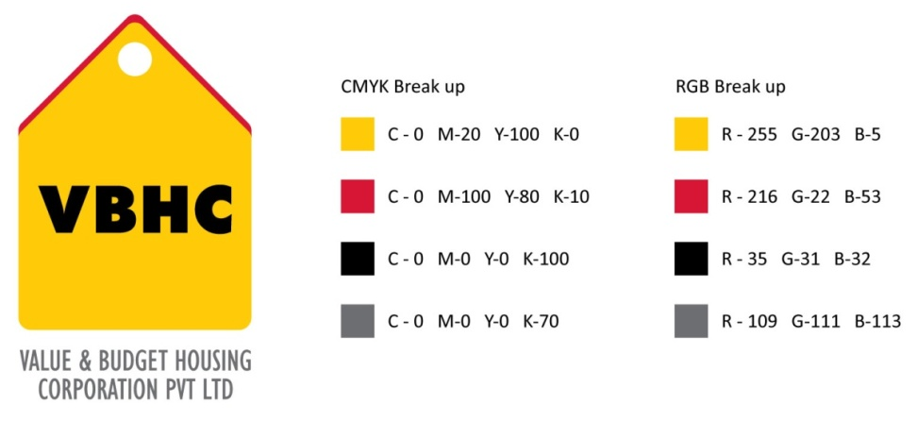
Document Control No : VBHC/OPE/P/02
Revision No : Rev 1.1
Date of Revision : 31st August 2023
 | Name/Designation | Signature | Date
Written By | Shivaprasad
Reviewed By | Kumar GVS

HISTORY OF REVISIONS

Revision No. | Revision Date | Chapter/clause no.  & text affected | Reason for Revision

TABLE OF CONTENTS

SL No. | CONTENTS | PAGE NO.
1. | Purpose | 1
2. | Process Trigger | 1
3. | Scope and Application | 1
4. | Process Owner  5. | 1
5. | Successor and Predecessor | 1
6. | Responsibilities & Authorities | 1
7. | Definitions and Abbreviations | 1
8. | Process Flow Chart | 2
9. | Process Description | 3
10. | Efficiency measures and effectiveness measures | 4
11. | Risk associated with the process | 4
12. | Formats for maintaining records | 4
13. | Records | 7
14. | Annexure I | 8

DAILY CONSTRUCTION MANAGEMENT

- PURPOSE
To establish a process for daily construction management
- PROCESS TRIGGER
This process is carried out daily at the construction site.
- SCOPE AND APPLICATION
This procedure applies to all the construction activities carried at VBHC.
- PROCESS OWNER
Assistant Manager, Operations.
- PREDECESSOR AND SUCCESSOR PROCESSES
Predecessor Process:
Successor Process:
- RESPONSIBILITY AND AUTHORITY

- DEFINITIONS & ABBREVIATIONS
- AGM : Assistant General Manager
- MOM : Minutes of Meeting
- MR : Management Representative

- PROCESS FLOW CHART
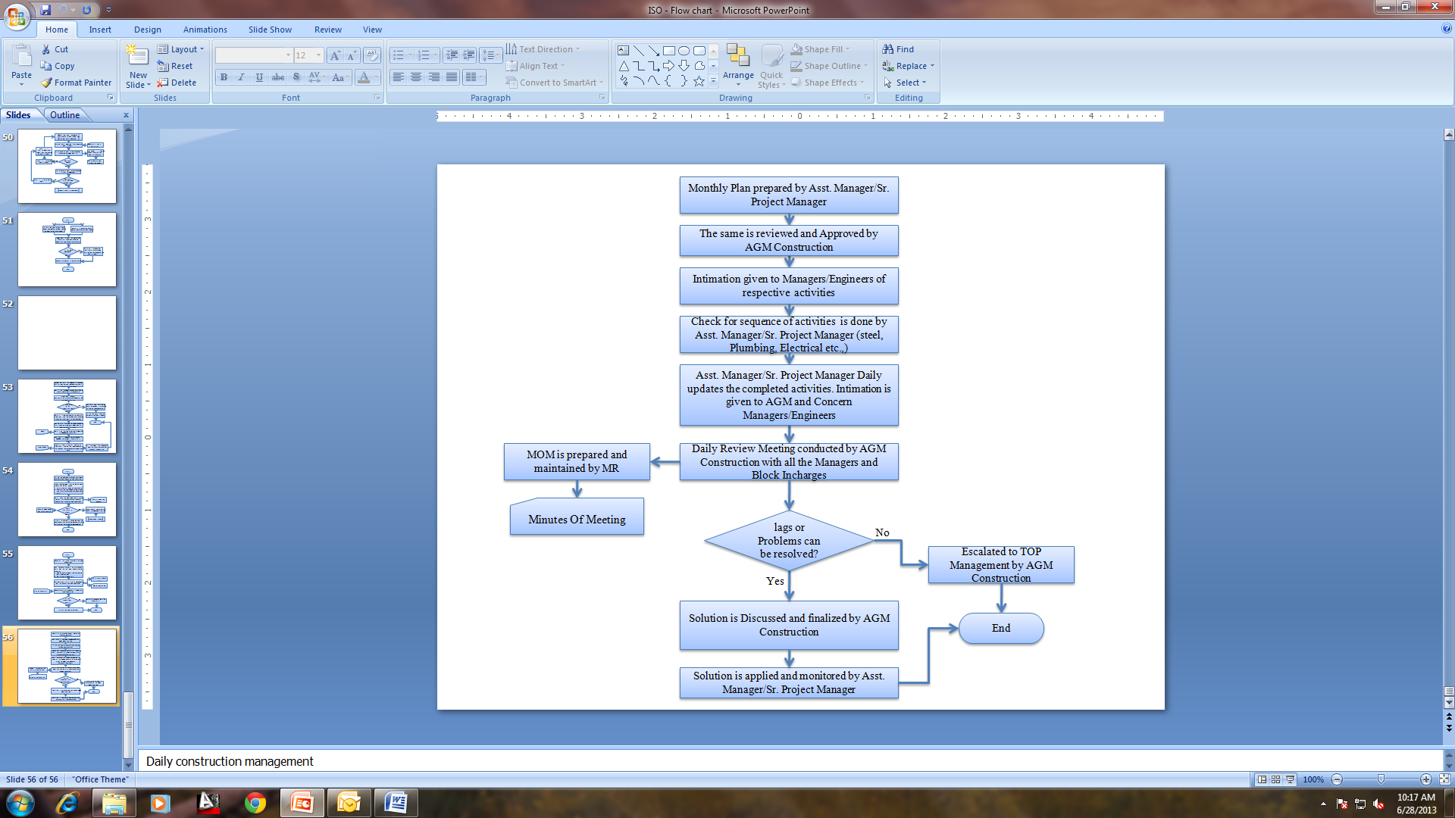

- PROCESS DESCRIPTION
  - Project Management team updates the monthly schedule to the master schedule.
  - Monthly Schedule is prepared by Asst. Manager - Operations, every month last working day he submits the next month’s schedule to AGM – Construction for review.
  - AGM – Construction reviews the schedule on the same or the very next day, and if found necessary shall suggest any changes in the schedule to Asst. Manager - Operations.
  - After the changes done by Asst. Manager – Operations the schedule is approved by AGM – Construction.
  - After the approval by AGM construction, intimation is given to PMC dept and Managers/Engineers who handle the respective activities through email.
  - Asst. Manager/Sr. Project Manager checks for the execution of activities in sequence (steel, Plumbing, Electrical etc.,) and if any corrections observed, intimation is given to incharge of the activity.
  - Asst. Manager/Sr. Project Manager daily updates the completed activities and intimates about the same to AGM, PMC team and Concern Managers/Engineers.
  - Project Management team updates Master Schedule, the planned vs Actual Progress and the remarks every month, intimates the same to Operations dept. through email.
  - AGM Construction with all the Managers and Block Incharges conducts daily Review Meeting. The following issues are discussed during meeting:
- Updating daily work done
- Reasons for lags in the schedule if any.
- Any issues/problems at site which affects the work schedule.
- Possible solutions to overcome the issues/problems
  - Project Management team at site prepares and maintains the MOM for every review meeting.
  - If the issues/Problems cannot be resolved, then it is escalated to AGM – Construction, AVP and TOP Management by Project Management team.
  - If the issues/Problems can be resolved, then solution is applied and monitored by Asst. Manager/Sr. Project Manager
- EFFECIENCY MEASURES AND EFFECTIVENESS MEASURES
Efficiency Measures:
Effectiveness Measures: Planned Vs Actual Progress
- RISK ASSOCIATED WITH THE PROCESS

- FORMATS FOR MAINTAINING RECORDS GENERATED IN THE PROCESS
Master Schedule
- RECORDS
Minutes of Meeting – Minimum Retention Period – 1Yr

ANNEXURE I.
Name of Format | Code
Master Schedule | VBHC/OPE/F/01

