PRE –CONSTRUCTION AND CONSTRUCTION MONITORING

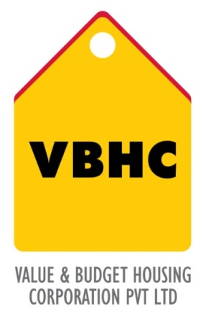
Document Control No : VBHC/PMC/P/02
Department : PMC
Revision No : Rev 1.0

 | Name/Designation | Signature | Date
Written By | Shivaprasad
Reviewed By | Kumar GVS

HISTORY OF REVISIONS

Revision No. | Revision Date | Chapter/clause no.  & text affected | Reason for Revision

TABLE OF CONTENTS
SL No. | CONTENTS | PAGE NO.
1. | Purpose | 1
2. | Process Trigger | 1
3. | Scope and Application | 1
4. | Process Owner  5. | 1
5. | Successor and Predecessor | 1
6. | Responsibilities & Authorities | 2
7. | Definitions and Abbreviations | 2
8. | Process Flow Chart | 2
9. | Process Description | 3
10. | Efficiency measures and effectiveness measures | 3
11. | Risk associated with the process | 3
12. | Formats for maintaining records | 3
13. | Records | 3
14. | Annexure 1 | 4

PRE-CONTRUCTION AND CONSTRUCTION MONITORING

- PURPOSE
To monitor and coordinate availability of all required resources just in time to control inventory costs and holding costs; ensure timely delivery of drawings and details for execution on site, to provide all inputs just in time to the execution team for smooth and timely delivery of the project

- PROCESS TRIGGER
This is a continuous process during site preliminary works are carried out by Operation (Execution) team and is triggered by approval of the Preconstruction Master Schedule by the COO and by commencement of construction.

- SCOPE AND APPLICATION
This process applies to all VBHC projects and includes deployment of site facilities, provision of drawings, provision of men and material, but excludes sample flats, and covers all phases/elements/parts of the project from commencement of construction to project closeout.

- PROCESS OWNER
PMC - Head.

- PREDECESSOR AND SUCCESSOR PROCESSES
Predecessor Process: Pre-construction site preliminaries (P33,OP), Project Master Schedule (P3,PMC), Update Construction Schedule (P28,PMC) , Recruitment (P49,HR) ,Daily construction management(P34,OP),Site Coordination( P29,PMC)
Successor Process: Update Construction Schedule (P28,PMC)
- RESPONSIBILITY AND AUTHORITY
To monitor and coordinate pre – construction and construction activities: Manager – PMC, Head - PMC
- DEFINITIONS & ABBREVIATIONS
PMS : Project Master Schedule.
PMC : Project Management.

COO : Chief Operating Officer
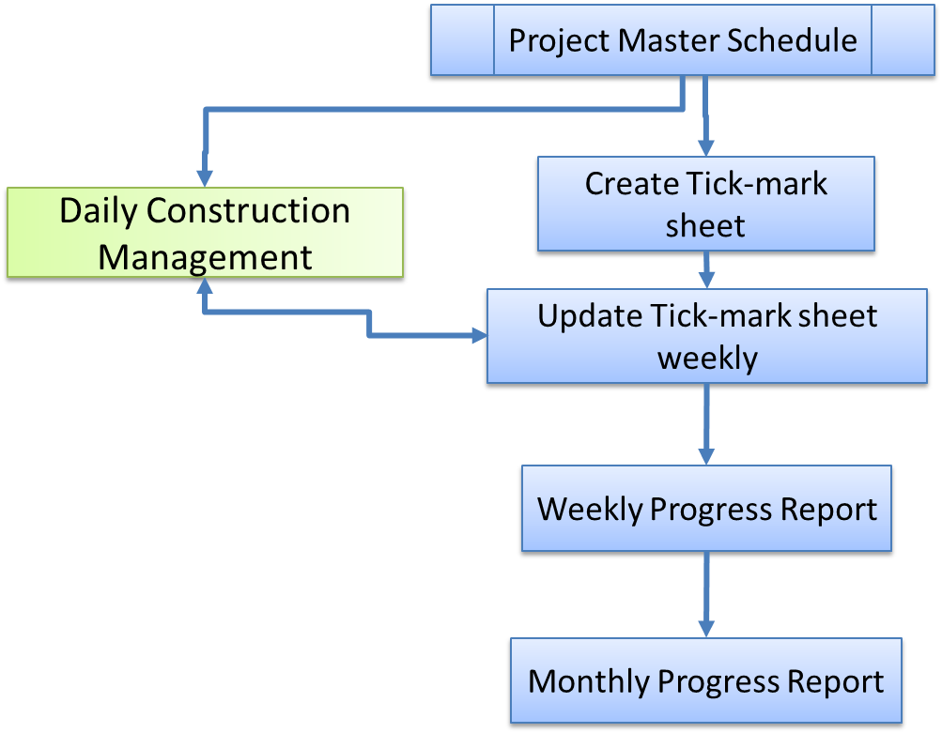
- PROCESS FLOW CHART

- PROCESS DESCRIPTION
  - Tick mark sheets (for substructure, superstructure and finishing) and weekly progress report is a check list of activities prepared block wise for all the activities in block at micro level. This shows the progress of each activity under the block.
  - With Reference to the physical progress at site the tick mark sheet and the WPR is updated weekly by the PMC team.
  - With the inputs from tick mark sheet, Weekly progress reports and Monthly progress report are generated. The weekly progress report is generated on 1st day of the week and is distributed among Top Management and Functional Heads. The monthly progress report is generated during the first week of the month and is distributed among Top Management.
  - The review of delays and risk mitigation plan are elaborated in the Weekly progress report.

- EFFECIENCY MEASURES AND EFFECTIVENESS MEASURES
Efficiency Measures: % number of times the weekly/monthly report is submitted on time
Effectiveness Measures: Completion of project as per Project Master Schedule

- RISK ASSOCIATED WITH THE PROCESS
Delay in timely delivery and quality of blocks.

- FORMATS FOR MAINTAINING RECORDS GENERATED IN THE PROCESS
- Tick mark sheets
- Weekly progress report
- Monthly progress report
- RECORDS

ANNEXURE I
Name of Format | Code
Internal Tick mark sheets | VBHC/PMC/F/02
External Tick mark sheets | VBHC/PMC/F/03
Weekly progress report | VBHC/PMC/F/04
Monthly progress report | VBHC/PMC/F/05

