INTERNAL AUDIT

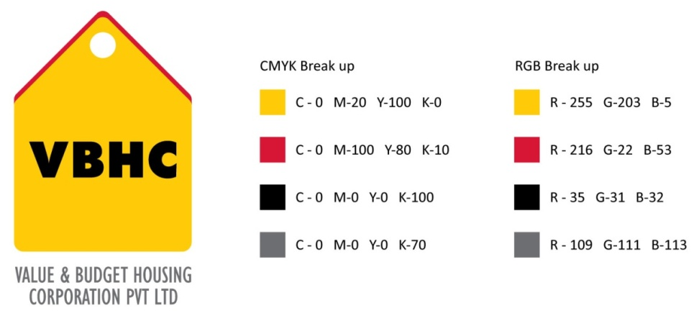
Document Control No : VBHC/QMS/P/02
Revision No : Rev 1.1
Date of Revision : 31st August 2023

 | Name/Designation | Signature | Date
Written By | Ramesh
Reviewed By | Nagesh
Approved By | Kumar GVS

HISTORY OF REVISIONS

Revision No. | Revision Date | Chapter/clause no.  & text affected | Reason for Revision

TABLE OF CONTENTS
SL No. | CONTENTS | PAGE NO.
1. | Purpose | 1
2. | Process Trigger | 1
3. | Scope and Application | 1
4. | Process Owner  5. | 1
5. | Successor and Predecessor | 1
6. | Responsibilities & Authorities | 1
7. | Definitions and Abbreviations | 2
8. | Process Flow Chart | 2
9. | Process Description | 3
10. | Efficiency measures and effectiveness measures | 5
11. | Risk associated with the process | 5
12. | Formats for maintaining records | 5
13. | Records | 5
14 | Annexure I | 6

INTERNAL AUDIT

- PURPOSE
To establish a system of conducting periodic audits of the Quality Management System with a view to continually improve it and ensure compliance to the requirements of ISO:9001.

- PROCESS TRIGGER
The internal audits are conducted at a predetermined frequency and this process is a continuous one

- SCOPE AND APPLICATION
This procedure covers all the departments of VBHC, all projects where QMS is implemented and all processes documented under the QMS.

- PROCESS OWNER
Management Representative

- PREDECESSOR AND SUCCESSOR PROCESSES
Predecessor: Record Control
Successor: MRM for VBHC’s QMS

- RESPONSIBILITY AND AUTHORITY
Implementing a formal quality audit system to determine compliance with the Program QMS requirements: MR
Designating qualified auditing personnel: MR
Reviewing and evaluating the audit results and for making any recommendations for corrective action to the Program Management Team: MR
- DEFINITIONS & ABBREVIATIONS
MR – Management Representative
Auditee: The department / project head that is being audited

- PROCESS FLOW CHART
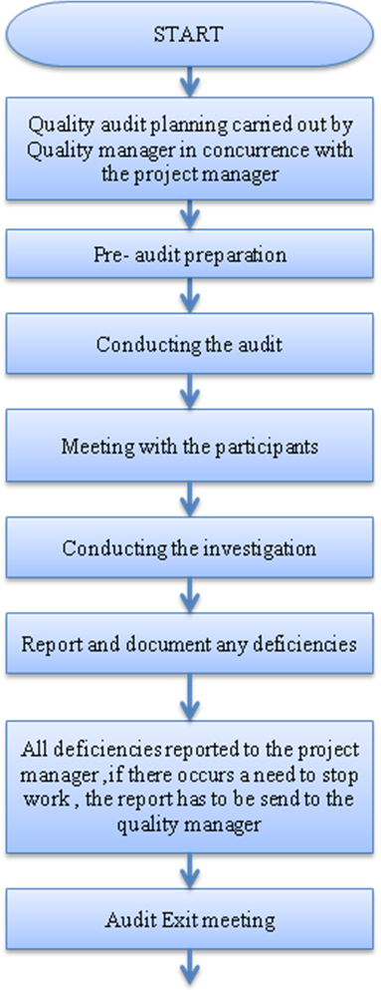

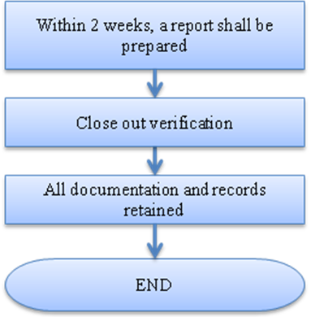

- PROCESS DESCRIPTION
  - Quality Audit Planning and Scheduling is carried out by the MR in consultation with all process owners. The audit plan will be made such that all processes and all projects [geographic locations] of VBHC are covered by at least one audit in every calendar year. Processes directly related to product realization and customer satisfaction shall be audited more frequently.
- Frequency of the audit. The internal audits shall be conducted once every 3 months.
- Scheduling of the audit. MR shall prepare an audit schedule in advance to ensure that all process owners are aware of the nature of and prescribed time for these audits.
- Audit plans. Plans are to be established prior to the audit and will cover the following areas.
- specific areas to be audited
- specific scheduled dates for the audit
- preparation and review of checklists against specific documented criteria
- implementation of corrective actions related to previous audits
  - Pre-Audit Preparation:
- The auditee makes the necessary arrangement in consultation with all process owners to prepare for the audit.
- A list of certified internal auditors is developed and maintained.
- Review the contract documents, the participant's quality procedures, plans or manuals, if submitted. Determine the areas to be audited and methods to be used. Prepare an audit plan and develop a quality audit checklist.
  - The audit is conducted as per the audit schedule.
  - An introduction meeting is conducted with the participant’s to discuss the scope of the audit; request a briefing on the organization and identify channels of communication for the audit; identify records, equipment, installations or tests to be reviewed; and tentative time and place for the exit review meeting is established.
  - Investigation phase of the audit should be conducted by completing each item on the applicable checklist. The completed checklist should be retained in the audit file.
  - Report and document any noted deficiencies. Discrepancies of a minor nature that are corrected during the audit or which do not require follow-up do not have to be documented.
  - All the deficiencies are reported to the auditee. If, in the opinion of the auditor, the nature or number of deficiencies should warrant a "stop work" order, provide the recommendation immediately to the MR.
  - An audit closing meeting is held to:
- review details of the audit and discuss each unsatisfactory condition identified
- record agreements as to recommended actions and completion dates
- advise when the audit report will be issued
Within two weeks following the completion of the audit, a report shall be prepared by the leader of the internal audit team..
  - The auditor in coordination with the quality department, as applicable, shall perform follow-up as necessary to verify the corrective actions.
  - Audit findings are summarized and presented to the top management by the MR during the Management Review Meetings.
  - Feedback on performance of auditors: The MR shall seek the feedback from every auditee about the performance of the audit / audit team.

- EFFECIENCY MEASURES AND EFFECTIVENESS MEASURES
Efficiency Measures: Number of audits conducted per year
Effectiveness Measures: Number of repeat NCs
Number of improvements effected due to audit findings.

- RISK ASSOCIATED WITH THE PROCESS

- FORMATS FOR MAINTAINING RECORDS GENERATED IN THE PROCESS
- Audit Report
- Audit Schedule

- RECORDS
Audit Schedule, Audit Reports, CAPA, CAPA LOG, NCR & NC LOG – Minimum Retention Period – Current Year & Rev.

Name of Format | Code
Audit Report | VBHC/QMS/F/05
Audit Schedule | VBHC/QMS/F/06
13. ANNEXURE

