**SALES PLANNING AND LAUNCH**



**Document Control No** : VBHC/S&M/P/02

**Revision No**  : Rev 1.1

**Date of Revision** : 1st April 2023

|  |  |  |  |
| --- | --- | --- | --- |
|  | ***Name/Designation*** | ***Signature*** | ***Date*** |
| ***Written By*** | ***Rajeesh MR*** |  |  |
| ***Reviewed By*** | ***Siddharth Gautam*** |  |  |
|  |  |  |  |

**HISTORY OF REVISIONS**

|  |  |  |  |
| --- | --- | --- | --- |
| **Revision No.** | **Revision Date** | **Chapter/clause no.**  **& text affected** | **Reason for Revision** |
|  |  |  |  |
|  |  |  |  |
|  |  |  |  |
|  |  |  |  |
|  |  |  |  |
|  |  |  |  |
|  |  |  |  |
|  |  |  |  |
|  |  |  |  |
|  |  |  |  |
|  |  |  |  |
|  |  |  |  |
|  |  |  |  |
|  |  |  |  |
|  |  |  |  |

**TABLE OF CONTENTS**

|  |  |  |
| --- | --- | --- |
| **SL No.** | **CONTENTS** | **PAGE NO.** |
| 1. | Purpose | 1 |
| 2. | Process Trigger | 1 |
| 3. | Scope and Application | 1 |
| 4. | Process Owner  5. | 1 |
| 5. | Successor and Predecessor | 1 |
| 6. | Responsibilities & Authorities | 1 |
| 7. | Definitions and Abbreviations | 2 |
| 8. | Process Flow Chart | 2 |
| 9. | Process Description | 2 |
| 10. | Efficiency measures and effectiveness measures | 3 |
| 11. | Risk associated with the process | 4 |
| 12. | Formats for maintaining records | 4 |
| 13. | Records | 4 |
| 14 | Annexure I | 5 |

**SALES PLANNING AND LAUNCH**

1. **PURPOSE**

To plan sales and launch the project in order to attain maximum returns from the project.

1. **PROCESS TRIGGER**

The process is triggered once the pre construction approvals and the project finance is obtained.

1. **SCOPE AND APPLICATION**

All VBHC projects

1. **PROCESS OWNER**

Head – Sales & Marketing

1. **PREDECESSOR AND SUCCESSOR PROCESSES**

Predecessor: Securing Project Finance (P4,Fin), Obtain Pre-Con Approvals (P18,L)

Successor: Project sales including closure (P41, S&M)

1. **RESPONSIBILITY AND AUTHORITY**

* Deciding date of launch: Top management
* Allocation of budget: Finance department
* Approval of budget and marketing plans: Marketing Head
* Deciding the terms of pricing: This is done by the top management.

1. **DEFINITIONS & ABBREVIATIONS**
2. **PROCESS FLOW CHART**

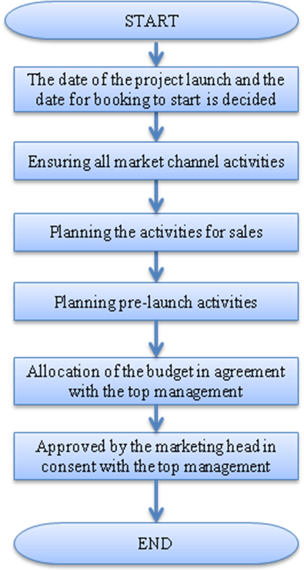

1. **PROCESS DESCRIPTION** 
   1. The date of the project launch and the date when sales should start are also decided by the top management.
   2. All marketing activities that will promote sales are decided such as:

* Pamphlets.
* Brochures
* Hoardings at site
* Hoarding in the city.
* Website that is project specific.
* Newspaper ads
* Newspaper inserts
* Radio ads
* Channel partner communication.
* Model Apartment
  1. The activities carried out while booking is also planned which includes
* Deciding the terms of pricing: This is done by the top management.
* Preparing the presentation to show the customers
* Deciding the discounts to be offered
* Targets are set on a monthly basis.
  1. Pre- launch activities such as kiosk activities, online, websites, distribution of brochures are planned out.
  2. Budget is allocated as per the finance model, for marketing and sales procedures by the finance department in agreement with top management.

1. **EFFECIENCY MEASURES AND EFFECTIVENESS MEASURES**

Efficiency Measures:

Effectiveness Measures:

* The response generated in each campaign
* Number of leads generated
* Number of sales vs leads generated

1. **RISK ASSOCIATED WITH THE PROCESS**

If sales are not planned and if project not launched properly, this may reduce the number of sales in turn reducing the returns expected from the project.

1. **FORMATS FOR MAINTAINING RECORDS GENERATED IN THE PROCESS**

Value Pricing Sheet

1. **RECORDS**

**ANNEXURE I.**

|  |  |
| --- | --- |
| **Name of Format** | **Code** |
| Value Pricing Sheet | VBHC/S&M/F/02 |