CHANGE MANAGEMENT

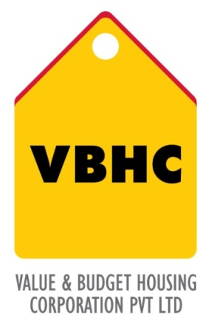
Document Control No : VBHC/TOP/P/02
Revision No : Rev 1.1
Date of Revision : 31st August 2023

 | Name/Designation | Signature | Date
Written By | Ramesh Kumar
Reviewed By | Kumar GVS

HISTORY OF REVISIONS

Revision No. | Revision Date | Chapter/clause no.  & text affected | Reason for Revision

TABLE OF CONTENTS
SL No. | CONTENTS | PAGE NO.
1. | Purpose | 1
2. | Process Trigger | 1
3. | Scope and Application | 1
4. | Process Owner  5. | 1
5. | Successor and Predecessor | 1
6. | Responsibilities & Authorities | 1
7. | Definitions and Abbreviations | 1
8. | Process Flow Chart | 2
9. | Process Description | 2
10. | Efficiency measures and effectiveness measures | 4
11. | Risk associated with the process | 4
12. | Formats for maintaining records | 4
13. | Records | 4

CHANGE MANAGEMENT

- PURPOSE
To establish a Change Management process to design, evaluate, approve, implement, and measure effectiveness of organizational change.

- PROCESS TRIGGER
This is an ongoing process

- SCOPE AND APPLICATION
This process applies to all the changes identified within the organization.

- PROCESS OWNER
TOP Management

- PREDECESSOR AND SUCCESSOR PROCESSES
Predecessor Process: Internal and External Communication
Successor Process: Setting Corporate Objectives

- RESPONSIBILITY AND AUTHORITY
All activities are carried out by top management

- DEFINITIONS & ABBREVIATIONS

- PROCESS FLOW CHART
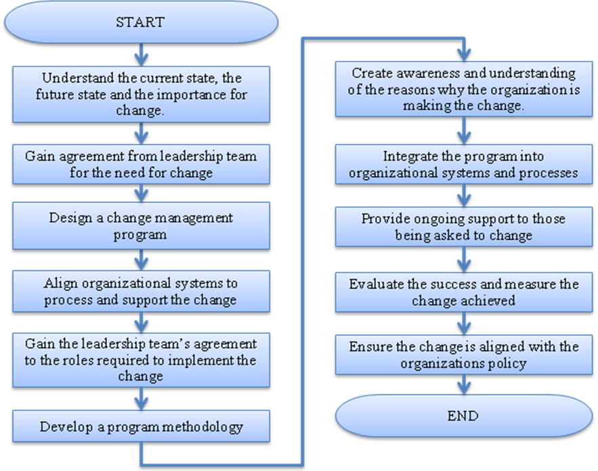

9. PROCESS DESCRIPTION
9.1 The Change management is initiated by the top management by understanding the current state (i.e. what are people doing and why) and the future state of the organization (i.e. what needs to be done and why).This is carried out by reviewing organizational information, systems and processes. Those who have to undergo change are identified.
9.2 Agreement is obtained from the leadership team (Head of departments) for the need for change
9.3 The Change management program is designed in consultation with the Heads of Departments. The end objective of the change management programme is identified in measurable terms, as much as possible
9.4 All organizational systems and processes are aligned to support the program.
9.5 The leadership teams agree to the roles required to implement the change. A Change management coordinator is identified.
9.6 The change management coordinator facilitates development of the program methodology and the program content: guides and tools to implement the change.
9.7 The change management program is integrated into organizational systems and processes
9.8 Awareness and understanding is created about why the organization is making the change. Clear communication is required. Communication is carried out by the top management, either they inform the entire company via mail or the leadership team informs the employees who will be directly involved in the change program.
9.9 Roles are clarified and core capabilities to be developed are defined.
The core capabilities required for each role is developed by:
- Change leadership workshop
- Management workshops
9.10 Ongoing support is provided to those who are being asked to change.
9.11 The success of the program is evaluated and the change achieved is measured. Those that have successfully made the change are rewarded and recognized
9.12 The change management program is ensured to be line with the organizational policies
10. EFFECIENCY MEASURE AND EFFECTIVENESS MEASURE
Efficiency Measures:
- Proper Planning
- Proper Communication
- Proper Evaluation
Effectiveness Measures:
- RISK ASSOCIATED WITH THE PROCESS
It can be very difficult to introduce change to an organization. Failure to recognize and deal with this fact has been the cause of many project failures.

- FORMATS FOR MAINTAINING RECORDS GENERATED IN THE PROCESS

- RECORDS

