**CONTRACT MANAGEMENT**

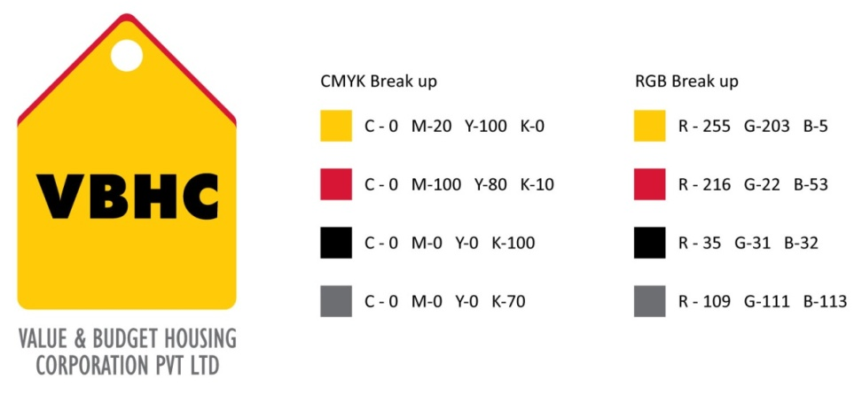

**Document Control No** : VBHC/P&C/P/03

**Revision No**  : Rev 3.0

**Date of Revision** : 26-08-2023

|  |  |  |  |
| --- | --- | --- | --- |
|  | ***Name/Designation*** | ***Signature*** | ***Date*** |
| ***Written By*** | ***Chandra Mohan JM*** |  |  |
| ***Reviewed By*** | ***Shiva Prasad*** |  |  |
| ***Approved By*** | ***Kumar GVS*** |  |  |

**HISTORY OF REVISIONS**

|  |  |  |  |
| --- | --- | --- | --- |
| **Revision No.** | **Revision Date** | **Chapter/clause no.**  **& text affected** | **Reason for Revision** |
| 3 | 26-Aug- 2023 |  |  |
|  |  |  |  |
|  |  |  |  |
|  |  |  |  |
|  |  |  |  |
|  |  |  |  |
|  |  |  |  |
|  |  |  |  |
|  |  |  |  |
|  |  |  |  |
|  |  |  |  |
|  |  |  |  |
|  |  |  |  |
|  |  |  |  |
|  |  |  |  |

**TABLE OF CONTENTS**

|  |  |  |
| --- | --- | --- |
| **SL No.** | **CONTENTS** | **PAGE NO.** |
| 1. | Purpose | 1 |
| 2. | Process Trigger | 1 |
| 3. | Scope and Application | 1 |
| 4. | Process Owner  5. | 1 |
| 5. | Successor and Predecessor | 1 |
| 6. | Responsibilities & Authorities | 1 |
| 7. | Definitions and Abbreviations | 2 |
| 8. | Process Description | 2 |
| 9. | Efficiency measures and effectiveness measures | 3 |
| 10. | Risk associated with the process | 3 |
| 11. | Formats for maintaining records | 4 |
| 12. | Records | 4 |

**CONTRACT MANAGEMENT**

1. **PURPOSE**

The purpose of contract management is the process of managing, executing and analyzing the management of contract efficiently engaged by VBHC and to address claims & any changes arising in scope of contract, Agreed Price, Resource and Time during the period of contract in order for the Construction Phase to commence and run smoothly.

1. **PROCESS TRIGGER**

Contract Management is an ongoing process.

1. **SCOPE AND APPLICATION**
2. This procedure applies to all the projects of VBHC
3. **PROCESS OWNER**

Procurement and Contracts-Head

1. **PREDECESSOR AND SUCCESSOR PROCESSES**

Predecessor Process : Appointment of Contractors (P & C) which includes floating enquiry, getting quotes along with pre-qualification questionnaires with respect to the particular scope of work, evaluate PIs collected, collection of proposals , preparing Comparative Statement, Finalization of contractors

Successor Process : Measurement, Certification and Payment (OP)

Daily Construction Management (OP), evaluation of contractor’s performance

1. **RESPONSIBILITY AND AUTHORITY**

To approve on quality standards: Operation & Projects Head & Quality Head.

To approve finalized vendors: Operation & Projects Head & AVP- Procurement.

To approve indent/Requisition: Execution Heads & Project Managers.

To approve Modification Request

* of value ≤ 1 lakh Rupees : AVP – Procurement & Contracts
* of value >1 lakh Rupees : Operation & Projects Head & Senior Vice President Operations

Clearance for execution from site perspective and budget perspective is obtained by Operation & Projects Head

1. **DEFINITIONS & ABBREVIATIONS**
2. Contract : A [contract](http://en.wikipedia.org/wiki/Contract) is a written, legally binding agreement between the parties identified in the agreement to fulfill the terms and conditions outlined in the agreement.
3. Work order : A written order, signed by the owner or his representative, of a work/service requiring performance by the contractor without ambiguity of any sort
4. Scope of work : The work that must be performed to deliver a product, service, or result with the specified features and functions
5. **PROCESS DESCRIPTION**
   1. After the award of contract intimation about work start is given to Contractor by Site Incharge.
   2. Intimation about award of contract is given to Site Incharge by Contracts dept. through email.
   3. During the period of a contract, change can be driven by a number of factors; that in turn can lead to changes in the scope of work, Price, Material quantities and workload.
   4. Change in Work Order:
      * 1. In case of any changes to work order is required, The Request for change is filled by the concerned engineer and submitted to PM/Project Incharge.
        2. The project Incharge based on his assessment will mention the justification for recommendation of change request and will send out the scan copy to all concerned for further process.
        3. The estimation engineer on receival of the RFC, Will prepare the Variation Statement, if there is a cost impact immediately and send out the cost impact for further approval & If there is no cost impact also he shall mention the same.
        4. Once after all the scrutiny/ discussion on value engineering points, with all concerned team members and management team, the final decision will be arrived on the way forward and the final variation statement will be prepared by estimation team and they shall get the approval on the cost variance if any in the variation statement and construction budget revised accordingly and Request for change is circulated to site team for further process after taking the approval from Head Projects & Operation.
        5. Contracts team reviews the Change Request, discusses the changes with Site Incharge and negotiates with the Contractor for the same and arrives at a possible agreeable solution.
        6. If Estimation team recommends for no change in Quantity/Scope of work then, Change Request is not approved by Contracts team and work is executed as per contract terms and conditions
        7. Else Change request is approved by AVP –Procurement & Contracts for value ≤ 1 lakh Rupees, by Operation & Projects Head for value > 1 lakh Rupees and then change is incorporated in the work order and work is executed as per the contract terms and conditions.
   5. Termination of contract:
      * 1. Evaluation of contractor performance is elaborated in the process of contractor evaluation and vendor assessment VBHC/ P&C/P/04/AR02
        2. At his discretion of Site Incharge, he may recommend terminating the contract based on performance of contractor as per contract terms and conditions in Consultation with Head – Procurement and Contracts, for final contract closure.
   6. Claims and Disputes:
      * 1. For any claims or disputes raised at site by contractor, the Site Incharge shall discuss with the contractor and arrive at a possible agreeable solution.
        2. If the Site Incharge could not arrive at a possible solution he escalates the same to AVP – Procurement and Contracts. AVP – Procurement and Contracts negotiates with the contractor and arrives at a possible agreeable solution; terms of claim settlement are communicated to the contractor.
6. **EFFECIENCY MEASURES AND EFFECTIVENESS MEASURES**

Efficiency Measures : No of claims and disputes resolved

No of changes made to the contract or work order during the period of contract

Effectiveness Measures : Contractor Performance Rating

1. **RISK ASSOCIATED WITH THE PROCESS**

Due to more claims and disputes construction scheduled time may increase which in turn increases the cost of construction.

1. **FORMATS FOR MAINTAINING RECORDS GENERATED IN THE PROCESS**

Change Request form – Record maintained till the closure of the project

Variation form - Record maintained till the closure of the project

1. **RECORDS**

**ANNEXURE I**

|  |  |
| --- | --- |
| **Name of Format** | **Code** |
| Change Request form | VBHC/P&C/P/03/CM01 |
| Variation form | VBHC/P&C/P/03/CM02 |