HARDWARE & SOFTWARE INVENTORY MANAGEMENT



**Document Control No** : VBHC/IT/P/03

**Revision No** : Rev 2.1

**Date of Revision** : 23rd August 2023

|  |  |  |  |
| --- | --- | --- | --- |
|  | ***Name/Designation*** | ***Signature*** | ***Date*** |
| ***Written By*** | ***Kannan K.R (AVP IT)*** |  |  |
| ***Reviewed By*** | ***Venkatesh Katta (IT Consultant)*** |  |  |
|  |  |  |  |

# Value and Budget Housing Corporation Pvt. Ltd. 74&75, Millers Road

**Vasanth Nagar, Near Vikram Hospital Bangalore - 560052 | Karnataka**

|  |  |  |  |
| --- | --- | --- | --- |
| STANDARD OPERATING PROCEDURE | | | |
| Value and Budget Housing Corporation Pvt Ltd | HARDWARE & SOFTWARE INVENTORY  MANAGEMENT | DOC.NO: VBHC/IT/P/03 |  |

**HISTORY OF REVISIONS**

|  |  |  |  |
| --- | --- | --- | --- |
| **Revision No.** | **Revision Date** | **Chapter/clause no.** | **Reason for Revision** |
|  |  |  |  |
|  |  |  |  |
|  |  |  |  |
|  |  |  |  |
|  |  |  |  |
|  |  |  |  |
|  |  |  |  |
|  |  |  |  |
|  |  |  |  |
|  |  |  |  |
|  |  |  |  |
|  |  |  |  |
|  |  |  |  |
|  |  |  |  |
|  |  |  |  |

**TABLE OF CONTENTS**

|  |  |  |
| --- | --- | --- |
| **SL No.** | **CONTENTS** | **PAGE NO.** |
| 1. | Purpose | 4 |
| 2. | Process Trigger | 4 |
| 3. | Scope and Application | 4 |
| 4. | Process Owner | 4 |
| 5. | Successor and Predecessor | 4 |
| 6. | Responsibilities & Authorities | 4 |
| 7. | Definitions and Abbreviations | 5 |
| 8. | Process Flow Chart | 6 |
| 9. | Process Description | 7,8 |
| 10. | Efficiency measures and effectiveness measures | 9 |
| 11. | Risk associated with the process | 9 |
| 12. | Records | 9 |

# HARDWARE & SOFTWARE INVENTORY MANAGEMENT

1. **PURPOSE**

To ensure that adequate IT resources such as new Software, Hardware, and License are available for effective business performance

# PROCESS TRIGGER

This process is triggered whenever a request for new software or hardware or license is made by owner of relevant department to the IT Infra Lead / IT Head.

# SCOPE AND APPLICATION

This process is applicable to all corporate IT Procurement/Licensing/Leasing and Management of asset-inventory, including monthly tracking.

# PROCESS OWNER

IT Infra Lead / IT Head

# PREDECESSOR AND SUCCESSOR PROCESSES

Predecessor Process: Successor Process:

# RESPONSIBILITY AND AUTHORITY

To Approve Quotes: IT Head

To Approve Configuration: IT Infra Lead / IT Head To Approve Setup & configuration: IT Infra Engineer

# DEFINITIONS & ABBREVIATIONS

* 1. IT Head : Head of IT Department
  2. IT : Information Technology
  3. TAT : Turn Around Time

# PROCESS FLOW CHART

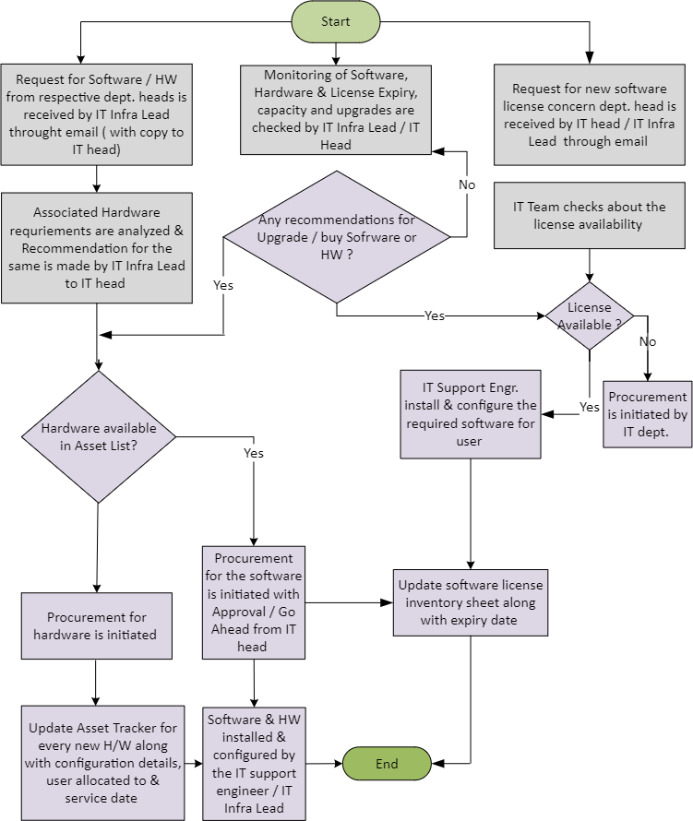

1. **PROCESS DESCRIPTION**

# New Software Request:

* + 1. Request from owner/head of relevant department (along with approval by Dept. Head) is forwarded to IT Infra Lead through email (with a copy to IT Head).
    2. Associated Hardware requirements and associated cost are analyzed and recommendation is made by IT Infra Lead and approved by the IT Head for hardware requirements and by owner/head of relevant department for cost.
    3. Procurement for the same is initiated with the approval of IT Head.
    4. Refer step approval process for Procurement of Software / Hardware in the below table.

|  |  |  |  |  |
| --- | --- | --- | --- | --- |
| **Particulars** | **Quadra License** | **Salesforce License** | **Other Software Licenses** | **IT Hardware**  **/Peripherals** |
| Requestor | Department | User/Department | User/Department | Users/Department |
| First Level Approval | Finance Head | Approved by Sales/Marketing Head | IT Head | IT Head/Operation Head/CEO** |
| Second Level Approval |  | CEO | CEO** |  |

** Other Software Licenses / IT Peripherals: CEO / Operational Head approval may be required based on the cost and volume.

* + 1. Procured Software is Installed and Configured by the IT Support Engineer.

# New Software and additional users or New Employees or Periodic Maintenance Analysis / Incident Management revealing need for New Hardware to be procured or existing hardware to be upgraded

* + 1. If Hardware asset is available, the recommendation from IT Infra Lead is made to the IT Head.
    2. If the Hardware asset unavailable or insufficient, Procurement is initiated with Approval / Go-Ahead from IT Head.
    3. Delivered Hardware is Installed & Configured by the IT Support Engineer and IT Infra Lead.

# New License Request:

* + 1. New Employee request from HR or request from the owner of relevant department (along with approval by Dept. Head) is forwarded to IT Support Engineer through email with copy to IT Infra Lead / IT Head
    2. IT Support Engineer refers to the License Inventory for available Licenses.
    3. If license is available, the IT Support Engineer installs & configures the required software.
    4. If license is not available, procurement is initiated by IT Infra Lead. Post delivery/procurement, the IT Support Engineer installs and configures the required software

# Software, Hardware & License Capacity & Inventory Tracking

* + 1. Every new software along with configuration details and expiry-date (if any) are entered into the License Inventory tracker (along with usernames for whom the License has been given to).
    2. Every new Hardware along with configuration details, user allocated to and service- date (if any) are entered into the Hardware asset tracker
    3. Service dates/Expiry dates are reviewed monthly by IT Infra Lead, capacity and upgrade/buy requirements are monitored by auto alerts generated by software and action taken, accordingly by IT Infra Lead.

1. **EFFECIENCY MEASURES AND EFFECTIVENESS MEASURES** Efficiency Measures: Average TAT for new License, Hardware or Software Effectiveness Measures: Resolution of issues

# RISK ASSOCIATED WITH THE PROCESS

* + 1. Delay in resolution could impact the productivity of construction site or other business processes.
    2. Increasing trend in # incidents could lead to system instability.

# 11 RECORDS

Quotations from Vendors – Minimum Retention Period – 1yr/Till Project Completion Purchase Orders – Minimum Retention Period – 1yr/Till Project Completion