**TRANSPORTATION**

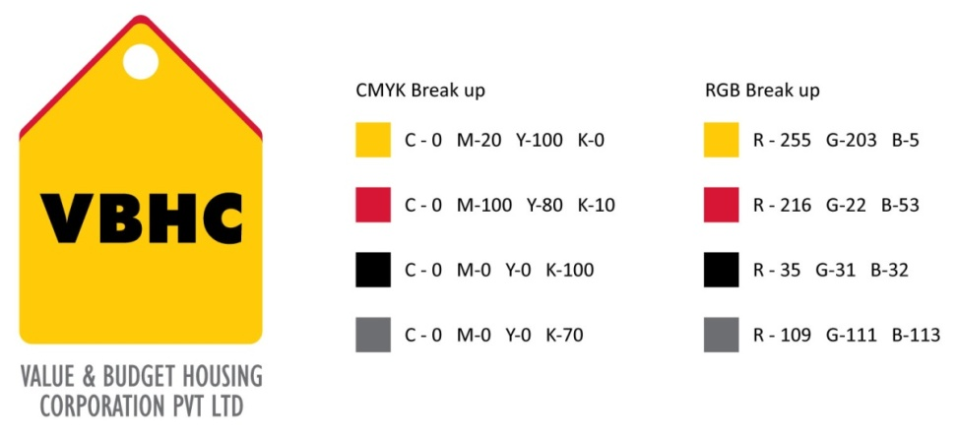

**Document Control No** : VBHC/ADM/P/03

**Revision No** : Rev 1.1

**Date of Revision** : 31st August 23

|  |  |  |  |
| --- | --- | --- | --- |
|  | ***Name/Designation*** | ***Signature*** | ***Date*** |
| ***Written By*** | ***Ajith kumar*** |  |  |
| ***Reviewed By*** | ***Kumar GVS*** |  |  |
| ***Approved By*** |  |  |  |

**HISTORY OF REVISIONS**

|  |  |  |  |
| --- | --- | --- | --- |
| **Revision No.** | **Revision Date** | **Chapter/clause no.**  **& text affected** | **Reason for Revision** |
|  |  |  |  |
|  |  |  |  |
|  |  |  |  |
|  |  |  |  |
|  |  |  |  |
|  |  |  |  |
|  |  |  |  |
|  |  |  |  |
|  |  |  |  |
|  |  |  |  |
|  |  |  |  |
|  |  |  |  |
|  |  |  |  |
|  |  |  |  |
|  |  |  |  |

**TABLE OF CONTENTS**

|  |  |  |
| --- | --- | --- |
| **SL No.** | **CONTENTS** | **PAGE NO.** |
| 1. | Purpose | 1 |
| 2. | Process Trigger | 1 |
| 3. | Scope and Application | 1 |
| 4. | Process Owner  5. | 1 |
| 5. | Successor and Predecessor | 1 |
| 6. | Responsibilities & Authorities | 1 |
| 7. | Definitions and Abbreviations | 1 |
| 8. | Process Flow Chart | 2 |
| 9. | Process Description | 3 |
| 10. | Efficiency measures and effectiveness measures | 4 |
| 11. | Risk associated with the process | 4 |
| 12. | Formats for maintaining records | 4 |
| 13. | Records | 4 |

**TRANSPORTATION**

1. **PURPOSE**

A process, for the selection and deployment of suitable vendors for the purpose of transportation.

1. **PROCESS TRIGGER**

This process is triggered by the initiation of any project.

1. **SCOPE AND APPLICATION**

All VBHC projects.

1. **PROCESS OWNER**

Administration – Head

1. **PREDECESSOR AND SUCCESSOR PROCESSES**

Predecessor: Project Master Schedule ( P30, PMC )

Successor: End of Project

1. **RESPONSIBILITY AND AUTHORITY**

Evaluation of Vendors : Admin Head

Provision of SOP : Vendor

Provision of SLA : Admin Department

1. **DEFINITIONS & ABBREVIATIONS**

LOI- Letter of Intent

SOP- Standard Operations Procedure

SLA – Service Legal Agreement

1. **PROCESS FLOW CHART FOR SELECTION OF VENDORS**

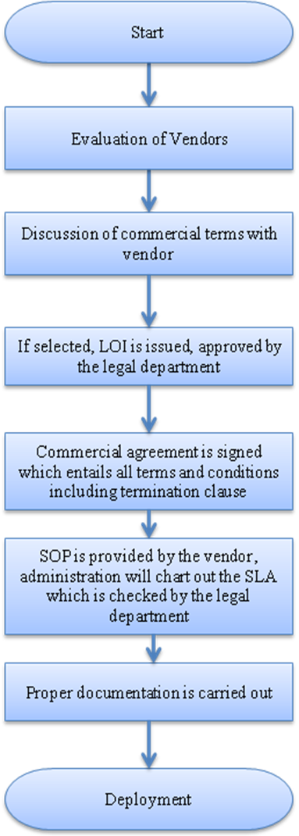

1. **PROCESS DESCRIPTION FOR SELECTION OF VENDORS**
2. Invitation of proposals from vendors.
3. Evaluation of vendors based on certain parameters:

* Relevant experience
* Amount of training
* Reference

9.3 Commercial terms discussed.

* 1. The administration head selects the most suitable vendor, and LOI is issued.
  2. The LOI should be checked and approved by the legal department.
  3. Commercial agreement is signed which includes all terms and conditions including termination clause
  4. SOP is provided by the vendor, and a SLA is issued to the vendor.

SLA will contain requirements from the company’s side about certain aspects:

* Safety aspects
  + Seatbelt
  + Usage of mobile phones while in duty
  + Speed limits
  + Upkeep of vehicle
  + Attending to repairs and maintenance
  + First aid in vehicle
  + Extra tyre
  + Tools
* Driver aspects
  + Non alcoholism or any disturbing issues
  + Behavior with employees
  + Uniforms
  + Appearance
  + Discipline
  + Punctuality
  1. Proper documentation has to be carried out by the administration department on confirmation
  2. Deployment is carried out

1. **EFFECIENCY MEASURES AND EFFECTIVENESS MEASURES**

Efficiency Measures: Number of days taken to appoint the vendor

Effectiveness Measures: Number of adverse incidents

1. **RISK ASSOCIATED WITH THE PROCESS**

If proper evaluation and deployment is not carried out, efficiency reduces in turn causing loss to the company.

1. **FORMATS FOR MAINTAINING RECORDS GENERATED IN THE PROCESS**
2. **RECORDS**