BUDGET TRACKING, COST CONTROL AND REVISIONS

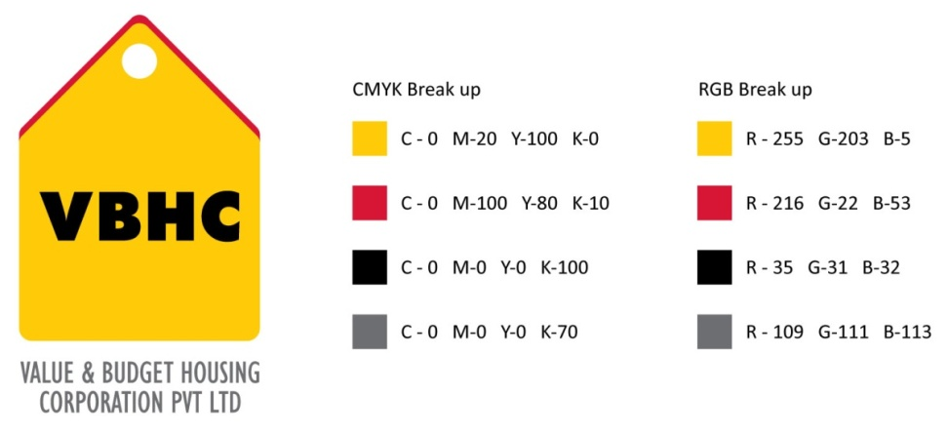
Document Control No : VBHC/EST/P/03
Revision No : Rev 1.1
Date of Revision : 31st August 2023

 | Name/Designation | Signature | Date
Written By | Azhar Ahmad
Reviewed By | Kumar GVS

HISTORY OF REVISIONS

Revision No. | Revision Date | Chapter/clause no.  & text affected | Reason for Revision

TABLE OF CONTENTS
SL No. | CONTENTS | PAGE NO.
1. | Purpose | 1
2. | Process Trigger | 1
3. | Scope and Application | 1
4. | Process Owner  5. | 1
5. | Successor and Predecessor | 1
6. | Responsibilities & Authorities | 1
7. | Definitions and Abbreviations | 1
8. | Process Flow Chart | 2
9. | Process Description | 4
10. | Efficiency measures and effectiveness measures | 4
11. | Risk associated with the process | 4
12. | Formats for maintaining records | 5
13. | Records | 5
14 | Annexure I | 6

BUDGET TRACKING, COST CONTROL AND REVISIONS

- PURPOSE
To track the Cost Escalation due to materials and price variance and evaluate financial impact
- PROCESS TRIGGER
This process is triggered when project construction starts and is an ongoing process until project completion.

- SCOPE AND APPLICATION
This process is applicable to all ongoing and new projects of VBHC.

- PROCESS OWNER
Head – Estimation

- PREDECESSOR AND SUCCESSOR PROCESSES
Predecessor Process: Project Budget R2 (EST)
Successor Process: Procure Materials (P&C), Appoint Contractors (P&C)

- RESPONSIBILITY AND AUTHORITY
Budget approval by : Head Estimation.

- DEFINITIONS & ABBREVIATIONS
IT : Information Technology
OP : Operations Department
- PROCESS FLOW CHART
MATERIAL VARIANCE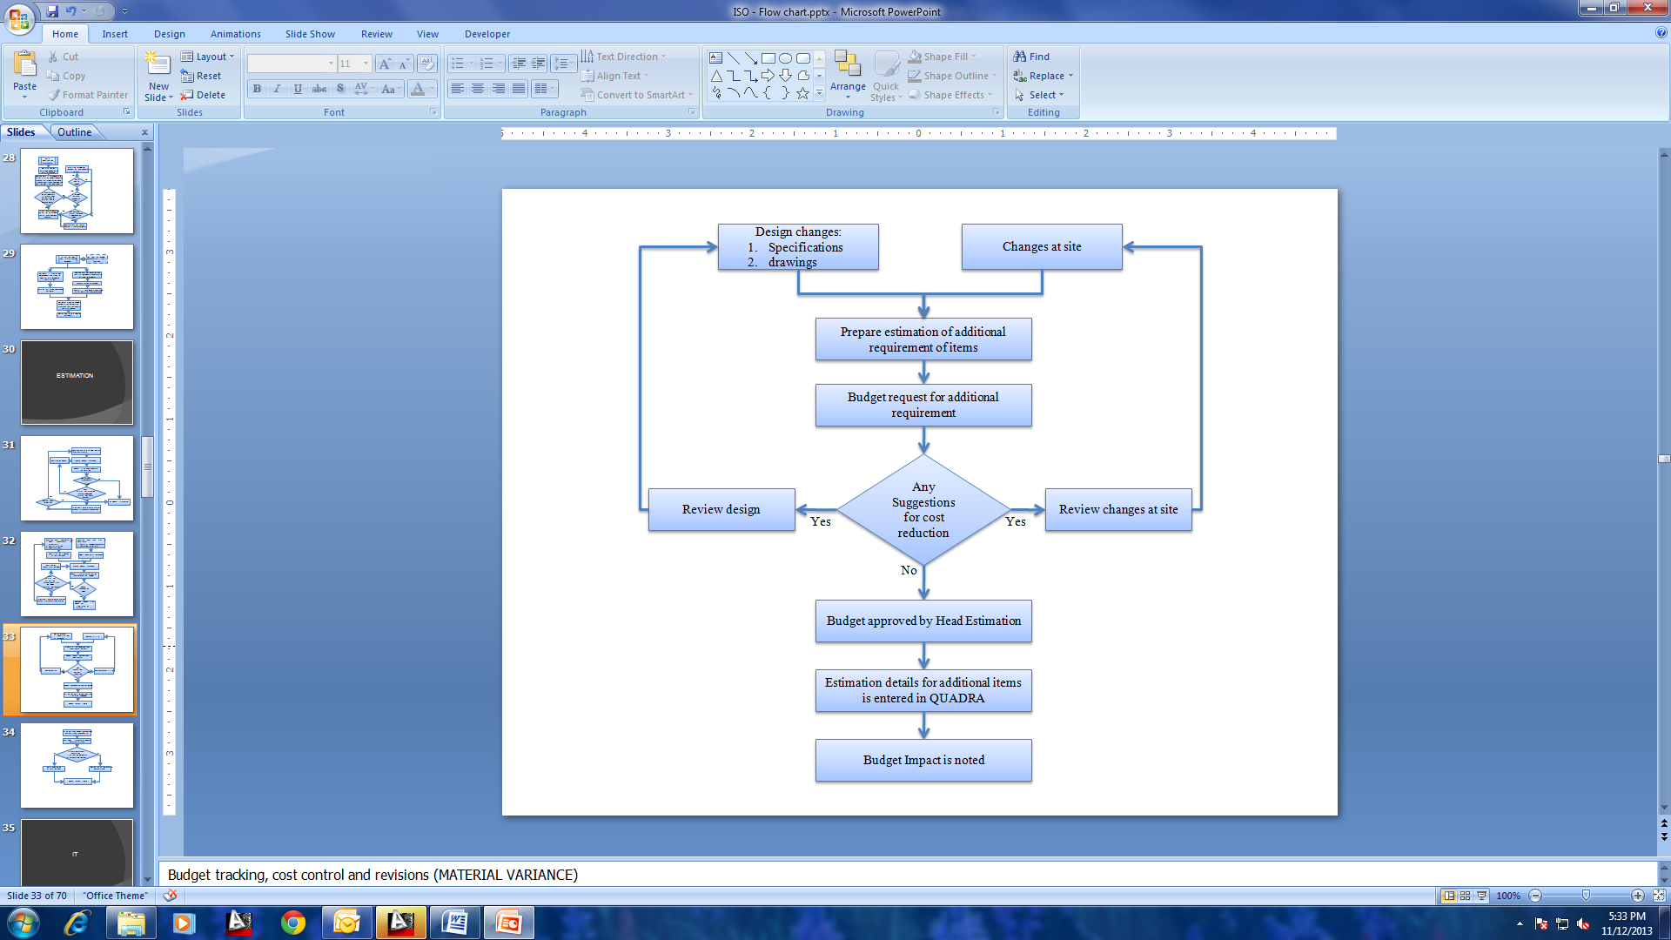

PRICE VARIANCE
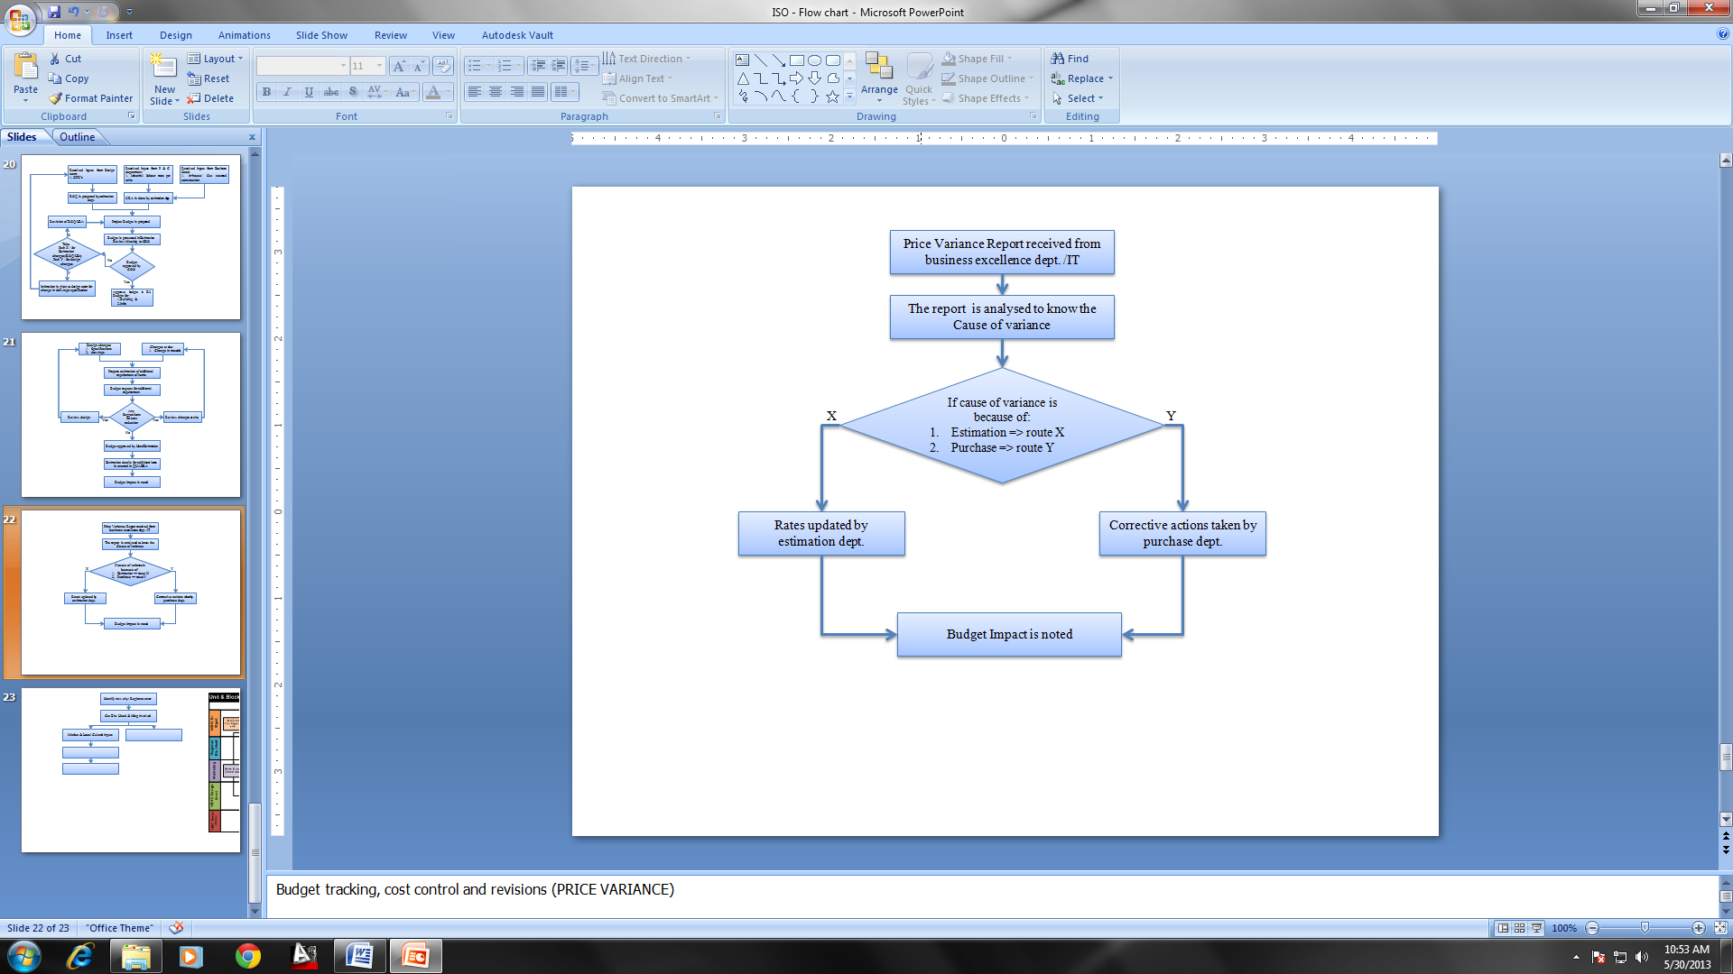

- PROCESS DESCRIPTION
  - Material Variance:
    - For any Design changes or changes at site, estimation is prepared for additional items required by Estimation team.
    - Budget request is send for additional items required Manager – Estimation.
    - If there are any suggestions given for cost reduction in budget, intimation is given by Manager – Estimation to design team to review the design and to OP dept to review the changes at site.
    - If there are no suggestions for cost reduction, Budget is approved by Head Estimation.
    - Estimation details of approved additional items are entered into QUADRA by Manager – Estimation.
    - Budget impact is noted by Manager – Estimation.
  - Price Variance:
    - Price Variance Report is received from Business Excellence dept by Manager – Estimation.
    - The same is analysed Manager – Estimation for the cause of Variance.
    - Based on the analysis, the estimation and purchase department will plan the course of action and start implementing the same.
    - Budget impact is noted Manager – Estimation.

- EFFECIENCY MEASURES AND EFFECTIVENESS MEASURES
Efficiency Measures: Deviation between R1 and R2 Budget
Effectiveness Measures:

- RISK ASSOCIATED WITH THE PROCESS

- FORMATS FOR MAINTAINING RECORDS GENERATED IN THE PROCESS

- RECORDS

