PROJECT FINANCIAL CLOSURE

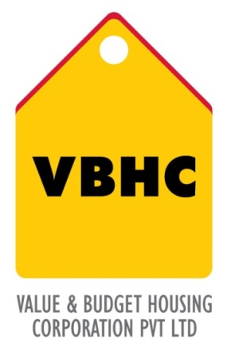
Document Control No : VBHC/FIN/P/03
Revision No : Rev 1.0
Date of Revision : 31st August 2013

 | Name/Designation | Signature | Date
Written By
Reviewed By
Approved By

HISTORY OF REVISIONS

Revision No. | Revision Date | Chapter/clause no.  & text affected | Reason for Revision

TABLE OF CONTENTS
SL No. | CONTENTS | PAGE NO.
1. | Purpose | 1
2. | Process Trigger | 1
3. | Scope and Application | 1
4. | Process Owner  5. | 1
5. | Successor and Predecessor | 1
6. | Responsibilities & Authorities | 1
7. | Definitions and Abbreviations | 1
8. | Process Flow Chart | 2
9. | Process Description | 2
10. | Efficiency measures and effectiveness measures | 3
11. | Risk associated with the process | 3
12. | Formats for maintaining records | 3
13. | Records | 3

PROJECT FINANCIAL CLOSURE

- PURPOSE
To complete all project-related financial transactions, finalize and close the entire project related financial accounts.

- PROCESS TRIGGER
This process is triggered once the project construction is regarded as complete, compliance with legal laws and all applicable approvals for handover obtained.
3.0 SCOPE AND APPLICATION
All VBHC projects.

4.0 PROCESS OWNER
Finance – Head / Controller
- PREDECESSOR AND SUCCESSOR PROCESSES
Predecessor Process: Milestone Billing and Collection (CRM,P44)
Successor Process: END

- RESPONSIBILITY AND AUTHORITY
Verification of completion of statement of work: PMC department
Completion and closure of all financial transactions : Finance Controller

- DEFINITIONS & ABBREVIATIONS
C.F.O: Chief Financial Officer
M.D: Managing Director
- PROCESS FLOW CHART

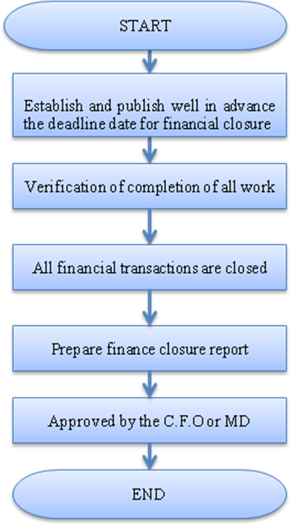

- PROCESS DESCRIPTION
9.1 The deadline date for the completion of all financial transactions and closing of financial accounts is established, in advance, and published to all project staff and vendors.
9.2 All acceptance criteria in the Statement of Work is verified to have been met by the PMC department.
9.3 The finance controller completes and closes all the following transactions:
- Bank accounts
- Fixed deposits
- Recoverable from subsidiaries
- Customer money received
- Payment for loans and creditors
- Any tax liabilities
- Any advances from staff
- Employee transfer ( in accordance with the HR department)
- Close out mortgages
- Minority interest calculations
- Ensure statutory liabilities
9.4 Report project profitability to investors.
9.5 Financial Closure report prepared by the finance department.
9.6 Approved by the C.F.O and MD.

- EFFECIENCY MEASURES AND EFFECTIVENESS MEASURES
Efficiency Measures: Number of days to approve closure report
Effectiveness Measures:

- RISK ASSOCIATED WITH THE PROCESS

- FORMATS FOR MAINTAINING RECORDS GENERATED IN THE PROCESS

- RECORDS
Financial Closure Report

