OBTAIN PRE-CON APPROVALS
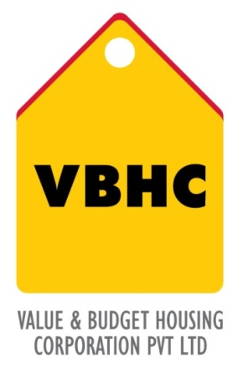
Document Control No : VBHC/L&A/P/03

Revision No : Rev 1.1

Date of Revision : 31st August 2023

 | Name/Designation | Signature | Date
Written By | Royal Reddy
Reviewed By | Kumar GVS

HISTORY OF REVISIONS

Revision No. | Revision Date | Chapter/clause no.  & text affected | Reason for Revision

TABLE OF CONTENTS
SL No. | CONTENTS | PAGE NO.
1. | Purpose | 1
2. | Process Trigger | 1
3. | Scope and Application | 1
4. | Process Owner  5. | 1
5. | Successor and Predecessor | 1
6. | Responsibilities & Authorities | 1
7. | Definitions and Abbreviations | 1
8. | Process Flow Chart | 2
9. | Process Description | 2
10. | Efficiency measures and effectiveness measures | 5
11. | Risk associated with the process | 5
12. | Formats for maintaining records | 5
13. | Records | 5
14. | Annexure 1 | 6

OBTAIN PRE-CON APPROVALS

- PURPOSE
To define the required project specific approvals before the start of construction and to obtain them from an authorized body.

- PROCESS TRIGGER
This process is triggered after Master Plan is prepared.

- SCOPE AND APPLICATION
All VBHC projects.

- PROCESS OWNER
Head : Land Committee

- PREDECESSOR AND SUCCESSOR PROCESSER
Predecessor Process: Master Plan including phasing, concept and schematic (D,22)
Successor Process: Sales Planning and Launch (18, SM), Obtain approvals of Home Loans from Banks (29, SM)

- RESPONSIBILITY AND AUTHORITY
Preparation of Project Specific Approval List: Land Committee

- DEFINITIONS & ABBREVIATIONS

- PROCESS FLOW CHART

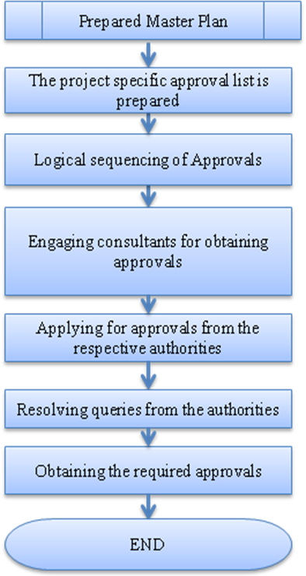

- PROCESS DESCRIPTION
  - For each project, depending on the State laws and regulations, the approvals required before construction will be different. A project specific list is prepared by the business head in consultation with the land department.
The list may include the following approvals:

TABLE 1: List of approvals required:

S.No | Type of Approval | Approving Authority | Pre-requisites
1. | Land Use Conversion | Development Authority/Municipality
2. | NOC from Pollution Control Board/ Environmental Clearance | State Pollution Control Board and Ministry of Environment
3. | NOC from Forest Department | Forest Department
4. | Road Access Clearance before building plan approval | NHAI/PWD
5. | AAI Height NOC( before building plan approval) | Civil Aviation Department
6. | Building Layout Approval | Development Authority
7. | Commencement Certificate | Development Authority/ Municipality
8. | Fire fighting Scheme Approval | Chief Electrical Inspectorate of Govt
9. | Lift Escalator Installation Approval ( wherever applicable) | Lift Inspectorate
10. | Electric Substation NOC ( for all substations/transformers in the building) | State Electricity Board
11. | DG Sets Installation approval | Chief Electrical Inspectorate
12. | Certificate of clearance of all electrical installations in the building | State Electricity Board
13. | Environment Clearance ( for 125 acres project with built up area above 20000sq metres) | Ministry of Environment and Forests
14. | Bore well Registration Certificate | Central Groundwater Authority
15. | Electrical Load/ Electrical Connection | State Electricity Board
16. | Permission for Sewer Connection | Municipal Authority
17. | Permission for Water Connection | Municipal Authority
18. | Consent to Establish work at site | Pollution Control Board

  - Once the list is prepared, the list is logically sequenced to find the interdependency between the approvals that are required.
  - Consultants are appointed by the land department head to assist with obtaining the approvals.
  - Approvals are applied for from the authorities respectively by the business head in the case consultants are not appointed, otherwise it is done by the consultants.
  - Any queries if raised by the authorities are resolved by business head ( for business related queries) and the respective discipline heads ( eg for queries related with electrical – electrical head , plumbing – plumbing head etc.)
  - Obtaining all the required approvals. This is informed to the top management and the head of departments. It is circulated internally by the business head and the land department.

- EFFECIENCY MEASURES AND EFFECTIVENESS MEASURES
Efficiency Measures:
Approvals are obtained in the scheduled time.
Number of queries due to incomplete documentation
Effectiveness Measures:

- RISK ASSOCIATED WITH THE PROCESS
If the approvals are not obtained, the occurrence of risks during the project phase might increase.

- FORMATS FOR MAINTAINING RECORDS GENERATED IN THE PROCESS
List of approvals for pre-construction

- RECORDS

ANNEXURE I
Name of Format | Code
List of approvals for pre-construction | VBHC/L&A/F/01

