RECEIVE MATERIAL MAINTAIN INVENTORY @SITE

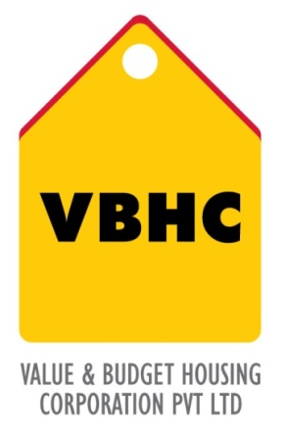
Document Control No : VBHC/OPE/P/03
Revision No : Rev 1.1
Date of Revision : 31st August 2023

 | Name/Designation | Signature | Date
Written By | Shivaprasad
Reviewed By | Kumar GVS

HISTORY OF REVISIONS

Revision No. | Revision Date | Chapter/clause no.  & text affected | Reason for Revision

TABLE OF CONTENTS
SL No. | CONTENTS | PAGE NO.
1. | Purpose | 1
2. | Process Trigger | 1
3. | Scope and Application | 1
4. | Process Owner  5. | 1
5. | Successor and Predecessor | 1
6. | Responsibilities & Authorities | 1
7. | Definitions and Abbreviations | 1
8. | Process Flow Chart | 2
9. | Process Description | 3
10. | Efficiency measures and effectiveness measures | 2
11. | Risk associated with the process | 4
12. | Formats for maintaining records | 4
13. | Records | 4

RECEIVE MATERIAL MAINTAIN INVENTORY @ SITE

- PURPOSE
To establish process to Receive Material and Maintain Inventory at Site to ensure that the right quantity and quality of materials and equipments delivered by vendor in a timely manner.

- PROCESS TRIGGER
When goods received on site

- SCOPE AND APPLICATION
This procedure applies to all the materials and equipments received at VBHC site.

- PROCESS OWNER
Store Manager

- PREDECESSOR AND SUCCESSOR PROCESSES
Predecessor Process: Procure Materials (P24,P&C)
Successor Process: Daily Construction Management (P34, OP)

- RESPONSIBILITY AND AUTHORITY
Approval of DMR in QUADRA by Store Manager

- DEFINITIONS & ABBREVIATIONS
- PO : Purchase Order
- AGM : Assistant General Manager
- AVP : Associate Vice President
- DMR : Daily Material Report
- MRN : Material Receipt Note

- PROCESS FLOW CHART
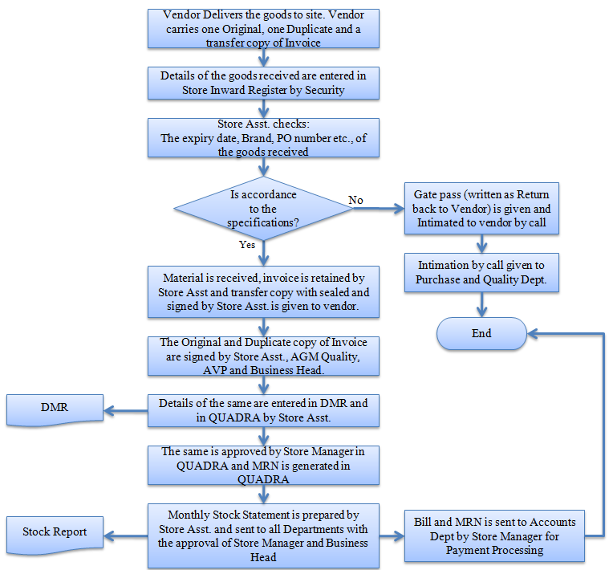
- PROCESS DESCRIPTION
  - When goods are received at the site, the details of the goods received are entered in Store Inward Register by Security at the main gate and then the vehicle moves to store.
  - The Quality check for the goods received is carried out by Quality dept. once the clearance is given by Quality dept then goods are moved into store.
  - At store the Store Asst. checks the expiry date, brand, and PO number etc., of the goods.
  - If they are in not in accordance to the specifications, then Gate pass (written as Return back to Vendor) is given to the vendor representative and Intimation by call is given to vendor, Purchase and Quality Dept by Store Asst.
  - Else Material is received, original and duplicate copies of invoice are retained by Store Asst and transfer copy with seal and signature of the Store Asst. is returned to vendor.
  - The Original and Duplicate copy of Invoice are signed by Store Asst., AGM Quality, AVP and Business Head.
  - Details of the same are entered in DMR and in QUADRA by Store Asst.
  - The same is approved by Store Manager in QUADRA and MRN is generated in QUADRA
  - Monthly Stock Statement is generated in Quadra by Store Asst. and sent to all Departments with the approval of Store Manager and Business Head
  - Bill and MRN are sent to Accounts dept by Store Manager for Payment Processing.

- EFFECIENCY MEASURES AND EFFECTIVENESS MEASURES
Efficiency Measures:
Effectiveness Measures:

- RISK ASSOCIATED WITH THE PROCESS
  - Poor inventory management can affect not only to the increase in costs, but also contribute to schedule and project delays.
  - The lack and incomplete of up-to-date information regarding on-site stock is caused by the poor tracking and locating of materials in construction sites.
- FORMATS FOR MAINTAINING RECORDS GENERATED IN THE PROCESS
DMR
STOCK REPORT
- RECORDS
Consumables File
Hardware Items file
C.P Items File
Cement File
Steel file
Door Frames &Shatters file
Wood Items File
Plumbing Items file
Structural Steel File
Sanitary Items File
Tiles file
Aggregate file
Electrical Items file
Safety Items File
PO File

ANNEXURE I
Name of Format | Code
DMR (Daily Material Report) | VBHC/OPE/F/02
Stock Report | VBHC/OPE/F/03

