UPDATE CONSTRUCTION SCHEDULE

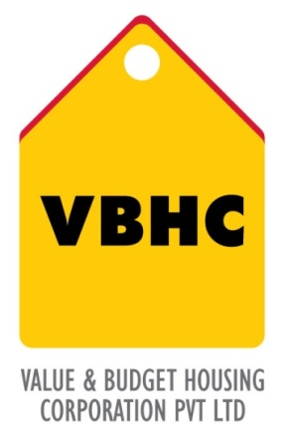
Document Control No : VBHC/PMC/P/03
Department : PMC
Revision No : Rev 1.0

 | Name/Designation | Signature | Date
Written By | Shivaprasad
Reviewed By | Kumar GVS

HISTORY OF REVISIONS

Revision No. | Revision Date | Chapter/clause no.  & text affected | Reason for Revision

TABLE OF CONTENTS

SL No. | CONTENTS | PAGE NO.
1. | Purpose | 1
2. | Process Trigger | 1
3. | Scope and Application | 1
4. | Process Owner  5. | 1
5. | Successor and Predecessor | 1
6. | Responsibilities & Authorities | 1
7. | Definitions and Abbreviations | 1
8. | Process Flow Chart | 2
9. | Process Description | 2
10. | Efficiency measures and effectiveness measures | 3
11. | Risk associated with the process | 3
12. | Formats for maintaining records | 3
13. | Records | 3
14. | Annexure 1 | 4
UPDATE CONSTRUCTION SCHEDULE

- PURPOSE
To update and track the progress with respect to the PMS

- PROCESS TRIGGER
This process is triggered when project master schedule is approved.

- SCOPE AND APPLICATION
Identification of possible Challenges; providing mitigation plan; plan parallel and independent activities to minimize lags in the project; identification of critical path

- PROCESS OWNER
PMC - Head.

- PREDECESSOR AND SUCCESSOR PROCESSES
Predecessor Process :Pre Con and Construction Monitoring (P27,PMC)
Successor Process : Pre Con and Construction Monitoring (P27,PMC), Site Coordination (P29,PMC)

- RESPONSIBILITY AND AUTHORITY
To update construction schedule: PM - Manager.

- DEFINITIONS & ABBREVIATIONS
PMS: Project Master Schedule.
PMC: Project Management.

- PROCESS FLOW CHART
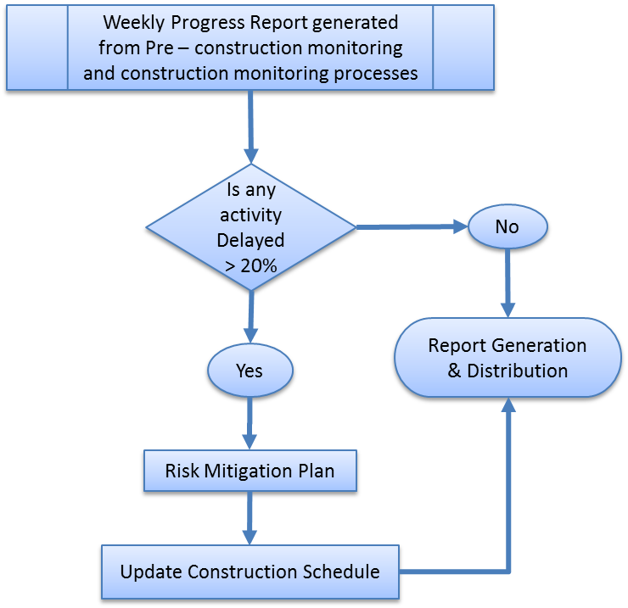

- PROCESS DESCRIPTION
  - The Weekly progress report generated and published weekly in the process Pre – construction and construction monitoring, is a source for tracking delay.
  - The delay is calculated based on actual % upon planned %. It is indicatively reported in the Weekly Progress report with the use of different colours.
  - If the delay is less than the allowable limit (20% - activity wise), the percentages are highlighted in yellow. If the delay is more than 20%, the percentages are highlighted in red. If actual % is equal to planned %, it is highlighted in green. If for a block, the work is on hold, it is highlighted in blue.
  - If delay is less than allowable limit (20% - activity wise), the construction schedule remains unchanged.
  - Risk Mitigation Plan: If delay is greater than allowable limit, the delay is analyzed and risk mitigation plan is reported in the Weekly Progress report itself.
  - Update Construction Schedule: In cases of delay, the construction schedule is updated on Microsoft Project (MSP) tool as per the risk mitigation plan. The projected dates for the activities are anticipated.
  - Report generation & distribution: The MSP is uploaded on the server.

- EFFECIENCY MEASURES AND EFFECTIVENESS MEASURES
Efficiency Measures: Number of days taken to update the schedule from the time 20% delay is established
Effectiveness Measures:

- RISK ASSOCIATED WITH THE PROCESS
Failure to update the schedule may affect other planning processes making resource deployment ineffective

- FORMATS FOR MAINTAINING RECORDS GENERATED IN THE PROCESS
Project Master Schedule format

- RECORDS
Updated Schedule ( MSP file )

ANNEXURE I
Name of Format | Code
Weekly Progress Report | VBHC/PMC/F/04

