RECORD CONTROL

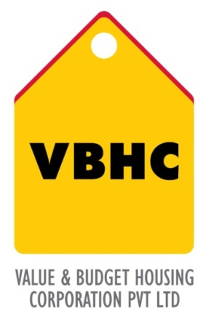
Document Control No : VBHC/QMS/P/03
Revision No : Rev 1.1
Date of Revision : 31st August 2023

 | Name/Designation | Signature | Date
Written By | Ramesh
Reviewed By | Nagesh
Approved By | Kumar GVS

HISTORY OF REVISIONS

Revision No. | Revision Date | Chapter/clause no.  & text affected | Reason for Revision

TABLE OF CONTENTS
SL No. | CONTENTS | PAGE NO.
1. | Purpose | 1
2. | Process Trigger | 1
3. | Scope and Application | 1
4. | Process Owner  5. | 1
5. | Successor and Predecessor | 1
6. | Responsibilities & Authorities | 1
7. | Definitions and Abbreviations | 2
8. | Process Flow Chart | 3
9. | Process Description | 4
10. | Efficiency measures and effectiveness measures | 5
11. | Risk associated with the process | 5
12. | Formats for maintaining records | 5
13. | Records | 5
14 | Annexure I | 6

RECORD CONTROL

- PURPOSE
To establish record control system that includes preparation, review, approval, issue, distribution control of formats and system to ensure that records are maintained in legible, readily identifiable, retrievable, properly stored and protected from damage, and retention & disposal of records

- PROCESS TRIGGER
This process triggers when a new record is generated.

- SCOPE AND APPLICATION
This procedure is applicable to all functions in VBHC as per the scope specified in Quality Management System Manual.

- PROCESS OWNER
Department Head/Functional Head

- PREDECESSOR AND SUCCESSOR PROCESSES
Predecessor Process: None
Successor Process: All processes of VBHC QMS

- RESPONSIBILITY AND AUTHORITY
Management Representative:
MR has the authority to identify records that are required to demonstrate compliance to the Quality Management System requirements.
Process owner:
All process owners are authorized and responsible for identifying, maintaining and disposal of records pertaining to their area of activities in consultation with MR.
- DEFINITIONS & ABBREVIATIONS
- MR : Management Representative
- QMS : Quality Management System
- FORMAT : A format is a document, designed with appropriate provisions to enter the relevant process monitoring and/or measurement results and signature for checker/approving authority to demonstrate the objective evidence for process monitored and/or as measured.
- RECORD : Record is a special type of document, which shows the objective evidence for process performed, i.e. monitoring, measurement, inspection and test results etc.

- PROCESS FLOW CHART
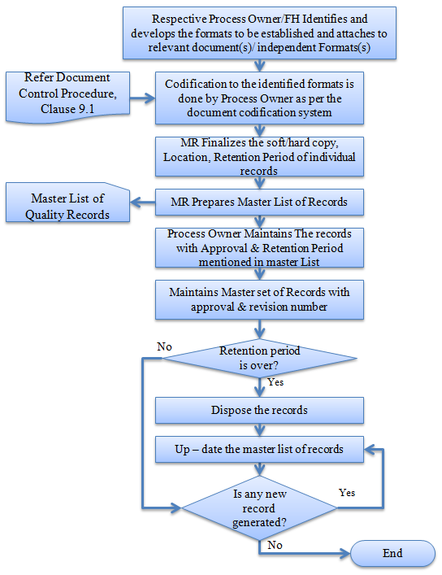
- PROCESS DESCRIPTION
VBHC's quality management system details the identification, storage, protection, retrieval, retention and disposition of records, including pertinent subcontractor records, through documented procedures. Records are readily available and identifiable to the product or processes involved and are protected against damage, loss, and deterioration. Retention times of Quality Records are documented within individual procedures.
  - Control of records
Respective process owners / functional heads shall establish and maintain records as detailed in the respective quality system procedure. Records established and maintained should provide evidence of conformity to requirements of and effective operation of the quality management system. Following controls should be applied:
- Identification: Each record should be identified as per clause no. 9.3 of procedure for control of documents.
- Storage: Medium of storage of information (Hard copy or in electronic media) that should be appropriate to its distribution needs, frequency of retrieval, regulatory requirements and company policy is decided by the process owner, with approval of MR.
- Protection: Records should be preserved to ensure protection against access (to information) and damage / loss of data. For example, it can be filed in a Box file and stored in a secured place.
- Retrieval: To ensure speedy retrieval of information, the custodian may have ready reckoner to know where the records are stored and preserved.
- Retention time: Time duration up to which records are kept should be decided taking in to consideration requirements for Analysis of data (frequency), Audit requirements, Statutory and regulatory requirements. This shall be as shown in the approved process documents.
- Disposition (of record): Method followed to dispose the record should ensure that the confidentiality is maintained or information is not made public which otherwise may affect the business interest of the organization. For example, after retention period, records may be kept in records room for 2 years and then shredded OR soon after the retention time, they are shredded to avoid its unintended use.
  - Control of records (data) in electronic media
Originator of documents shall ensure that necessary checks and controls have been established to approve, incorporate changes and re-approve by provisioning of password protection for the specific fields. Originator shall ensure that back up of data is taken on any update made to preserve and protect the data.
- EFFECIENCY MEASURES AND EFFECTIVENESS MEASURES
Efficiency Measures:
Effectiveness Measures:
- RISK ASSOCIATED WITH THE PROCESS

- FORMATS FOR MAINTAINING RECORDS GENERATED IN THE PROCESS
Master List of Records
- RECORDS
Master List of Records & Master List of Documents – 1 year / Till Project Completion

ANNEXURE I
Name of Format | Code
Master List of Records | VBHC/QMS/F/04

