ITP METHODOLOGY

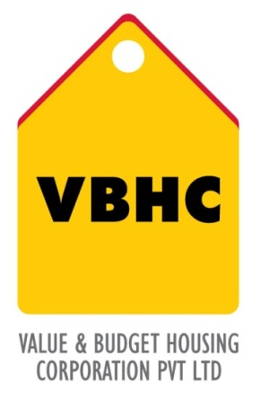
Document Control No : VBHC/QUA/P/03
Revision No : Rev 1.1
Date of Revision : 31st August 2023
 | Name/Designation | Signature | Date
Written By | Rakshith
Reviewed By | Shivaprasad

HISTORY OF REVISIONS

Revision No. | Revision Date | Chapter/clause no.  & text affected | Reason for Revision

TABLE OF CONTENTS
SL No. | CONTENTS | PAGE NO.
1. | Purpose | 1
2. | Process Trigger | 1
3. | Scope and Application | 1
4. | Process Owner  5. | 1
5. | Successor and Predecessor | 1
6. | Responsibilities & Authorities | 1
7. | Definitions and Abbreviations | 2
8. | Process Flow Chart | 2
9. | Process Description | 3
10. | Efficiency measures and effectiveness measures | 4
11. | Risk associated with the process | 4
12. | Formats for maintaining records | 4
13. | Records | 4
14 | Annexure I | 4

ITP METHODOLOGY

- PURPOSE
The purpose of an Inspection and Test Plan is to put together in a single document that records all inspection and testing requirements relevant to a specific process, verifying conformity with specified contractual requirement

- PROCESS TRIGGER
None

- SCOPE AND APPLICATION
Applies to all items of work

- PROCESS OWNER
Asst. Manager – Quality

- PREDECESSOR AND SUCCESSOR PROCESSES
Predecessor Process : None
Successor Process : Construction

- RESPONSIBILITY AND AUTHORITY
Developing ITP : Asst. Manager – Quality
Approval of ITP’s : Construction Head

- DEFINITIONS & ABBREVIATIONS
- ITP : Inspection and Test Plan
- Hold Point : ‘hold’ point defines a point beyond which work may not proceed without the authorization of a designated service provider or authority.
- Witness Point : ‘witness’ point provides a party (such as the customer, service provider and a regulatory authority) with the opportunity to witness the inspection or test or aspect of the work, at their discretion.

- PROCESS FLOW CHART

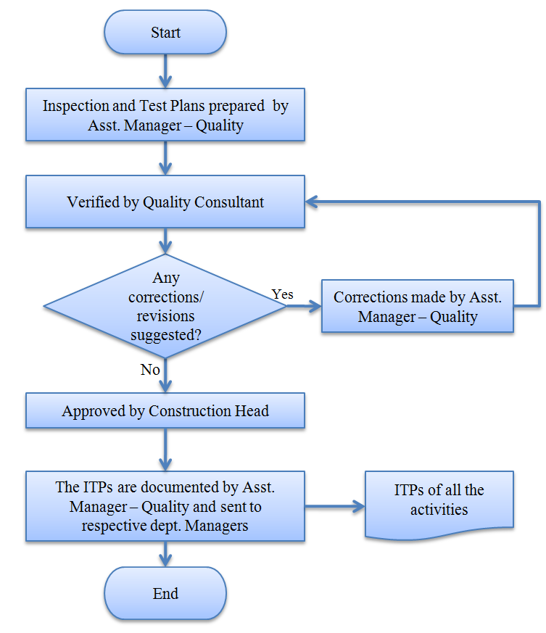

- PROCESS DESCRIPTION
  - A list of materials that need to be covered by ITP is drawn.
  - ITP is listing the sequence of activities, and shall include a minimum of the following:
- All examinations, inspections and tests to be performed with reference to all important characteristics of the materials.
- Items of materials to be inspected or tested, by whom and at what stage or frequency.
- Witness point and Hold point
- References to relevant standards and the acceptance criteria
- Format of the records to be maintained.
  - Asst. Manager – Quality prepares each Inspection and Test Plan to reflect the requirements of the contract documents and send for review to Quality Consultant and the recommendations are suitably incorporated in the ITP.
  - The finalized ITP’s are approved by Construction Head
  - The ITPs are documented by Asst. Manager – Quality and an authorized copy (hard) is sent to Quality consultant & Site Incharge.
  - In case of repeated/frequent defects/NCs in any item of work, the ITP is reviewed for its continued effectiveness and amended if required.
- EFFECIENCY MEASURES AND EFFECTIVENESS MEASURES
Efficiency Measures:
Number of materials included in ITP out of required number to be covered.
Effectiveness Measures:
Quality of completed works
ITP in compliance with IS standards
- RISK ASSOCIATED WITH THE PROCESS
Lack of ITP’s affects the overall quality of the product, Increases reworks which in turn increases the cost of construction.
- FORMATS FOR MAINTAINING RECORDS GENERATED IN THE PROCESS
List of materials covered in ITP
- RECORDS
Quality Assurance Plan – (ITPs of all the Materials are included in Quality Assurance Plan)
ANNEXURE I
Name of Format | Code
List of materials covered in ITP | VBHC/QUA/F/32
ITP : for concrete including RMC | VBHC/QUA/F/01
ITP : for steel or wire mesh | VBHC/QUA/F/02
ITP : for door frames, composite shutters & flushed doors | VBHC/QUA/F/03

