**PROJECT SALES**

**Document Control No** : VBHC/S&M/P/03

**Revision No**  : Rev 1.1

**Date of Revision** : 1st April 23

|  |  |  |  |
| --- | --- | --- | --- |
|  | ***Name/Designation*** | ***Signature*** | ***Date*** |
| ***Written By*** | ***Rajeesh MR*** |  |  |
| ***Reviewed By*** | ***Siddharth Gautam*** |  |  |
|  |  |  |  |

**HISTORY OF REVISIONS**

|  |  |  |  |
| --- | --- | --- | --- |
| **Revision No.** | **Revision Date** | **Chapter/clause no.**  **& text affected** | **Reason for Revision** |
|  |  |  |  |
|  |  |  |  |
|  |  |  |  |
|  |  |  |  |
|  |  |  |  |
|  |  |  |  |
|  |  |  |  |
|  |  |  |  |
|  |  |  |  |
|  |  |  |  |
|  |  |  |  |
|  |  |  |  |
|  |  |  |  |
|  |  |  |  |
|  |  |  |  |

**TABLE OF CONTENTS**

|  |  |  |
| --- | --- | --- |
| **SL No.** | **CONTENTS** | **PAGE NO.** |
| 1. | Purpose | 1 |
| 2. | Process Trigger | 1 |
| 3. | Scope and Application | 1 |
| 4. | Process Owner  5. | 1 |
| 5. | Successor and Predecessor | 1 |
| 6. | Responsibilities & Authorities | 1 |
| 7. | Definitions and Abbreviations | 2 |
| 8. | Process Flow Chart | 2 |
| 9. | Process Description | 2 |
| 10. | Efficiency measures and effectiveness measures | 3 |
| 11. | Risk associated with the process | 4 |
| 12. | Formats for maintaining records | 4 |
| 13. | Records | 4 |
| 14 | Annexure I | 5 |

**PROJECT SALES**

1. **PURPOSE**

To conduct a detailed procedure from generation of leads till booking takes place in order to promote sales.

1. **PROCESS TRIGGER**

The process is triggered when leads are generated.

1. **SCOPE AND APPLICATION**

All VBHC projects

1. **PROCESS OWNER**

Marketing Head

1. **PREDECESSOR AND SUCCESSOR PROCESSES**

Predecessor: Obtain pre con approvals (, L), Securing Project Finance (FIN)

Successor: CRM Department

1. **RESPONSIBILITY AND AUTHORITY**

All activities are carried out by the Sales and Marketing Team

1. **DEFINITIONS & ABBREVIATIONS**

CPA - Cost per Acquisition

CPL - Cost per Lead

1. **PROCESS FLOW CHART**

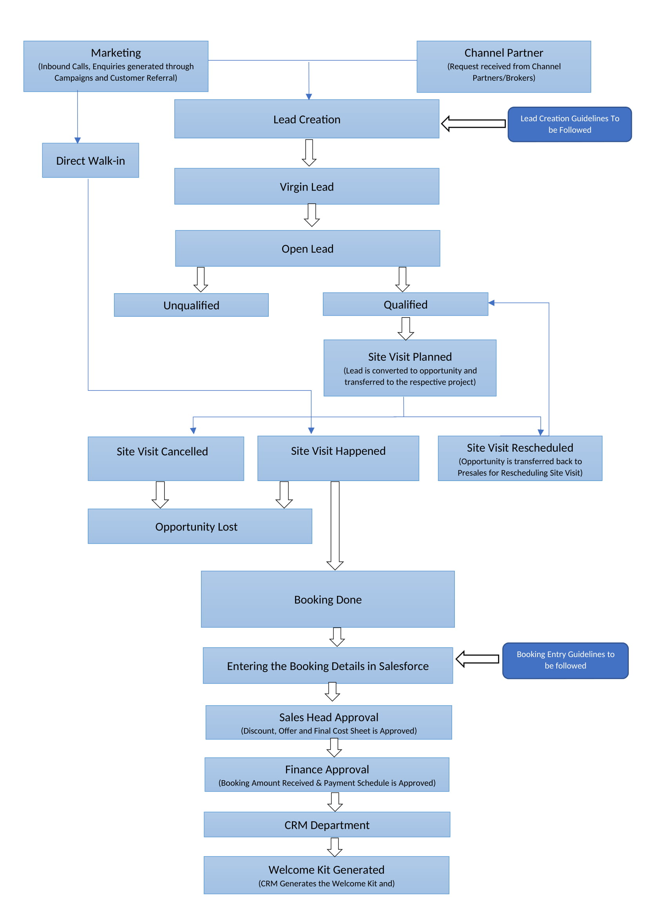

1. **PROCESS DESCRIPTION:**
2. Enquiries received from Portals, Marketing Campaigns, Channel Partner & Customers Referrals are created in Salesforce.
3. Once the Leads are created in the Salesforce. The Presales department initiates the calling on the Virgin Leads based on the response the leads get classified into Open, Qualified and Unqualified Stage
4. Open Leads-There should be a minimum of 8 calling attempts made before unqualifying an open lead( 2 attempts should be made on day 1 and day 2 of receiving the lead and remaining 4 attempts should be done on next 4 days with 1 attempt each day.).
5. The Qualified leads are been followed up and Site Visits are fixed, In the Site Visit planned stage lead is converted into opportunity and must be transferred to the Sales Team in the respective projects.
6. Based on the Site Visit Status the following actions are taken

* Site Visit Cancelled- Opportunity must be marked as lost if the customer cancels the Site Visit and mentions that he is no longer interested in the project.
* Site Visit Re-Scheduled- Opportunity must be transferred back to respective Presales agent.
* Site Visit Happened- The Feedback is collected by the Salesperson in the Enquiry Form and the details of the visit must be updated in the Salesforce and the opportunity is moved to Site Visit Done Stage.

1. Upon Site Visit completion based on the follow ups made the opportunity must be moved to either Booking Closure or Opportunity Lost Stage
2. Bookings must be entered into Salesforce within 48 hours. (Check List to be followed by Salesperson is mentioned).
3. Approval on Discount, Cost Sheet and Offer must be given by the Sales Head. Post approval the Booking is forwarded to Finance Department for approval.
4. Finance Department verifies the payment received towards the booking, Apartment Cost and Closes the booking. Post Approval the Booking is forwarded to CRM Department.
5. CRM Department based on the details mentioned in the Salesforce will generate a Welcome Kit which will be sent to the customer.

**Lead Creation Guidelines:**

The leads are either automatically created in Salesforce through Campaigns on Facebook, Google, Corporate Website & Other Online Portals, etc. or Manually created for Channel Partner, Customer Referrals and Enquiries generated from Offline activities. The below mentioned process must be followed for creating leads under Customer Referral, Channel Partner and Manual creation.

Channel Partner-

* The Channel Manager must send a request to Pre-Sales team to create a lead, the request should contain the Channel Partner Name, Customer Name, Mobile No & Email Id.
* The Presales team to create the lead and share the enquiry no with the respective channel manager for future references.

Customer Referral-

The Salesperson must send a request to Pre-Sales team to create a lead, the request should contain the Referred Customer Name, Mobile No, Email Id, Existing customer name, project and the apartment no. The Salesperson should also attach or forward the referral request mail received from the existing customer.

**Lead Duplication:**

* Any lead created in a source of awareness, irrespective of the current lead status will have the complete Merit/Claim/Right for next 90 days from the date of creation.
* In case of post office hours, wherein the channel partner has sent a request to register a lead. Meanwhile, if we have also directly received the same lead through the marketing campaigns into Salesforce. The Merit/Claim/Right of the lead will be decided based on the lead registration request mail time versus marketing lead creation time in Salesforce whichever is earlier.

**Booking Entry Checklist:**

1. Signed Application Form (All details to be filled, if applicable offer details to be mentioned)
2. PAN Card and Aadhar Card to be uploaded
3. Price Acknowledgement or Signed Cost Sheet to be uploaded
4. Customer’s DOB, Company Name, Designation, Current Address and Pin code must be compulsorily mentioned in the Salesforce
5. **EFFECIENCY MEASURES AND EFFECTIVENESS MEASURES**

Efficiency Measures:

* Monitor Lead Source versus Sales Conversion

Effectiveness Measures:

* Increase in Sales
* Decrease in CPL/CPA
* Number of interested customers/ total numbers visited project sites

1. **RISK ASSOCIATED WITH THE PROCESS**

If leads are not converted, there will be reduction in sales, which in turn does not provide the company with the necessary ROI.

1. **FORMATS FOR MAINTAINING RECORDS GENERATED IN THE PROCESS**

* Enquiry Form
* Application Forms

1. **RECORDS**

**ANNEXURE I.**

|  |  |
| --- | --- |
| **Name of Format** | **Code** |
| Application Form | VBHC/S&M/F/03 |
| Enquiry Form | VBHC/S&M/F/04 |
|  |  |