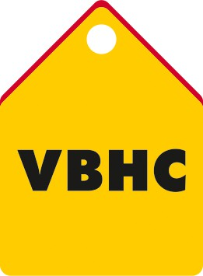USER & ACCESS MANAGEMENT

**Document Control No** : VBHC/IT/P/04

**Revision No** : Rev 2.1

**Date of Revision** : 23rd August 2023

|  |  |  |  |
| --- | --- | --- | --- |
|  | ***Name/Designation*** | ***Signature*** | ***Date*** |
| ***Written By*** | ***Kannan K R (AVP IT)*** |  |  |
| ***Reviewed By*** | ***Venkatesh Katta (IT Consultant)*** |  |  |
|  |  |  |  |

**Value and Budget Housing Corporation Pvt. Ltd. 74 & 75, Millers Road**

**Vasanth Nagar, Near Vikram Hospital Bangalore - 560052 | Karnataka**

|  |  |  |  |
| --- | --- | --- | --- |
| STANDARD OPERATING PROCEDURE | | | |
| Value and Budget Housing Corporation Pvt Ltd | USER AND ACCESS MANAGEMENT | DOC.NO: VBHC/IT/P/04 |  |

**HISTORY OF REVISIONS**

|  |  |  |  |
| --- | --- | --- | --- |
| **Revision No.** | **Revision Date** | **Chapter/clause no.** | **Reason for Revision** |
|  |  |  |  |
|  |  |  |  |
|  |  |  |  |
|  |  |  |  |
|  |  |  |  |
|  |  |  |  |
|  |  |  |  |
|  |  |  |  |
|  |  |  |  |
|  |  |  |  |
|  |  |  |  |
|  |  |  |  |
|  |  |  |  |
|  |  |  |  |
|  |  |  |  |

**TABLE OF CONTENTS**

|  |  |  |
| --- | --- | --- |
| **SL No.** | **CONTENTS** | **PAGE NO.** |
| 1. | Purpose | 4 |
| 2. | Process Trigger | 4 |
| 3. | Scope and Application | 4 |
| 4. | Process Owner | 4 |
| 5. | Successor and Predecessor | 4 |
| 6. | Responsibilities & Authorities | 4 |
| 7. | Definitions and Abbreviations | 4 |
| 8. | Process Flow Chart | 5 |
| 9. | Process Description | 6,7 |
| 10. | Efficiency measures and effectiveness measures | 7 |
| 11. | Risk associated with the process | 7 |
| 12. | Records | 7 |
|  |  |  |

**USER & ACCESS MANAGEMENT**

# PURPOSE

To control access to Network and Applications, and provision of email access to employees

# PROCESS TRIGGER

The process is triggered when any of the following occurs:

* Intimation from HR that a new employee has joined VBHC
* The manager of a current employee requests for additional/new access to be granted

# SCOPE AND APPLICATION

This process is applicable to all employees of VBHC.

# PROCESS OWNER

IT Infra Lead

# PREDECESSOR AND SUCCESSOR PROCESSES

Predecessor Process: Successor Process:

# RESPONSIBILITY AND AUTHORITY

To approve application or network access – Respective Dept Head To approve new user – HR Manager

# DEFINITIONS & ABBREVIATIONS

1. IT : Information Technology
2. HR : Human Resource
3. PW : Password
4. EPM : Enterprise Project Management

# PROCESS FLOW CHART

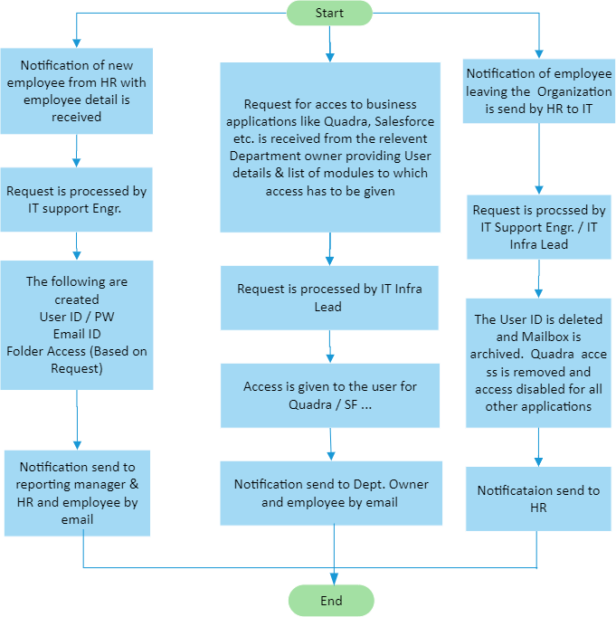

1. **PROCESS DESCRIPTION**

## New User creation for Domain, Mailbox, Quadra, Salesforce, Vault and File-Server Access

* + 1. Notification of new Employee from HR with the following details is received by IT:
       - Full Name
       - Employee code
       - Department
       - Designation
       - Reporting manager
       - Mobile number (optional)
    2. The request is processed by the IT Support Engineer and the User ID, Email ID are communicated to the HR and reporting manager. Appropriate access levels (predefined for new users and can be discretionary as per job roles) are given to the created User ID.

## New User creation for Quadra access

* + 1. Request is forwarded by the relevant Department Owner with the following details:
       - Employee Code
       - Employee Name
       - Quadra Modules to which access is needed based on his / her role.
       - Salesforce – CRM system to which access is needed based on his / her role
    2. The request is processed by the IT Support Engineer and the originator of the request along with the Employee are notified.

## New User creation for Salesforce access

* + 1. Request is forwarded by the relevant Department Owner with the following details to IT:
       - Employee Code
       - Employee Name
       - Functions to which access is needed or the Role and whether Read Only or Edit access needed
    2. The request is processed by the IT Support Engineer and the originator of the request along with the Employee are notified

## Removal of User from Domain on exit from VBHC

* + 1. Notification of Employee leaving the company (along with date of exit) is given by HR to IT
    2. The User ID is deleted, and the Mailbox archived for 60 days and then deleted.

## Disabling of access on Quadra, Salesforce and Fileserver

* + 1. Request is forwarded by the relevant Department Owner with the following details to IT:
       - Employee Code
       - Employee Name
    2. The access is removed from the User ID and the originator of the request along with the Employee is notified,

# EFFECIENCY MEASURES AND EFFECTIVENESS MEASURES

Efficiency Measures: Average TAT for resolution Effectiveness Measures:

# RISK ASSOCIATED WITH THE PROCESS

Delay in resolution could impact productivity Delay in resolution could impact data security

# RECORDS

Email from HR or concerned department request