MASTER PLAN
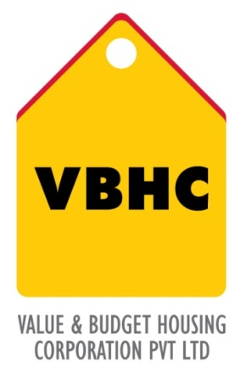

Document Control No : VBHC/DES/ /04
Revision No :
Date of Revision :

TYPE | PROPOSED PRODUCT MIX (SFT) | ACHIEVED PRODUCT MIX (SFT) | RERA CARPET AREA (SFT)

NOTE: Increase in saleable area of 2BHK Unit is due to request from sales team to increase the balcony size -905.34 sft
Departments | Signature | Date
Design
MEP
Sales/Marketing
Operations

HISTORY OF REVISION S
Revision No. | Revision Date | Drawing Number | Reason for Revision

TABLE OF CONTENTS
SL No. | CONTENTS
1. | Purpose
2. | Process Trigger
3. | Scope and Application
4. | Process Owner  5.
5. | Successor and Predecessor
6. | Responsibilities & Authorities
7. | Definitions and Abbreviations
8. | Process Flow Chart
9. | Process Description
10. | Efficiency measures and effectiveness measures
11. | Risk associated with the process
12. | Formats for maintaining records
13. | Records
14. | Annexure I

MASTER PLAN

- PURPOSE
Finalize Site-Plan and Project configuration for a given parcel of land.

- PROCESS TRIGGER
This process is triggered once the land is purchased and consultants are appointed.
- SCOPE AND APPLICATION
Applicable to all Land parcels purchased by VBHC

4.0 PROCESS OWNER
Design Head
- PREDECESSOR AND SUCCESSOR PROCESSES
Predecessor Process: Appointment of Consultants, Detailed tech due diligence
Successor Process: Sanction Drawings, Project Master Schedule

- RESPONSIBILITY AND AUTHORITY
- Lead Architect Responsible for Master plan
- Service heads responsible for respective service inputs
- Technical sign-off from Design Head
- Final signoff by the Marketing Head and Operations Head

- DEFINITIONS & ABBREVIATIONS
- STP-Sewage Treatment Plant
- RBH – Regional Business Head
- SFT – Square Feet
- FGL – Finish Ground Level

- PROCESS FLOW CHART

- PROCESS DESCRIPTION
  - Master planning process starts after all necessary surveys are done and the RBH confirms the Massing option which suits the design brief the best
  - Architectural Master plan is done by arrangement of blocks and allocating space for Service components
  - Area statement is prepared for the Proposed master plan
  - Once the Architectural Components are in place the master plan is reviewed to finalize the Road, FGL, STP, structure and any other plumbing or electrical requirements
  - The Master plan and area statements are updated after the review
  - The Master plan along with Ball Park estimation is sent for approval of the RBH

- EFFECIENCY MEASURES AND EFFECTIVENESS MEASURES
Efficiency Measures:
- Time taken to finalize the master plan
Effectiveness Measures:
- FSI achieved
- Cost/sqft of the proposed option

- RISK ASSOCIATED WITH THE PROCESS
There's a very high likelihood that the Massing Layout (done at the feasibility stage) will have to be reworked during the Master-Planning phase due to Changed Boundaries, immovable features on the site and drain points (revealed by the Infra-Survey).

- FORMATS FOR MAINTAINING RECORDS GENERATED IN THE PROCESS
- Area statements

- RECORDS
i. Unit plans -
ii. Masterplan -
iii. Area statement -

