FINANCIAL REPORTING

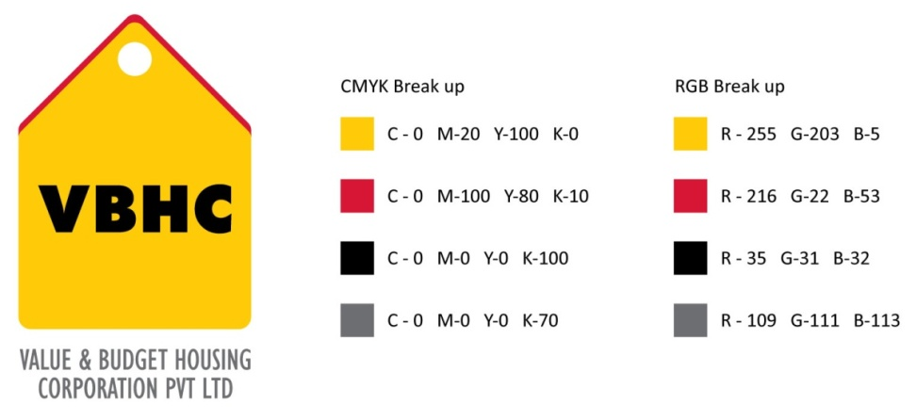
Document Control No : VBHC/FIN/P/04
Revision No : Rev 1.0
Date of Revision : 31st August 2013

 | Name/Designation | Signature | Date
Written By
Reviewed By
Approved By

HISTORY OF REVISIONS

Revision No. | Revision Date | Chapter/clause no.  & text affected | Reason for Revision

TABLE OF CONTENTS
SL No. | CONTENTS | PAGE NO.
1. | Purpose | 1
2. | Process Trigger | 1
3. | Scope and Application | 1
4. | Process Owner  5. | 1
5. | Successor and Predecessor | 1
6. | Responsibilities & Authorities | 1
7. | Definitions and Abbreviations | 2
8. | Process Flow Chart | 2
9. | Process Description | 3
10. | Efficiency measures and effectiveness measures | 4
11. | Risk associated with the process | 4
12. | Formats for maintaining records | 4
13. | Records | 4
14. | Annexure 1 | 5

FINANCIAL REPORTING

- PURPOSE
To present the financial data , operating performance and cash flows for an accounting period.

- PROCESS TRIGGER
The process is triggered when the need for presenting the financial reports occurs.( Annually, quarterly and monthly ( investor specific ) )

- SCOPE AND APPLICATION
All financial reporting carried out by the company.
This is carried out before every annual and quarterly board meeting , as well as investor specific meetings.

4.0 PROCESS OWNER
Finance – Head / Controller
- PREDECESSOR AND SUCCESSOR PROCESSES
Predecessor Process:
Successor Process: Corporate Level Compliance

- RESPONSIBILITY AND AUTHORITY
Preparation of financial reports: Finance department
Review and Correction: Finance head

- DEFINITIONS & ABBREVIATIONS

- PROCESS FLOW CHART
For annual meeting and quarterly meeting
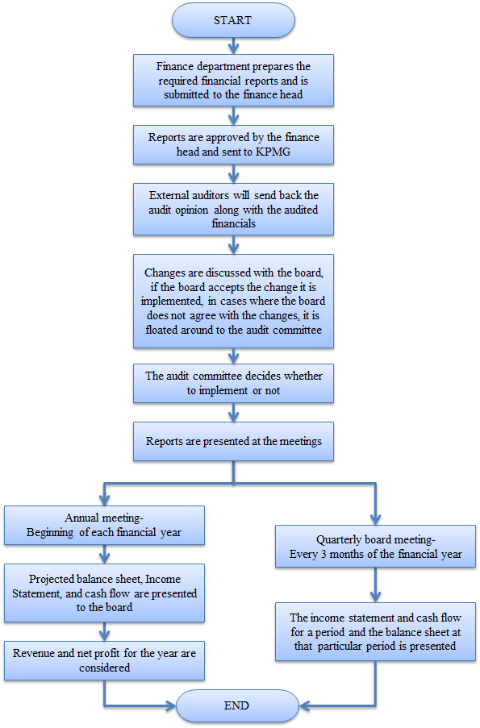

For investor specific meeting
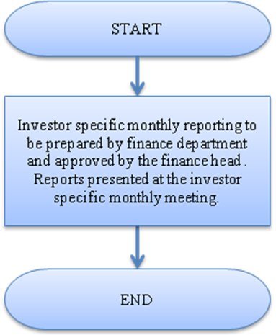

- PROCESS DESCRIPTION
For annual meeting and quarterly meeting
- The required financial statements (depending in which meeting to be presented at ) are prepared by the financial department and are submitted to the finance head. For quarterly meetings, a consolidated report is presented, whereas for annual meetings, entity and consolidated reports are presented.
- The finance head approves the reports for board presentation and are sent to the external auditor KPMG.
- Auditors will send back the audit opinion along with the audited financials.
- If there are any changes, it is discussed with the board. If the impact of the change is agreeable to, it is implemented. If the change impacts the financials, then the change is floated to the audit committee.
- The audit company can decide whether to implement the change or not.
There are two meetings conducted during which the financial reports are being presented:

9.4 Annual meeting: This happens at the beginning of each financial year. The projected balance sheet, income statement and cash flow statement are presented to the board. The revenue and net profit for the year are considered.
9.5 Quarterly board meeting: This meeting is conducted every 3 months of the financial year. The income statement and the cash flow statement for a period and the balance sheet at that particular period is presented to the board.

For investor specific meeting
9.6 Every month the investor specific reports are prepared by the finance department and approved by the finance head. These reports are presented at the investor specific meetings held on a monthly basis.

- EFFECTIVENESS AND EFFICIENCY MEASURES
Efficiency Measures: Time Based: Number of reports approved within n days of quarter/year ending
Effectiveness Measures:

- RISK ASSOCIATED WITH THE PROCESS

- FORMATS FOR MAINTAINING RECORDS GENERATED IN THE PROCESS
Balance Sheet
Profit and Loss Statement
Cash Flow Statement

- RECORDS

ANNEXURE I
Name of Format | Code
Balance Sheet | VBHC/FIN/F/01
Profit and Loss Statement | VBHC/FIN/F/02
Cash Flow Statement | VBHC/FIN/F/03

