SALARY AND WAGE ADMINSTRATION

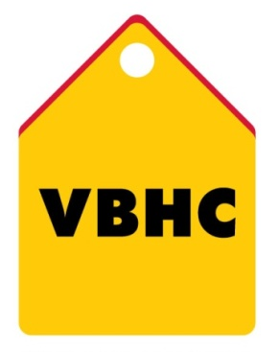
Document Control No : VBHC/HR/P/04
Revision No : Rev 1.1
Date of Revision : 01st April 2023

 | Name/Designation | Signature | Date
Written By | Shashidhar Rao
Reviewed By | Kumar GVS

HISTORY OF REVISIONS

Revision No. | Revision Date | Chapter/clause no.  & text affected | Reason for Revision

TABLE OF CONTENTS
SL No. | CONTENTS | PAGE NO.
1. | Purpose | 1
2. | Process Trigger | 1
3. | Scope and Application | 1
4. | Process Owner  5. | 1
5. | Successor and Predecessor | 1
6. | Responsibilities & Authorities | 1
7. | Definitions and Abbreviations | 1
8. | Process Description | 2
9. | Efficiency measures and effectiveness measures | 2
10. | Risk associated with the process | 3
11. | Formats for maintaining records | 3
12. | Records | 3
13. | Annexure I | 3

SALARY AND WAGE ADMINISTRATION
- PURPOSE
To establish a process for Salary and Wage Administration to develop, implement and maintain a Pay system.
- PROCESS TRIGGER
This is an ongoing process of managing a wage and salary structure.
- SCOPE AND APPLICATION
It is applicable to all the employees at VBHC.
- PROCESS OWNER
HR – Head & Manager
- PREDECESSOR AND SUCCESSOR PROCESSES
Predecessor Process: None
Successor Process: None
- RESPONSIBILITY AND AUTHORITY
Authorization of salary transfer is by : HR Head
Appointment of Payroll processing software appointed : TOP Management
- DEFINITIONS & ABBREVIATIONS
- HR : Human Resource dept.
- HR Head : HR Head
- LOP : Loss of Pay

- PROCESS DESCRIPTION
  - Payroll is processed in HRMS software ZINGHR and software was Approved by TOP Management.
  - Pay roll software consists of the following employee data from Zinghr HRMS:
- No of employees and employee details (entered in Zinghr by HR dept. at the time of joining of each employee).
  - Salary input information is given by HR team to HR Manager (for ex: hold LOP of the employee, Salary Advance Recovery etc.,)
  - HR Manager in the 4th week of every month incorporates the salary details in salary register generated from the software and send it to HR – Head for approval.
  - The salary registers is reviewed by HR Head and if any changes are recommended, then the salary register is sent back to HR team for revisions and step 8.3 and 8.4 are followed again.
  - Once all the revisions are done, intimation is given to Finance dept by HR Manager for Salary Fund transfers through email with entity wise salary payout amount.
  - HR Manager uploads the salary directly in the bank portal and sends the mail to concerned team for salary authorization on salary payouts. Pay slip is generated automatically in HRMS after 3 days of salary transfer and employee can retrieve it at any time.

- EFFECIENCY MEASURES AND EFFECTIVENESS MEASURES
Efficiency Measures: No of month’s employee salary disbursed by last working day of the month
Effectiveness Measures: Average No of errors in salary disbursements as a % of employee count

- RISK ASSOCIATED WITH THE PROCESS

- FORMATS FOR MAINTAINING RECORDS GENERATED IN THE PROCESS
Salary Register
Final pay out (Generated in HRMS)

- RECORDS

ANNEXURE I
Name of Format | Code
Salary Register | Generated & Available in HRMS

