APPROVALS FOR OCCUPANCY

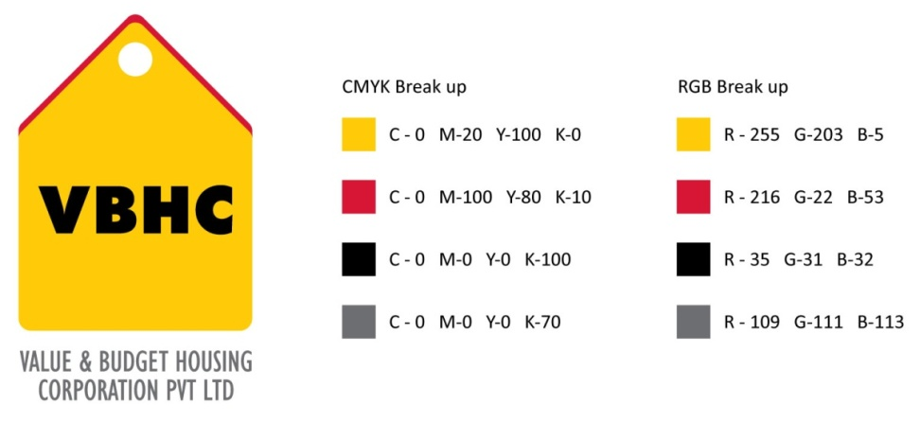
Document Control No : VBHC/L&A/P/04

Revision No : Rev1.1

Date of Revision : 31st August 2023

 | Name/Designation | Signature | Date
Written By | Royal Reddy
Reviewed By | Kumar GVS

HISTORY OF REVISIONS

Revision No. | Revision Date | Chapter/clause no.  & text affected | Reason for Revision

TABLE OF CONTENTS
SL No. | CONTENTS | PAGE NO.
1. | Purpose | 1
2. | Process Trigger | 1
3. | Scope and Application | 1
4. | Process Owner  5. | 1
5. | Successor and Predecessor | 1
6. | Responsibilities & Authorities | 1
7. | Definitions and Abbreviations | 1
8. | Process Flow Chart | 2
9. | Process Description | 3
10. | Efficiency measures and effectiveness measures | 3
11. | Risk associated with the process | 4
12. | Formats for maintaining records | 4
13. | Records | 4

APPROVALS FOR OCCUPANCY

- PURPOSE
To obtain the occupancy certificate that serves as an evidence for the completion of the project in compliance with the applicable laws.

- PROCESS TRIGGER
This process is triggered after the completion of the project.

- SCOPE AND APPLICATION
All VBHC projects.

- PROCESS OWNER
Head: Land Committee

- PREDECESSOR AND SUCCESSOR PROCESSES
Predecessor Process: Daily Construction Management (OP)
Successor Process: Property Registration ( CRM)

- RESPONSIBILITY AND AUTHORITY
Preparation of Necessary Documents to apply for Occupancy: Land Department

- DEFINITIONS & ABBREVIATIONS
STP- Sewage Treatment Plant
N.O.C- No Objection Certificate
M.O.E- Ministry of Environment
- PROCESS FLOW CHART

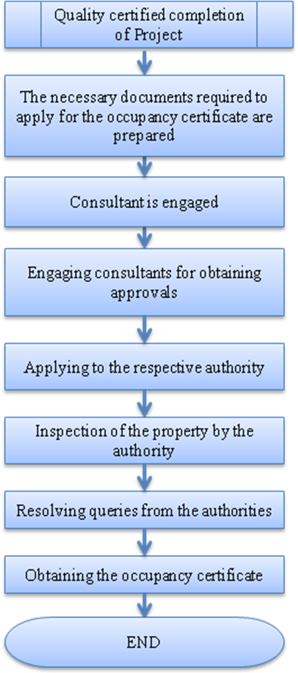

- PROCESS DESCRIPTION
  - The project should be complete in all respects such as including internal / external works, drive ways, street lights, aviation lights, installation of STP, water tank, harvesting pit, installation of lifts and their operation, common area & common toilet, external fire hydrants, fire fighting system etc before applying for Occupation Certificate.
  - A list of documents required to apply for occupancy is written. All the project specific documents are collected by PMC Head to facilitate the application for the occupation certificate :
  - Approved Building Plans,
  - Approved Service Estimate/ Plans,
  - Approval from the State Electricity Boards,
  - N.O.C of Central Groundwater Board,
  - N.O.C. of Airport authority,
  - N.O.C. From Pollution Board & M.O.E.,
  - Fire, Lifts, Gensets, S.T.P.
  - Consultants are appointed in order to assist with obtaining the certificate by the business head in consultation with the land department.
  - Approvals are applied from the authority.
  - The authority will inspect the project. The inspection is facilitated and attended by the business head and PMC head along with the respective discipline head of the project.
  - Any queries that are raised by the authority is replied and resolved by consultant in consultation with the land department.
  - Obtaining the occupancy certificate. This is informed to the top management and the head of departments. It is circulated internally by the business head and the land department.

- EFFECIENCY MEASURES AND EFFECTIVENESS MEASURES
Efficiency Measures:
- Approvals are obtained in the scheduled time (4 – 6 Months).
- Number of queries due to incomplete document submission- NIL
Effectiveness Measures:
- RISK ASSOCIATED WITH THE PROCESS
- If the occupancy certificate is not obtained, it will lead to the rise of risks later in the project.
- The project will not be provided with water or sewer connections.
- It is against the law to occupy or use a building until a Certificate of Occupancy and Use is issued

- FORMATS FOR MAINTAINING RECORDS GENERATED IN THE PROCESS
List of approvals for occupancy

- RECORDS

ANNEXURE I
Name of Format | Code
List of approvals for occupancy | VBHC/L&A/F/02

