DEMOBILIZE AND CLOSURE REPORT

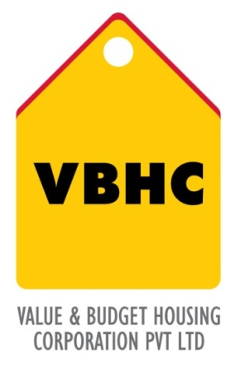
Document Control No : VBHC/OPE/P/04
Revision No : Rev 1.1
Date of Revision : 31st August 2023

 | Name/Designation | Signature | Date
Written By | Shivaprasad
Reviewed By | Kumar GVS

HISTORY OF REVISIONS

Revision No. | Revision Date | Chapter/clause no.  & text affected | Reason for Revision

TABLE OF CONTENTS
SL No. | CONTENTS | PAGE NO.
1. | Purpose | 1
2. | Process Trigger | 1
3. | Scope and Application | 1
4. | Process Owner  5. | 1
5. | Successor and Predecessor | 1
6. | Responsibilities & Authorities | 1
7. | Definitions and Abbreviations | 2
8. | Process Flow Chart | 2
9. | Process Description | 3
10. | Efficiency measures and effectiveness measures | 3
11. | Risk associated with the process | 3
12. | Formats for maintaining records | 4
13. | Records | 4

DEMOBILIZE AND CLOSURE REPORT

- PURPOSE
To Process the completing of all construction tasks and all documentation to close out contract and consider job complete.

- PROCESS TRIGGER
The process is triggered once the project construction is regarded as complete, compliance with legal laws and all applicable approvals for handover obtained and once the last handover is carried out
- SCOPE AND APPLICATION
All VBHC projects
- PROCESS OWNER
Head: Operation

- PREDECESSOR AND SUCCESSOR PROCESSES
Predecessor: Project IT Infra Setup (P48,IT) , Security (P50, Admin) , Labour Camp (P51,Admin) , Transportation (P52, Admin), Handover to Customers (P53, Admin)
Successor: End of Project

- RESPONSIBILITY AND AUTHORITY
- Approval for to start demobilization : Top Management
- Shifting of staff to another project: HR department with approval from Top management.
- All demobilization procedures : Operations Department

- DEFINITIONS & ABBREVIATIONS
- SPV : Special Purpose Vehicle

- PROCESS FLOW CHART
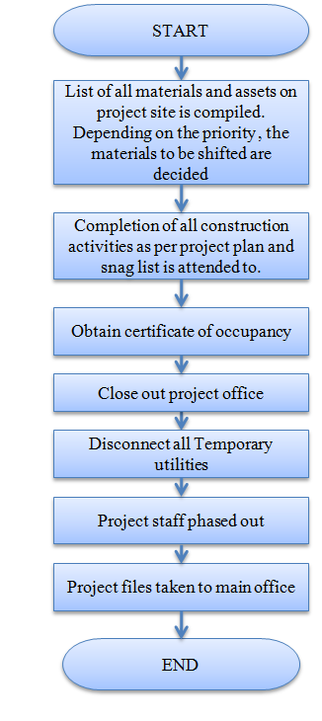

- PROCESS DESCRIPTION
  - A list of fixed assets and materials used in the project on the site are compiled. The list is compiled by the operations department in consultation with the top management. Depending on priority, it is decided which material or asset to be shifted.
  - All acceptance criteria in the Statement of Work is verified to have been met by the PMC department. Completion of all construction activities as per project plan is ensured and the entire snag list is attended to.
  - Demobilization starts immediately after the last hand over is complete. The business head will seek the approval of the top management to start demobilization. The HR department is informed that the demobilization has started.
  - The project office is closed. In the case of port cabins, they are dismantled and given to the scarp vendor by the operations team.
  - All temporary utilities used on site, like electric, phone and internet connections are all disconnected.
  - The project staff is shifted to other projects. This is the responsibility of the HR department with approval from the top management.
  - All the files and documents are taken to main office for documentation. The documents and files are taken over by the respective departments
10.EFFECIENCY MEASURE AND EFFECTIVENESS MEASURE
Efficiency Measures:
- Time taken for demobilization
- Number of quality snags emerging after demobilization [target NIL]
Effectiveness Measures:
- RISK ASSOCIATED WITH THE PROCESS
Demobilizing too early may increase cost of attending customer complaints
Demobilizing too late would lead to wastage of resources

- FORMATS FOR MAINTAINING RECORDS GENERATED IN THE PROCESS

- RECORDS

