SITE COORDINATION

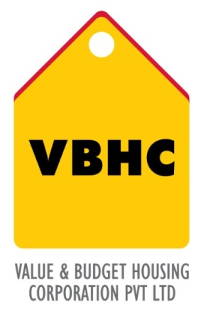
Document Control No : VBHC/PMC/P/04
Department : PMC
Revision No : Rev 1.0

 | Name/Designation | Signature | Date
Written By | Shivaprasad
Reviewed By | Kumar GVS

HISTORY OF REVISIONS

Revision No. | Revision Date | Chapter/clause no.  & text affected | Reason for Revision

TABLE OF CONTENTS

SL No. | CONTENTS | PAGE NO.
1. | Purpose | 1
2. | Process Trigger | 1
3. | Scope and Application | 1
4. | Process Owner  5. | 1
5. | Successor and Predecessor | 1
6. | Responsibilities & Authorities | 1
7. | Definitions and Abbreviations | 2
8. | Process Flow Chart | 2
9. | Process Description | 2
10. | Efficiency measures and effectiveness measures | 4
11. | Risk associated with the process | 4
12. | Formats for maintaining records | 4
13. | Records | 4
14. | Annexure 1 | 5
SITE COORDINATION

- PURPOSE
To coordinate with design team, estimation team, P&C team, Operation team for timely delivery of the project.

- PROCESS TRIGGER
This is a continuous process during construction phase.

- SCOPE AND APPLICATION
This process applies to all VBHC projects, includes coordination with P&C team for providing all required men and material just in time to control inventory costs and holding costs; design team and ensure timely delivery of drawings and details for execution on site; to coordinate with execution team to ensure smooth execution of Project.

- PROCESS OWNER
PMC - Head.

- PREDECESSOR AND SUCCESSOR PROCESSES
Predecessor Process: Project Master Schedule (P30,PMC) , Update Construction Schedule (P28,PMC) and Prepare project Budget R2 (P22,EST)
Successor Process: Pre Con and Construction Monitoring (P27,PMC) , Daily Construction Management (P34,OPs), Procure materials(P24,P&C), Procure contractors(P25,P&C),

- RESPONSIBILITY AND AUTHORITY
Site Coordination: PM – Manager, Head – PMC.

- DEFINITIONS & ABBREVIATIONS
PMS: Project Master Schedule.
PMC: Project Management.
P&C: Procurement and Contracts.

- PROCESS FLOW CHART
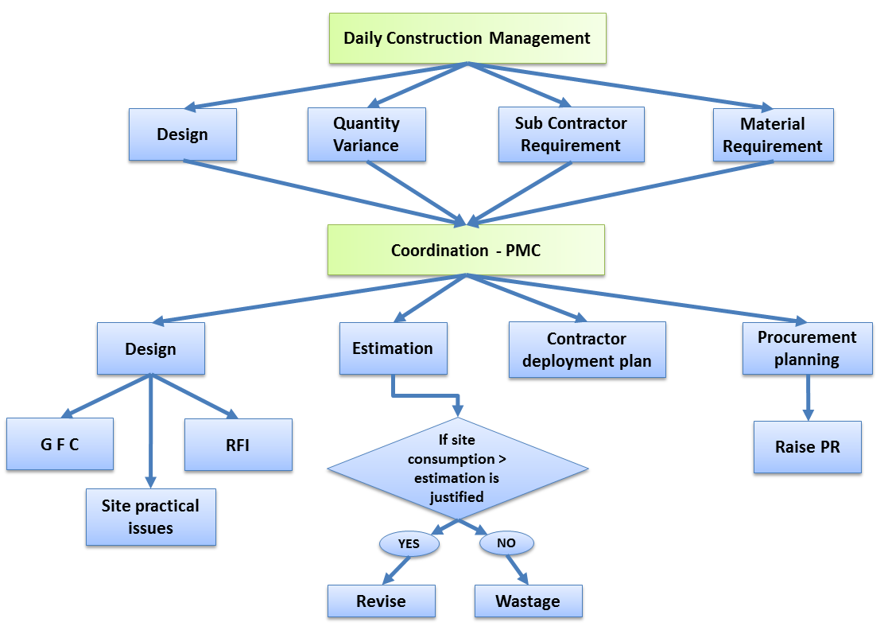

- PROCESS DESCRIPTION
  - Daily Construction Management: or the Operation team intimates the PMC team regarding the site issues faced with respect to the Design, material, contractor, etc. The issues faced are various GFC requirements, design change requirement, materials & contractors required at various stages of the project, variation in material quantities or amendment of contracts. In case there is no issue affecting the progress, a NIL report is sent by the site to PMC
PMC department coordinates with following departments:
  - Coordination with Design dept.:
    - Coordination for in time availability of GFC’s at site. Circulation of weekly drawing register.
    - Coordination for RFI’s raised against design issues at site are listed as below:
- For Practical issues to execute the existing design at site
- For alternative designs
- For Amendments in GFC’s available at site
    - In case of occurrence of any issue mentioned or clarifications, any personnel using the drawing approaches the PMC team on site. RFI is raised and sent to Design team.
    - Refer Design process of “RFI for design Issues from site” for resolution and documentation of RFI’s raised.
    - Once the resolution is done the same is sent through email to PMC.
  - Estimation dept.:
    - Coordination with the estimation team is need based, i.e in cases of :
- Site specific material requirement
- Rework to be carried out
- Special requirements such as spares, repairs etc.
- Deviations in the estimated quantities i.e estimated quantities less than the actual consumption at site
- Change in the unit of measurement
    - Coordination with the estimation team for estimation of an activity description in Work Order ( where the scope is yet to be decided).
  - Coordination with Procurement and Contracts dept.:
    - Coordination with Procurement Dept. for Material required at site.
      - PR is raised in Quadra by PMC team and send to procurement team through Quadra.
    - Coordination with Contracts Dept. for contractor requirement at site.
      - Work Calendar for a particular month is sent two months before to the Contracts Dept .Any immediate request for contractor is sent to Contracts team through mail.

- EFFECIENCY MEASURES AND EFFECTIVENESS MEASURES
Efficiency Measures: Average time to resolve issues to the satisfaction of the site team
Effectiveness Measures: Number of days delay in construction due to unresolved issues

- RISK ASSOCIATED WITH THE PROCESS

- FORMATS FOR MAINTAINING RECORDS GENERATED IN THE PROCESS

Request for Information Format

- RECORDS

ANNEXURE I
Name of Format | Code
Request for Information Format | VBHC/DES/F/04

