DOCUMENT CONTROL

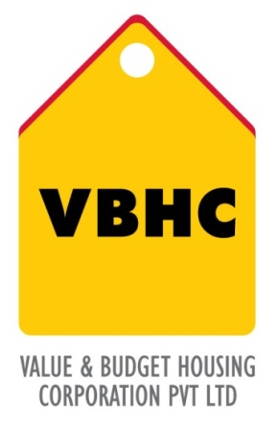
Document Control No : VBHC/QMS/P/04
Revision No : Rev 1.1
Date of Revision : 31st August 2023

 | Name/Designation | Signature | Date
Written By | Ramesh
Reviewed By | Nagesh
Approved By | Kumar GVS

HISTORY OF REVISIONS

Revision No. | Revision Date | Chapter/clause no.  & text affected | Reason for Revision

TABLE OF CONTENTS
SL No. | CONTENTS | PAGE NO.
1. | Purpose | 1
2. | Process Trigger | 1
3. | Scope and Application | 1
4. | Process Owner  5. | 1
5. | Successor and Predecessor | 1
6. | Responsibilities & Authorities | 2
7. | Definitions and Abbreviations | 3
8. | Process Flow Chart | 4
9. | Process Description | 5
10. | Efficiency measures and effectiveness measures | 12
11. | Risk associated with the process | 12
12. | Formats for maintaining records | 12
13. | Records | 12
14 | Annexure I | 11

DOCUMENT CONTROL

- PURPOSE
To define the process and responsibilities to ensure that internal documents, external and customer-supplied documents (standards, specifications, procedures, etc.), and data within VBHC are controlled.
- PROCESS TRIGGER
The process is triggered if any of the following occurs:
- If any new document is created
- If an existing document is being revised
- SCOPE AND APPLICATION
The requirements of this procedure apply to all documents [drawings, procedures, and work instructions], etc. used within the QMS related to products or services of VBHC.

- PROCESS OWNER
Management Representative

- PREDECESSOR AND SUCCESSOR PROCESSES
Predecessor Process: None
Successor Process: All processes under VBHC QMS

- RESPONSIBILITY AND AUTHORITY
  - Director/Chief Operating Officer (COO):
- Approve the documents prepared by the respective process owner/departmental heads.
- Reapprove the documents if any amendment is made in the original document.
- Suggest any improvement, changes or modification if necessary in the document.
  - Management Representative (MR):
- Prepare, review and update departmental procedures of his department.
- Review and control the documented procedures prepared by the respective process owner/departmental heads.
- In absence of director(s) and COO, approve the document.
- Issues approved documents to respective process owner and maintain the record.
- Withdraw obsolete document from the point of use.
- Review the amendment request in conjunction with the person proposing the amendment.
- Maintain and update document master list
  - Process Owner (HOD/PIC/Engineer):
- Identify and formulate documents required for their respective departments.
- Propose an amendment to the document, if required.
- Maintain the document master list at their respective department.
- Prepare document distribution list for their respective department.
- Issue documents as per document distribution list.
- Issue amended document as per document distribution list.

- DEFINITIONS & ABBREVIATIONS
- MR : Management Representative
- QMS : Quality Management System
- The following terms and definitions are referred from ISO 9000:2005:
Term | Clause | Definition
Document | 3.7.2 | Information and its supporting medium
Procedure | 3.4.5 | Specified way to carry out an activity or a process
Quality Manual | 3.7.4 | Document specifying the QMS of an organization
Record | 3.7.6 | Document stating results or evidence of activities performed
Specification | 3.7.3 | Document stating requirements

- PROCESS FLOW CHART
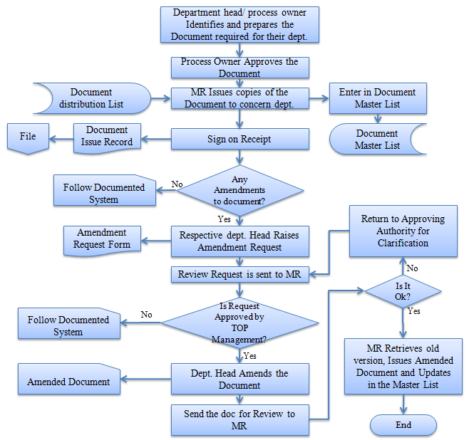

- PROCESS DESCRIPTION
  - QMS Documents:
    - This procedure applies throughout VBHC to the following documents, data, or other information sources that comprise the QMS:
- Quality Manual and QMS Procedures & Forms that describe the QMS and specific QMS processes applicable across all departments / areas
- Local work instructions, forms, or other process specific documentation applicable only to a specific department / area process
    - Using a standard format, the following requirements will be met for QMS document control:
- All documents shall be reviewed for adequacy prior to use
- Reviewed and updated as necessary and re-approve documents
- Ensured that changes and current revision status of documents are identified
- Ensured that relevant versions of applicable quality documents are available at points of use
- Prevent the unintended use of obsolete documents and to apply suitable identification to them if they are retained for any purpose
  - Preparation of Document:
Department head/ process owner shall identify documents required for their department and prepare this document as per the requirements given below.
The standard format for QMS procedures shall include, as appropriate:
- Header and footer on each page containing: document name, document number, revision level, latest revision date, latest printed date, page number
- Purpose
- Scope and application
- Definitions
- Responsibility and Authority
- Process Flow Chart
- Process description
- Checklist formats
- References
  - Identification of Document
Each document shall be identified with unique document name, document number, revision number and date of issue. VBHC’s QMS shall follow the document codification as explained below:
    - Codification of Documents:
A unique companywide document codification system to ensure proper identification and traceability of origin of documents has been established. The codification is as follows:

(COMPANY NAME/ DEPARTMENT CODE/ TYPE OF DOCUMENT/SERIAL NUMBER)

The following steps describe the document codification system:
- An alphanumeric system containing 11 characters has been developed for codifying the documents originated from various functional departments and project sites.
- The first four are alpha characters, which will denote the company/organization name as VBHC.
- Fifth to Seventh characters are alpha character and shall denote the functional department as follows:
Table No. 1
Department/ Function | Code
QUALITY MANAGEMENT SYSTEM | QMS
ESTIMATION | EST
ADMINISTRATION | ADM
CUSTOMER RELATIONSHIP MANAGEMENT | CRM
DESIGN | DES
FINANCE | FIN
HOME LOAN | HL
HUMAN RESOURCE | HR
INFORMATION TECHNOLOGY | IT
LAND & APPROVAL | L&A
LEGAL | LEG
OPERATIONS | OPE
PROCUREMNT AND CONTRACTS | C&P
PROJECT MANAGEMENT & CONSTRUCTION | PMC
QUALITY | QUA
SALES & MARKETING | S&M
TOP MANAGEMENT | TOP
ENVIRONMENT, HEALTH AND SAFETY | EHS

- Eighth character is an alpha characters and shall denote the type of document as follows:
Table No. 2
Type of Document | Code
System Manual | Q
Functional Manual | M
Construction Methodology/program | D
Plan | N
Procedure | P
Work Instruction | W
Record/Register/File | R
Guidelines | G
Specification/data-sheet | S
Formats | F
Inspection & Test Plans | I

- The ninth, tenth and eleventh characters are numeric characters, which will denote the serial no’s
    - An Example of Document Codification
For a procedure pertaining to Quality Management System, codification shall be as follows:
- First four letters will be VBHC
- Fifth, sixth and seventh letters will be denoted by QMS as this document belongs to Quality Management System (refer clause 9.3.1).
- The ninth letter will be denoted by P as this document is a Procedure (refer clause 9.3.1).
- Tenth eleventh and twelfth letters will be the serial number of the format; it can be any number from 01 to 999, suppose the number of the format is 104.
- Hence the Document Code will be - VBHC/ QMS/ P/ 104
This codification system will be applicable for those documents which are revised / newly created from May 14th, 2014.
    - Codification of Drawings:
A unique companywide document codification system to ensure proper identification and traceability of origin of drawings has been established and referred under clause – 10 in the documented procedure: GFC Generation - VBHC/DES/P/07
  - Document Approval:
    - After preparation of a document, it shall be reviewed and subsequently approved by the person authorized as per clause 6. All documents shall be reviewed by the Management Representative and the same shall be forwarded to the appropriate authority for their approval.
    - Each document shall contain a cover sheet which includes name and sign of document proposer, document reviewer and document approver.
    - Documents required for product realization may optionally be published, that is, made available to external users such as customers and suppliers. Only approved documents can be published externally.
  - Issuing documents:
    - After approval from the process owner, MR will prepare a document distribution and issue the document to the concerned department head and update the document master list. MR shall keep the document issue record.
    - MR shall also prepare and maintain document master list with current revision number.
    - Each department head shall also prepare a document distribution list & document master list for their individual department and issue the documents to concerned subordinates. Department head shall also maintain a document issue record.
  - Amendment of document:
    - If it is required to amend the document then amendment shall be made by the entity that created the original document & sent to the MR & top management for review and approve respectively.
    - If amendment gets approval from the management, then amended document shall be issued as per the procedure described above in Section 9.4.
    - If document is amended, previous version shall be retrieved from the point of use and new version of the same document shall be issued.
    - Document master list shall be updated with regards to the issue of amended document.
  - Control of External Documents:
    - Documents of external origin such as quality standards, industry standards, customer specifications, customer marks, etc. may be used as part of the product realization process.
    - Hard copies of external documents shall be verified periodically as current revision from the issuer.
    - It is the responsibility of Management and each Process Owner to review, implement, and maintain these documents and verify that they remain current at appropriate frequencies.
  - Uncontrolled Documents:
    - ‘Uncontrolled’ and ‘Reference Only’ are terms used which are deemed to have the same meaning.
    - Uncontrolled documents must be verified as current prior to use and are for informational purposes only.
    - They do not include documents required to ensure the quality of a product or process.
    - These documents are not available for external publication (Documents required for product realization may optionally be published, that is, made available to external users such as customers and suppliers); even it is issued and approved.
- EFFECIENCY MEASURES AND EFFECTIVENESS MEASURES
Efficiency Measures:
Effectiveness Measures: % current version of document found at the point of use
- RISK ASSOCIATED WITH THE PROCESS
Product realization or process activity based on superseded documents

- FORMATS FOR MAINTAINING RECORDS GENERATED IN THE PROCESS
Master List of Documents / Forms / External Documents & Distribution
- RECORDS
Record of Master List of Records & Master List of Documents - 1 yr. / till project completion

ANNEXURE I
Name of Format | Code
Master List of Documents / Forms / External Documents & Distribution | VBHC/QMS/F/03

