PRE-DELIVERY INSPECTIONS

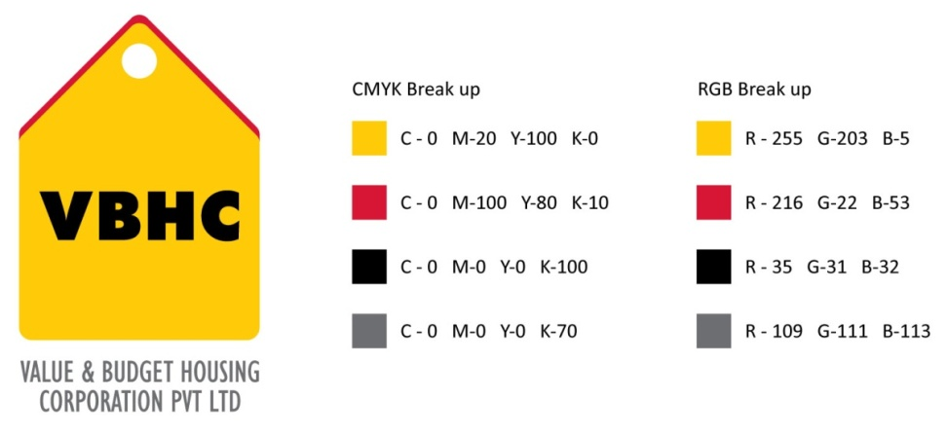
Document Control No : VBHC/QUA/P/04
Revision No : Rev 1.1
Date of Revision : 31st August 2023

 | Name/Designation | Signature | Date
Written By | Ramesh
Reviewed By | Nagesh
Approved By | Kumar GVS

HISTORY OF REVISIONS

Revision No. | Revision Date | Chapter/clause no.  & text affected | Reason for Revision

TABLE OF CONTENTS
SL No. | CONTENTS | PAGE NO.
1. | Purpose | 1
2. | Process Trigger | 1
3. | Scope and Application | 1
4. | Process Owner  5. | 1
5. | Successor and Predecessor | 1
6. | Responsibilities & Authorities | 1
7. | Definitions and Abbreviations | 2
8. | Process Flow Chart | 2
9. | Process Description | 3
10. | Efficiency measures and effectiveness measures | 4
11. | Risk associated with the process | 4
12. | Formats for maintaining records | 4
13. | Records | 4
14 | Annexure I | 5

PRE – DELIVERY INSPECTIONS

- PURPOSE
To establish a procedure for the control of Pre – Delivery so as to ensure that all terms of the contract have been met, that the home is substantially completed before handover to customer.

- PROCESS TRIGGER
This process triggers when Operations dept. handovers the project to Quality Dept. for Pre – Delivery Inspections

- SCOPE AND APPLICATION
This procedure applies to all flats and facilities to be handed over to a VBHC customer.

- PROCESS OWNER
Asst. Manager – Quality

- PREDECESSOR AND SUCCESSOR PROCESSES
Predecessor Process: Construction
Successor Process: Handover to customer

- RESPONSIBILITY AND AUTHORITY
Pre – Handing over Inspection Report signed by Block In – charge and Quality In – charge
The Asst. Manager – Quality is responsible for all requirements of Pre – Delivery Inspections of this procedure.

- DEFINITIONS & ABBREVIATIONS
- CRM : Customer Relationship Management
- PROCESS FLOW CHART
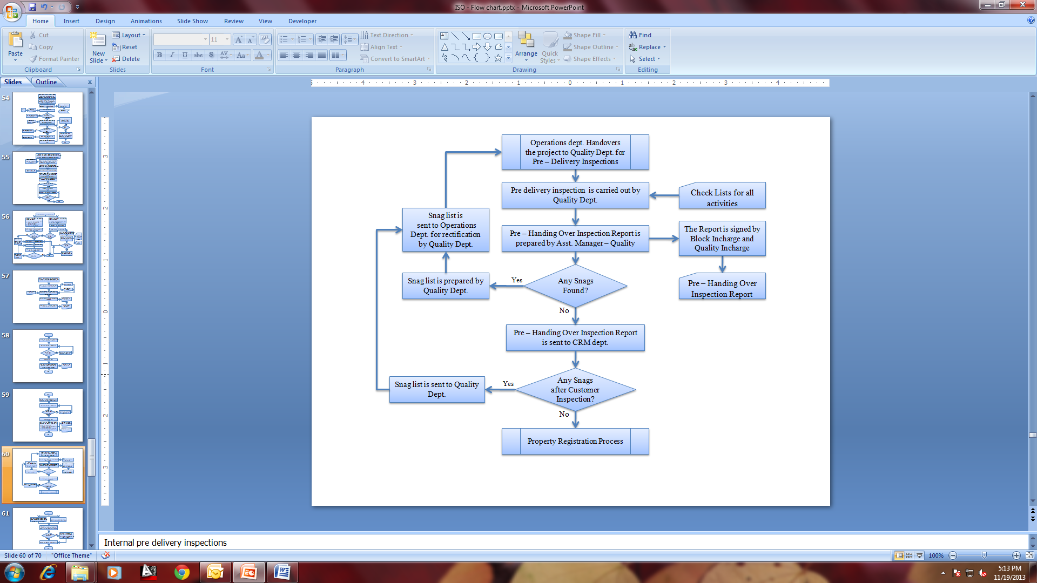

- PROCESS DESCRIPTION
  - After Operations dept. handovers the project to Quality dept. for Pre – Delivery Inspections, the inspection is carried out by Quality dept. to record any damaged, incomplete or missing items, or anything that is not operating properly.
  - If any Snags are found, they are recorded in Snag list by Quality dept. and Snag list is sent to Operations Dept. for rectification.
  - Pre – handing over Inspection Report is prepared by Asst. Manager – Quality and sent to CRM department, including the snag list
  - After all the rectifications it is forwarded to CRM dept for Property Registration Process

- EFFECIENCY MEASURES AND EFFECTIVENESS MEASURES
Efficiency Measures: Average time taken for completion of pre-handover inspection per flat
Effectiveness Measures: Average number of snags reported by the customers per flat

- RISK ASSOCIATED WITH THE PROCESS

- FORMATS FOR MAINTAINING RECORDS GENERATED IN THE PROCESS

Snag Checking Status Form
Snag Analysis Report

- RECORDS
Pre – Handing Over Inspection Report – Minimum Retention Period – Till Project Completion
Snag list – Minimum Retention Period – Till Project Completion

ANNEXURE I
Name of Format | Code
Snag Analysis Report | VBHC/QUA/F/33
Snag Checking Status Form | VBHC/QUA/F/34

