**PHONE**

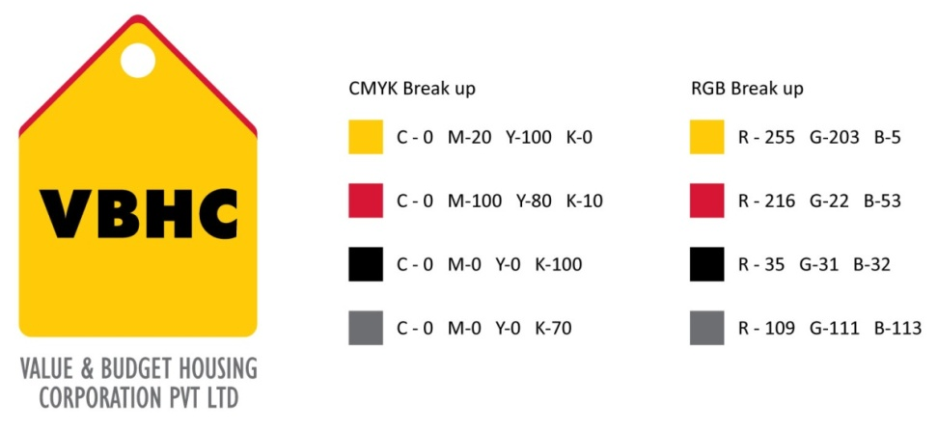

**Document Control No** : VBHC/ADM/P/05

**Revision No** : Rev 1.1

**Date of Revision :** 31st August 23

|  |  |  |  |
| --- | --- | --- | --- |
|  | ***Name/Designation*** | ***Signature*** | ***Date*** |
| ***Written By*** | ***Ajith Kumar*** |  |  |
| ***Reviewed By*** | ***Kumar GVS*** |  |  |
|  |  |  |  |

**HISTORY OF REVISIONS**

|  |  |  |  |
| --- | --- | --- | --- |
| **Revision No.** | **Revision Date** | **Chapter/clause no.**  **& text affected** | **Reason for Revision** |
|  |  |  |  |
|  |  |  |  |
|  |  |  |  |
|  |  |  |  |
|  |  |  |  |
|  |  |  |  |
|  |  |  |  |
|  |  |  |  |
|  |  |  |  |
|  |  |  |  |
|  |  |  |  |
|  |  |  |  |
|  |  |  |  |
|  |  |  |  |
|  |  |  |  |

**TABLE OF CONTENTS**

|  |  |  |
| --- | --- | --- |
| **SL No.** | **CONTENTS** | **PAGE NO.** |
| 1. | Purpose | 1 |
| 2. | Process Trigger | 1 |
| 3. | Scope and Application | 1 |
| 4. | Process Owner  5. | 1 |
| 5. | Successor and Predecessor | 1 |
| 6. | Responsibilities & Authorities | 1 |
| 7. | Definitions and Abbreviations | 1 |
| 8. | Process Flow Chart | 2 |
| 9. | Process Description | 2 |
| 10. | Efficiency measures and effectiveness measures | 3 |
| 11. | Risk associated with the process | 3 |
| 12. | Formats for maintaining records | 3 |
| 13. | Records | 3 |
| 14. | Annexure I | 4 |

**PHONE**

1. **PURPOSE**

To manage the process of obtaining phone connections to the employees.

1. **PROCESS TRIGGER**

This process is triggered when an employee needs to travel for company related reasons.

1. **SCOPE AND APPLICATION**

All VBHC employees at all levels.

1. **PROCESS OWNER**

Administration – Head

1. **PREDECESSOR AND SUCCESSOR PROCESSES**
2. **RESPONSIBILITY AND AUTHORITY**

First approval: Reporting manager

Final approval: Senior admin manager.

Sending all employee details to the network provider : Admin manager

1. **DEFINITIONS & ABBREVIATIONS**
2. **PROCESS FLOW CHART**

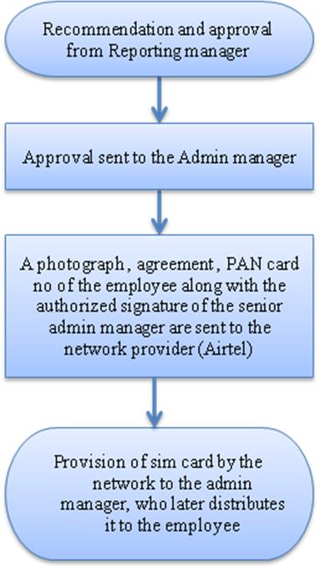

1. **PROCESS DESCRIPTION** 
   1. Any employee of the company, in order to avail a company connection, is to be recommended and approved by the reporting manager. The reporting manager recommends an employee depending on the work assigned to the employee.
   2. The request and approval is sent to the Admin manager by the reporting manager.
   3. A photograph, agreement, PAN card no along with the authorized signature of the senior admin manager is sent by the admin manager to the network provider (Airtel).
   4. The sim card and connection are provided by the network to the admin manager, who later hands it over to the employee. The connection comes with a credit of Rs 300 or Rs 1000, based on job priority. The company will only pay till Rs 300 or Rs 1000 on every monthly bill. If the bill exceeds Rs 300 or Rs 500 or Rs 1000, only with approval from the reporting manager, the company will pay the full amount. All company numbers with employee details will be entered in a format and kept with the admin department.
2. **EFFECIENCY MEASURES AND EFFECTIVENESS MEASURES**

Efficiency Measures: Number of days taken to provide the connection after request

Effectiveness Measures

1. **RISK ASSOCIATED WITH THE PROCESS**
2. **FORMATS FOR MAINTAINING RECORDS GENERATED IN THE PROCESS**

Employee Mobile Numbers

1. **RECORDS**

**ANNEXURE I**

|  |  |
| --- | --- |
| **Name of Format** | **Code** |
| Employee Mobile numbers | VBHC/ADM/F/05 |