GFC GENERATION
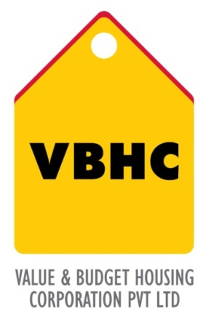

Document Control No : VBHC/DES/ /05
Revision No :
Date of Revision :

 | Name/Designation | Signature | Date
Reviewed By | Podapati Dharani
Approved By | Chakravarthi

TABLE OF CONTENTS
SL No. | CONTENTS | PAGE NO.
1. | Purpose | 1
2. | Process Trigger | 1
3. | Scope and Application | 1
4. | Process Owner  5. | 1
5. | Successor and Predecessor | 1
6. | Responsibilities & Authorities | 1
7. | Definitions and Abbreviations | 2
8. | Process Flow Chart | 2
9. | Process Description | 5
10. | Efficiency measures and effectiveness measures | 14
11. | Risk associated with the process | 14
12. | Formats for maintaining records | 14
13. | Records | 14
14. | Annexure I | 15

GFC GENERATION

- PURPOSE
To generate Good-For-Construction (GFC) drawings for use by Estimation Dept (for Quantification & subsequent costing) and Site Engineers for actual execution

- PROCESS TRIGGER
This process is triggered when Sanction Drawings are complete and informal review has been received from the authorities.
- SCOPE AND APPLICATION
Applicable to all projects developed by VBHC

- PROCESS OWNER
Design Head

PREDECESSOR AND SUCCESSOR PROCESSES

Predecessor: Obtain Pre-Con Approvals (P18, L)

Successor: Prepare Project Budget R2 (P27, Est.), Daily Construction Management (P41,OP), Procure Contractors (P&C,P29)

RESPONSIBILITY AND AUTHORITY

Lead Architect and Service heads Responsible for respective GFC generation

Technical sign-off from Design Head

Final signoff by the Estimation and Execution heads

DEFINITIONS & ABBREVIATIONS

GFC – Good for Construction

PROCESS FLOW CHART
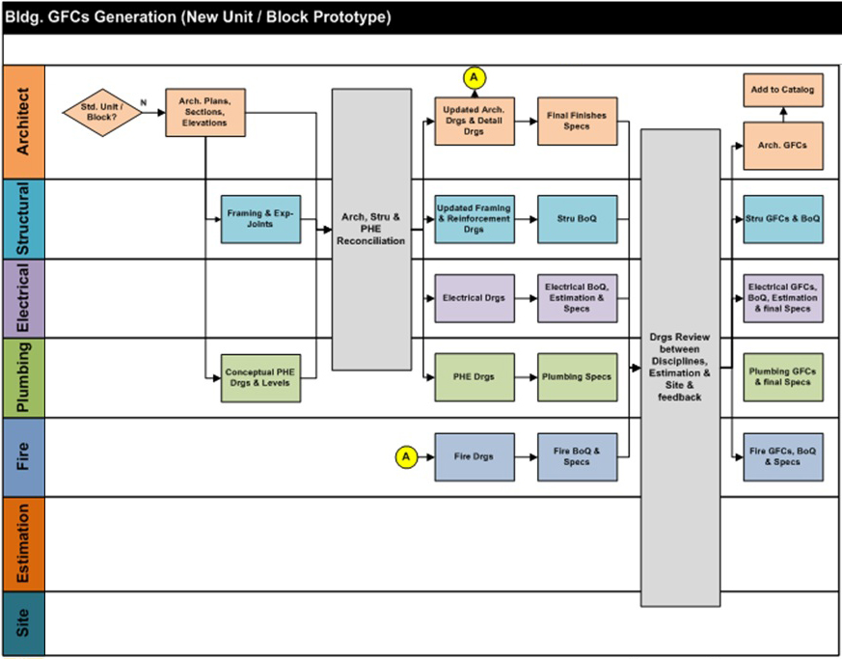
8.1 BUILDING GFC GENERATION (NEW UNIT / BLOCK PROTOTYPE)

8.2 GENERATION OF ELECTRICAL INFRA GFC’S

8.3 GENERATION OF PHE INFRA GFC’S

PROCESS DESCRIPTION
  - BUILDING GFC GENERATION (NEW UNIT / BLOCK PROTOTYPE)
9.1.1This process is triggered, when a new unit or block is to be designed.
9.1.2 The architect designs the unit or block and details out the architectural plans, sections and elevations. These are used as inputs by the structural and plumbing team to decide upon the structure as well as to prepare conceptual drawings and levels.
9.1.3 The architectural, structural, electrical, fire and plumbing team work together to detail and create drawings on software such as AutoCAD Revit, specifications and BoQ. These are sent to site and estimation department for review. The release of the drawings are recorded in the drawings release register.
9.1.4 Once the feedback is obtained, the architectural, structural, electrical, plumbing and fire produce the final GFC’s along with BoQ and final specs.
9.1.5 The final GFC’s BoQs and final specs are added into the catalog. (A catalog is a collection of drawings from previous projects)

Table 1: List of Architectural GFC’s
Sl No | Drawing Name
1 | Cover Sheet
2 | Ground and Typical Floor Plan
3 | Terrace and OHT level plan
4 | Elevations
5 | Sections
6 | Ground Floor-Floor Finish Detail
7 | Typical Floor - Floor Finish Detail
8 | False Ceiling Plan Ground Floor
9 | Finishes Schedule
10 | Staircase Detail
11 | Staircase and Lift Elevation
12 | Entrance Lobby Details and Ramp Details
13 | Railing Detail for Staircase
14 | Railing Details for Lobby and Corridor
15 | Balcony Details and Details at Window W1
16 | Toilet Details
17 | Kitchen Details
18 | Door Schedule and Details
19 | Window, Ventilator Schedule and Details
20 | MS Door Details

Table 2 : List of Electrical GFC’s ( Units/ Blocks )
Sl No | Drawing Name
1 | Model Apartment Electrical Layout
2 | Basement Floor Cable Tray Layout
3 | Basement Floor Electrical Layout
4 | Stilt/Ground Floor Cable Tray Layout
5 | Stilt/Ground Floor Electrical Layout
6 | First Floor Electrical Layout
7 | Typical Floor Electrical Layout
8 | Terrace Floor Electrical Layout
9 | Lightning Arrestor & L.M.R Electrical Layout
10 | Typical Flat Electrical Layout (1BHK )
11 | Typical Flat Electrical Layout (2BHK )
12 | Typical Flat Electrical Layout (3BHK )
13 | Typical Flat Electrical Layout (Studio)

Table 3: List of Plumbing GFC’s ( Units/ Blocks )
Sl No | Drawing Name
1 | Enlarged Toilet Details
2 | Enlarged Kitchen Details
3 | Stilt ceiling plumbing layout
4 | Ground and typical floor plumbing layout
5 | Terrace Floor water supply plan
6 | Terrace Floor rain water drainage
7 | OHT details
8 | Schematic Water Supply ( Block Wise )
9 | Lightning Arrestor & L.M.R Electrical Layout

Table 4: List of Structural GFCs
Sl No | Drawing Name
1 | General Notes
2 | Standard Details
3 | Column layout
4 | Column layout with location details
5 | Foundation layout and RC details
6 | Foundation section details
7 | Plinth beam layout and section details
8 | Ground floor shuttering and section details
9 | First floor shuttering layout and section details
10 | Second floor shuttering layout and section details
11 | Typical floor shuttering layout and section layout
12 | Terrace floor shuttering layout and section details
13 | Above terrace floor shuttering layout
14 | Lift and staircase head room shuttering layout
15 | Column schedule and lift core details
16 | Column schedule and lift core details
17 | Column schedule and lift core details
18 | Plinth beam RC details
19 | Ground floor beam RC details
20 | First floor beam RC details
21 | Second floor beam RC details
22 | Typical floor RC details
23 | Terrace floor RC details
24 | Wall elevations and RC details
25 | Ground floor slab RC details- bottom reinf.
26 | Ground floor slab RC details-top reinf.
27 | First floor slab RC details- bottom reinf.
28 | First floor slab RC details-top reinf.
29 | Second floor slab RC details- bottom reinf.
30 | Second floor slab RC details-top reinf.
31 | Typical floor slab RC details- bottom reinf.
32 | Typical floor slab RC details-top reinf.
33 | Terrace floor slab RC details-bottom reinf.
34 | Terrace floor slab RC details-top reinf.
35 | Staircase layout and RC details
36 | Compound wall details
37 | UG sump shuttering and RC details
38 | Retaining wall RC details
39 | Ramp RC details
40 | Drain RC details
41 | Drain RC cover slab detail

9.2 GENERATION OF ELECTRICAL INFRA GFC’S
9.2.1 The lead architect will provide the electrical design team with the master plan with service area location, levels, road profiles, road sections, building plans and sections. Depending on whether it is 3 or 5 KVA connection, the following are decided upon:
- Total Electrical capacity needed\
- Max Elec Room Fixed
- Transformer Location and Size
- DG Location
- Elec- Shaft Location
9.2.2 Electrical Drawings are prepared by the electrical architect using software such as AutoCAD Revit.
9.2.3 The lead architect, the electrical architect and the electrical design team review drawings and suggest changes if required.
9.2.4 All changes are carried out and the GFC drawings are finalized.
Table 5 : List of Electrical Infra GFC’s
Sl No | Drawing Name
1 | Main Single Line Diagram
2 | LT Cable routing Layout
3 | External Lighting Layout
4 | Transformer yard Equipment & Equipment Foundation Layout
5 | Earthing Layout

9.3 GENERATION OF PLUMBING INFRA GFC’S
9.3.1 The lead architect will provide the plumbing design team with the master plan with levels, road profiles, road sections, bore well location, landscape plan, building plans and sections. The following are decided upon:
- Area statement
- Size and location of UG sump
- Size and location of STP
- Size of OHT, Fire OHT and Flush
- No of Tanks
- No of Sumps.
9.3.2 The following are designed by the plumbing architect.
- Water Supply Network
- Water Automation System
- Pressurised/Non pressurised
- Borewell interconnection scheme
- RWH
- Sewage and storm water network Electrical Drawings are prepared by the electrical architect using software such as AutoCAD Revit.
9.3.3 The lead architect, the electrical architect and the electrical design team review drawings and suggest changes if required.
9.3.4 All changes are carried out and the GFC drawings are finalized.
Table 6 : List of Plumbing Infra GFC’s
Sl No | Drawing Name
1 | Site Plan - External Storm Water Layout
2 | Site Plan - External Sewer Drainage Layout
3 | Site Plan - External Water Supply Layout
4 | Site Plan - External Coordination Layout
5 | U.G Sump and Pump Room details
6 | S.T.P Location and Details

Table 7 : Summary of the process
# | Sub-Process Name | Business Impact of the Process | Inputs | Design Output | Reviewed and Approved By
1 | Architectural Design | Arch-GFCs (for execution & estimation) | 1.) Unit & Block Plans  2.) Road & Plinth Levels  3.) Approved Specs, Brands & Dimensions  4.) Approved Unit Configuration List  5.) Structural Input  6.) Services Inputs | 1.) 1st-Cut Dwgs to be shared with Structural Consultant  2.) Architectural GFCs | Lead Architect
2 | Structural Design | Stru-GFCs (for execution & estimation) | 1.) 1st-Cut Arch-Dwgs  2.) Architectural GFCs  3.) Soil-Test Reports  4.) Levels  5.) Service Inputs (Plumbing - Bldg & Infra) | 1.) 1st-cut Framing Dwgs to be shared with VBHC-Services  2.) Framing GFCs  3.) Reinforcement GFCs  4.) Stru-Infra GFCs  5.) BoQ | Consultant and Head- Design
3 | Electrical Design | Elec-GFCs (for execution & estimation) | 1.) 1st-Cut Arch-Dwgs  2.) Approved Unit-Configuration List  3.) Master Plan  4.) Road Drawings with Levels & Sections  5.) Electrical Infra Survey Report (for tapping point etc.)  6.) Drawings & Documentation from Lift-Vendor | 1.) Electrical GFCs (Bldg & Infra) | Head-Electrical
4 | Electrical BoQ & Estimation | Elec-BoQ (for execution & estimation) | 1.) Electrical GFCs (Bldg & Infra)  2.) Approval Specs & Brands | 1.) BoQs (Material List with Rates) | Head-Electrical
5 | PHE Design | PHE-GFCs (for execution & estimation) | 1.) 1st-Cut Arch-Dwgs  2.) Approved Unit-Configuration List  3.) Master Plan  4.) Road Drawings with Levels & Sections  5.) PHE Infra Survey Report (for tapping point etc.)  6.) Stru-Framing Drawings | 1.) PHE GFCs (Bldg & Infra)  2.) Input to be given to STP Vendor | Head-  Plumbing
6 | Roads & Levels | Roads & Excavation GFCs (for execution & estimation) | 1.) Master Plan  2.) Soil Report  3.) Topo Survey | 1.) Master Plan with Road Levels & Cross-Sections  2.) Road Profiles  3.) Retaining Walls  4.) Excavation Dwgs (as necessary)  5.) Cut/Fill Volumes | Head- BIM
7 | Landscape Design | Landscape-GFCs (for execution & estimation) | 1.) Master Plan  2.) Natural & Finished Ground Levels  3.) Service-Coordination Dwgs  4.) Landscape Plan | 1.) Landscape GFCs | Head- BIM

The release of these drawings are recorded in the drawings release register, while the status of the drawings are recorded in the weekly progress report.
The drawings are released on to site along with transmittal

CODIFICATION OF DRAWINGS
A unique companywide document codification system to ensure proper identification and traceability of origin of drawings has been established. The following steps describe the document codification system:
- An alphanumeric system containing both alphabets and numbers has been developed for codifying the drawings originated from the design department.
i.e VBHC/ PROJECT CODE/LOCATION / TYPE OF DWG / PURPOSE / DRAWING No/ Rn

10.1 Project Code will denote the code of the project :
Project Name | Project Code
Kengeri 2 | KEN 2
Kannamangala | KAN

**Codes will be added upon with upcoming projects
10.2 Location code indicates the location the drawing refers to on site :
Location | Location Code
Cluster | CLS
Block No ( e.g BLK A2) | BLK #
Infrastructure | INF
Amenities | AME
Temporary Structure | TM

10.3 Type of Drawing denotes whether the drawings is an architectural or plumbing or electrical or landscape drawings
Type of Drawing | Code
Architecture | A
Plumbing | P
Electrical | E
Landscape | L

10.4 Purpose indicates the purpose of the drawing.
Purpose | Code
Preliminary | PLR
Sanction | SNC
Airport | AIR
MoEF | MOF
Good for Construction | GFC
BWSSB | BWS
BESCOM | BES
Pollution Control Board | PCB

10.5 Drawing No will denote the number of the drawings
10.6 Rn – Rn refers to the revision number .

EFFECIENCY MEASURES AND EFFECTIVENESS MEASURES
Efficiency measures: Number of RFIs received per drawing
Number of revisions required
Effectiveness measures: Time taken to release all GFC from trigger

RISK ASSOCIATED WITH THE PROCESS

FORMATS FOR MAINTAINING RECORDS GENERATED IN THE PROCESS
Transmittals

RECORDS
Drawings Release Register

ANNEXURE 1
Name of Format | Code
- Transmittals | VBHC/DES/SW/05

